AZURE DEVOPS ARTECH

AZURE Pipeline using AKS Deployments

Before going to configure azure pipeline, please create account in portal.azure.com

**Prerequisites**

1. **Create Centos VM in Portal azure website**
2. **Create AKS Cluster in Portal azure website**
3. **Create organization in dev.azure.com**
4. **Create Project in dev.azure.com**
5. **Create Self-hosted agent in dev.azure.com**
6. **Finally create the Pipeline in dev.azure.com**

**Step1 : After login Portal azure website will get below screen**

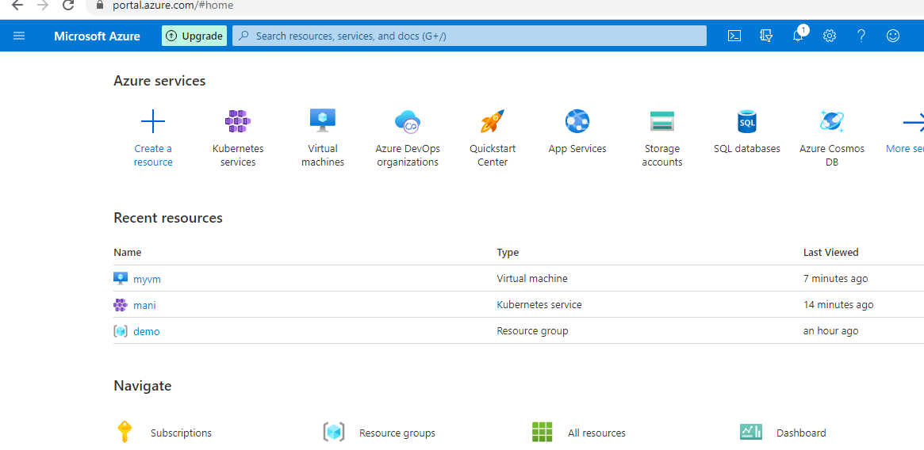

**Step 2 : create the vm**

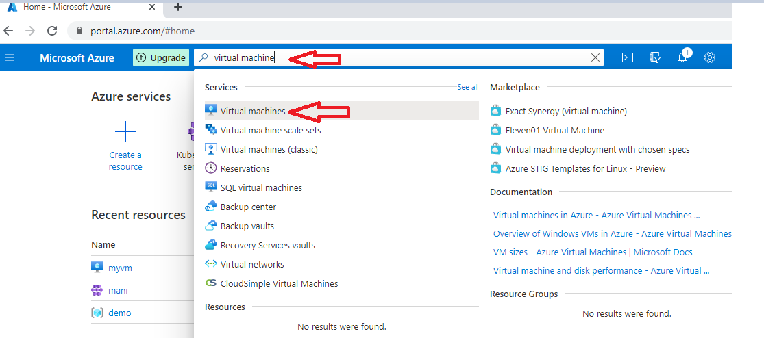

**Step3 :**

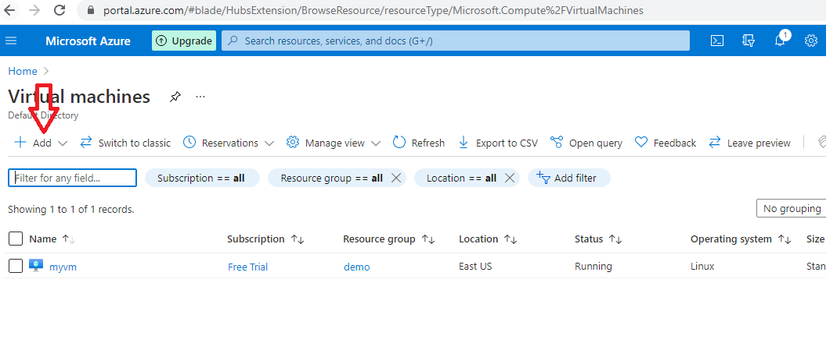

**Step4 :**

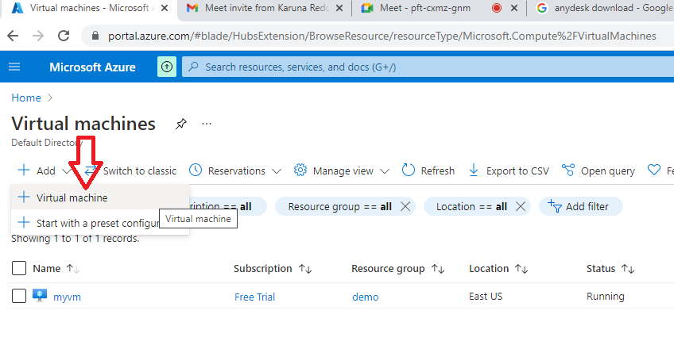

**Step5 : select the resource group and enter the vm name as you like**

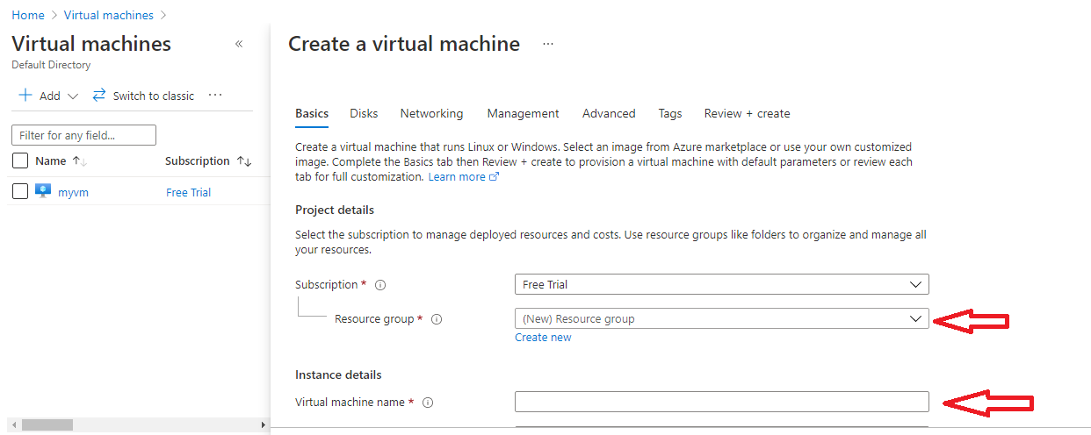

**Step 6 :**

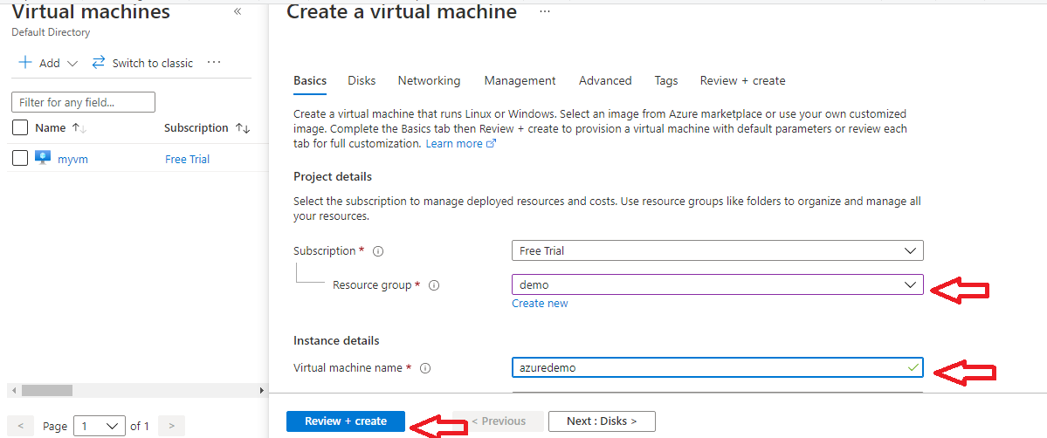

**Select centos 7.9 version**

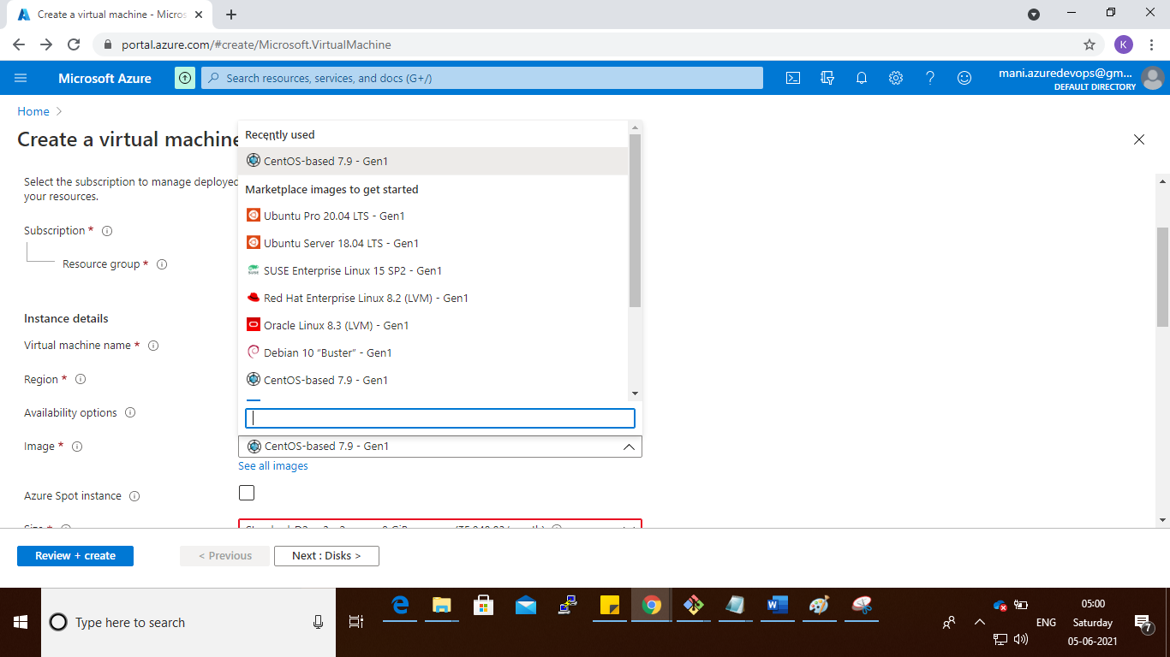

**Step7 :**

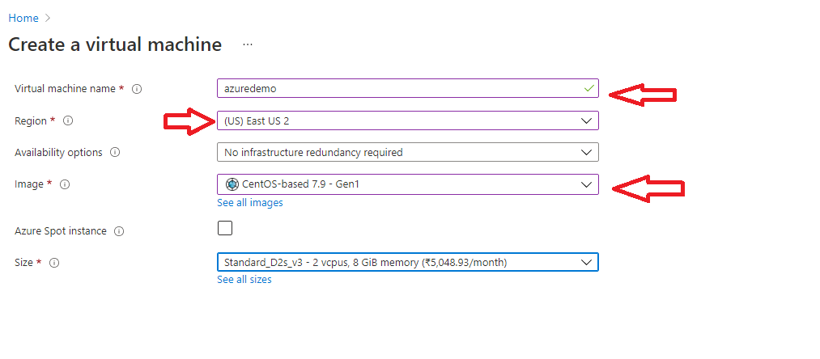

**Select the password option**

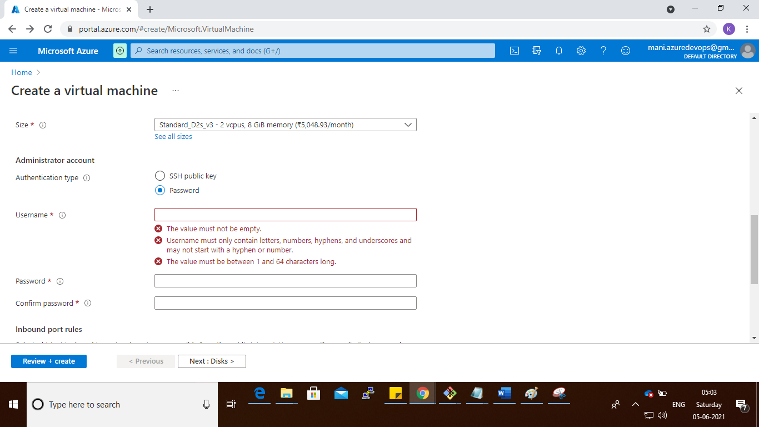

**Create the user and password**

**Note : password must reach the password policy**

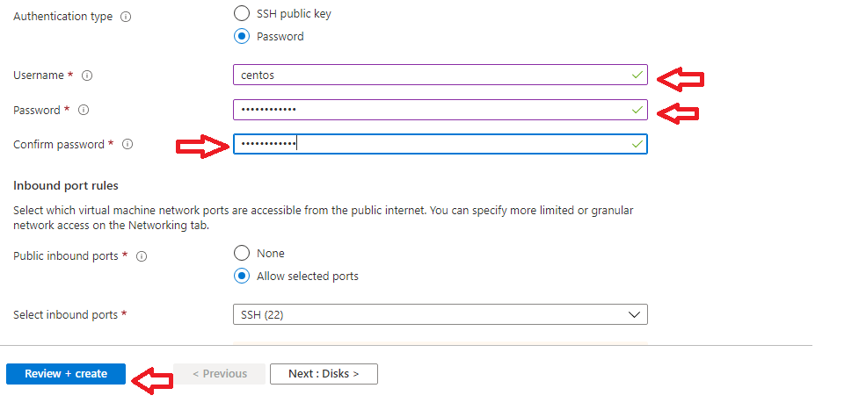

**Select the Review + create**

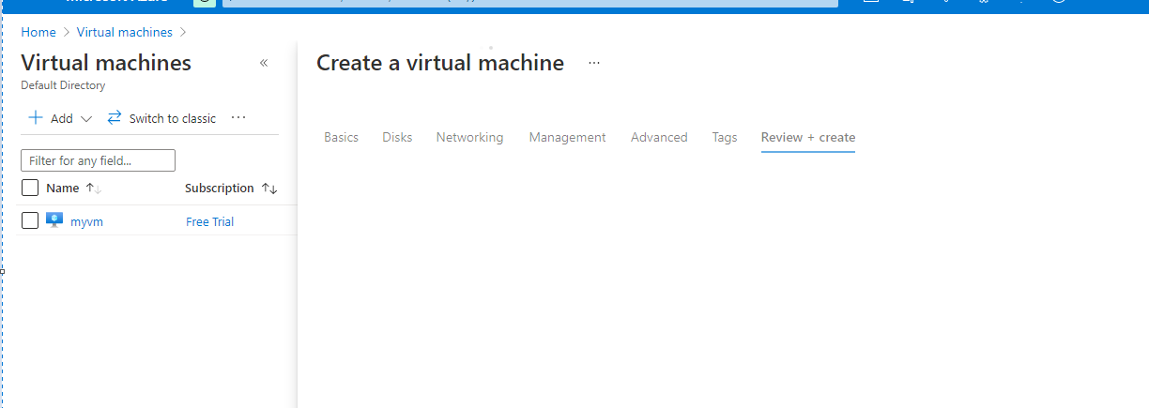

**Step 8 :**

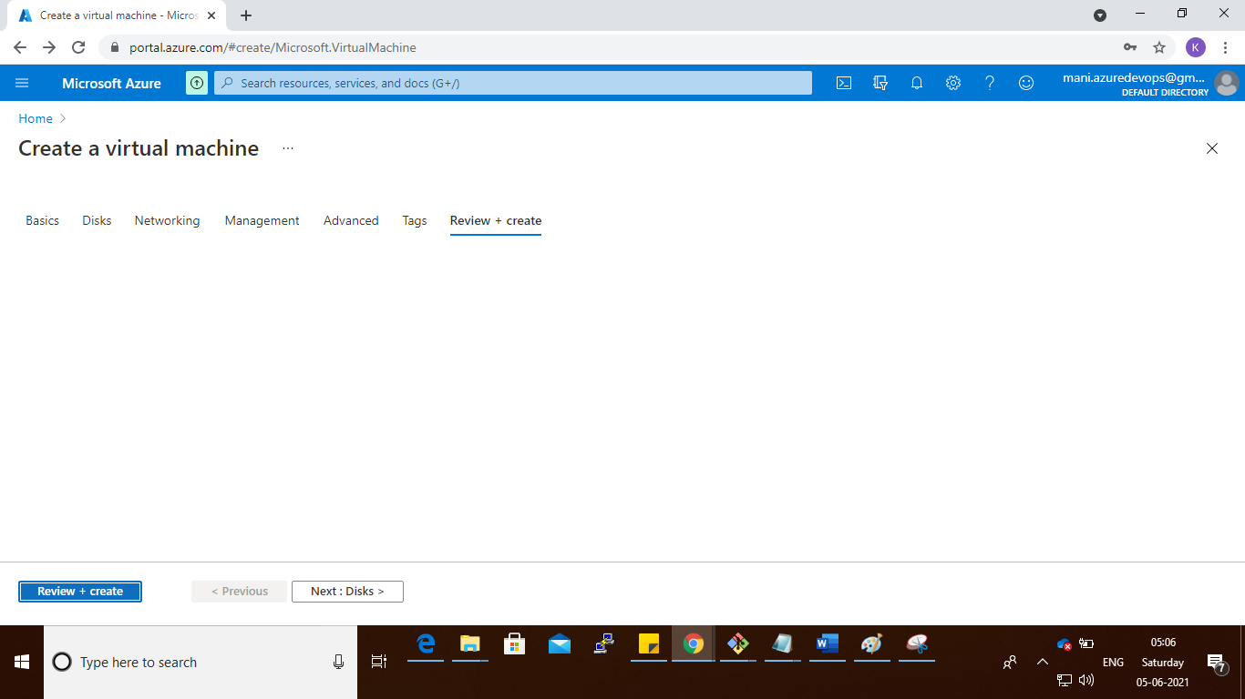

**Step 9:**

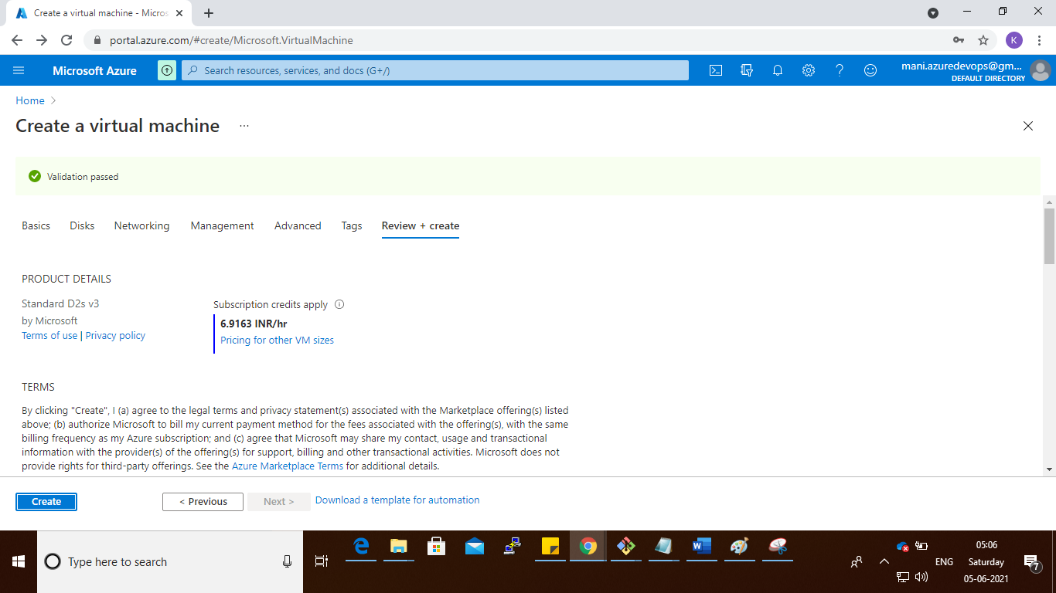

**Step 10 :**

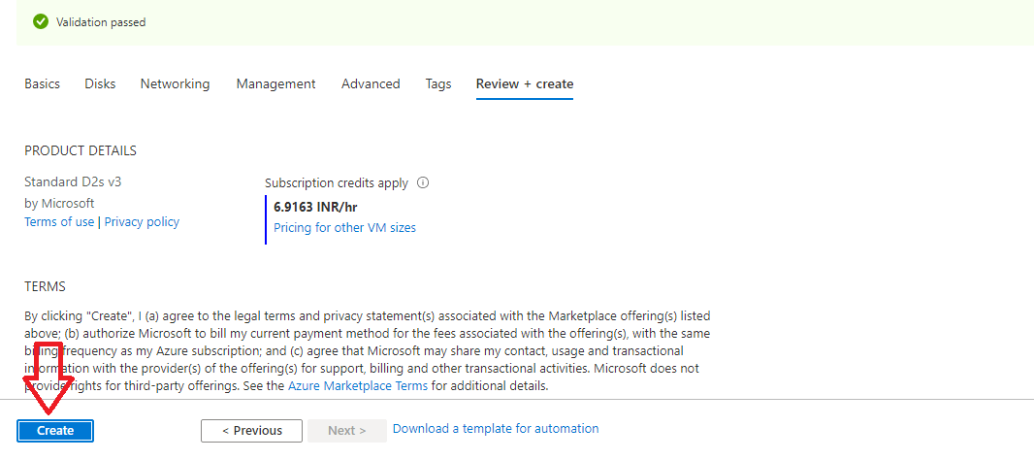

**Step 11 :**

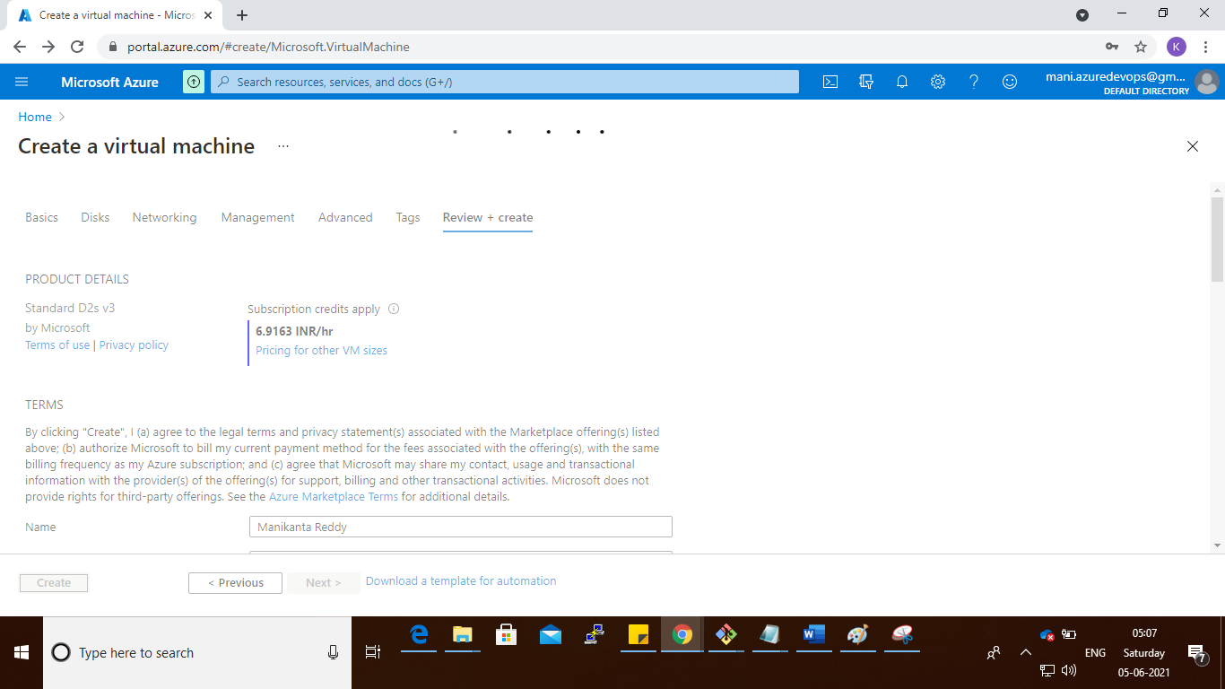

**Step 12 :**

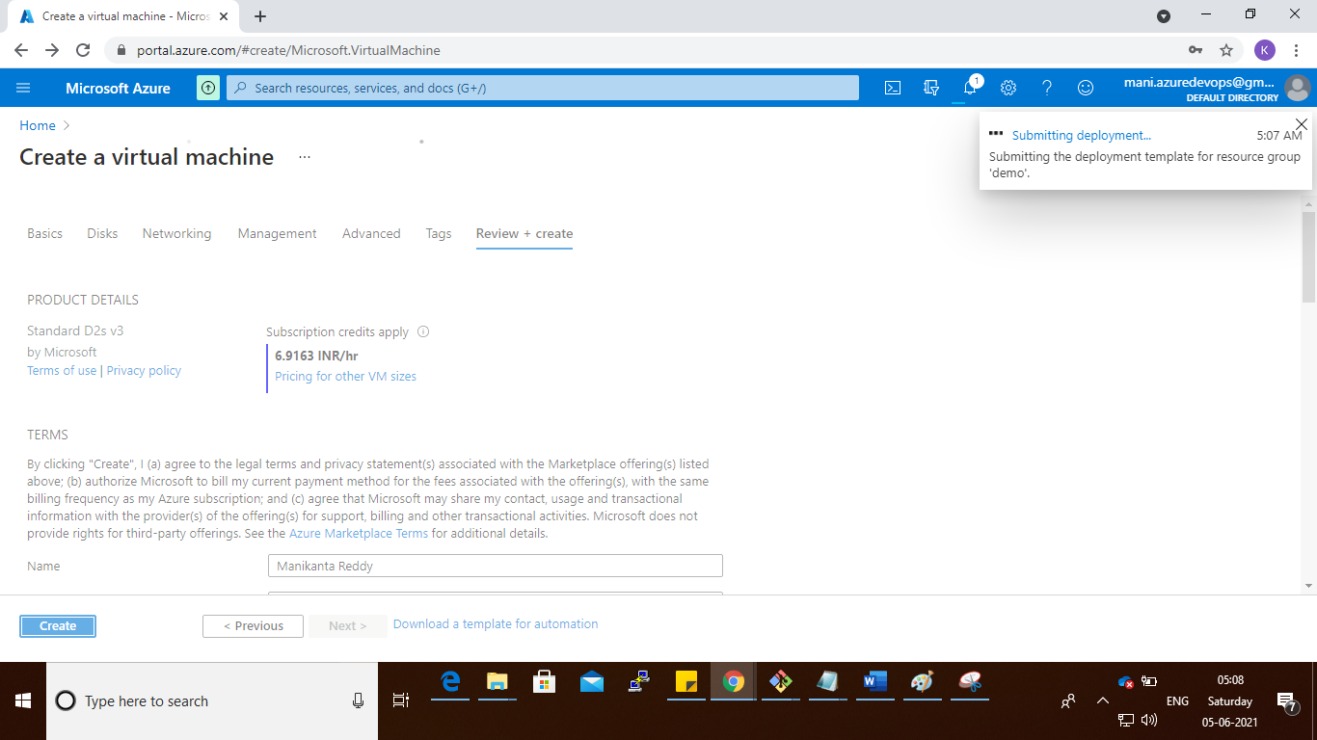

**Step 13 :**

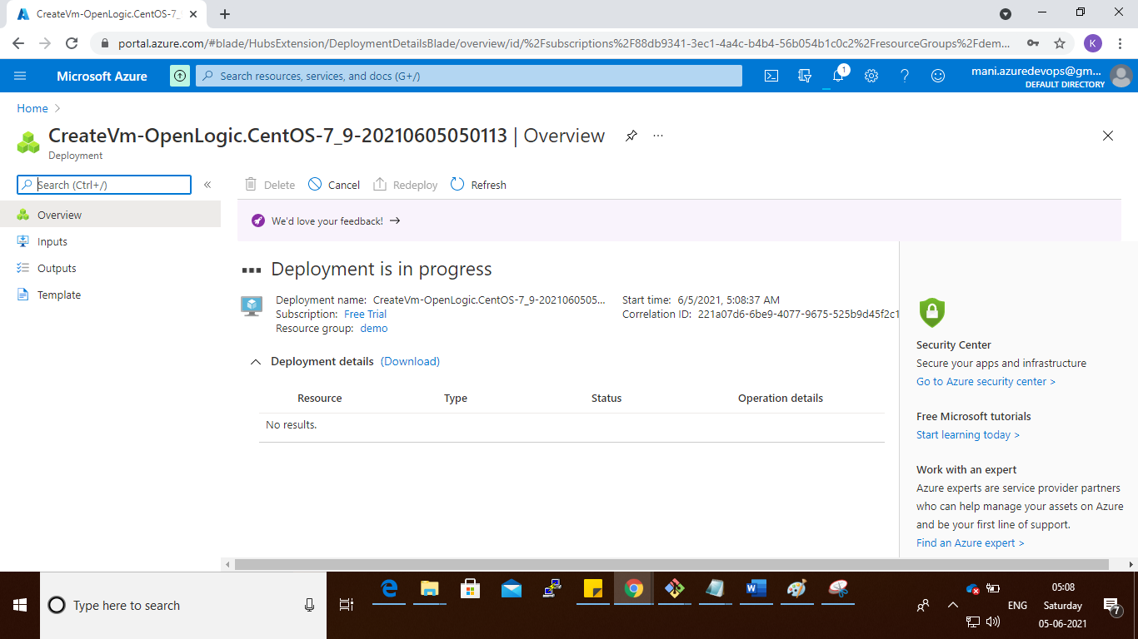

**Step 14 : VM Created Successfully**

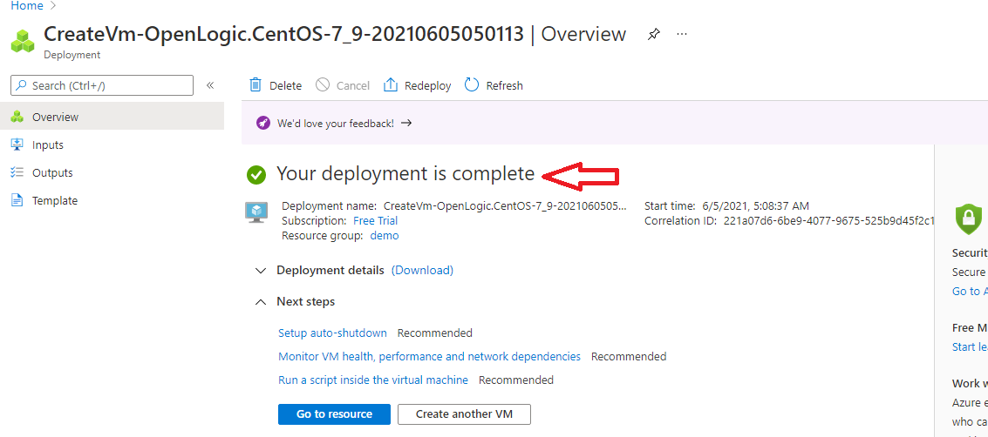

**Step 1:**

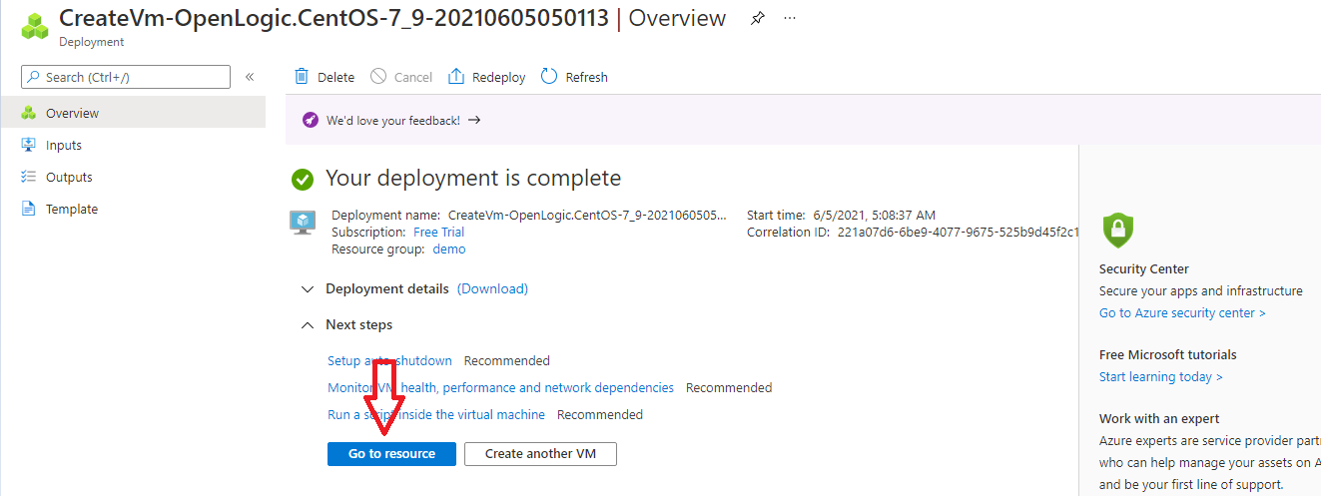

**Step 1: copy the public ip address**

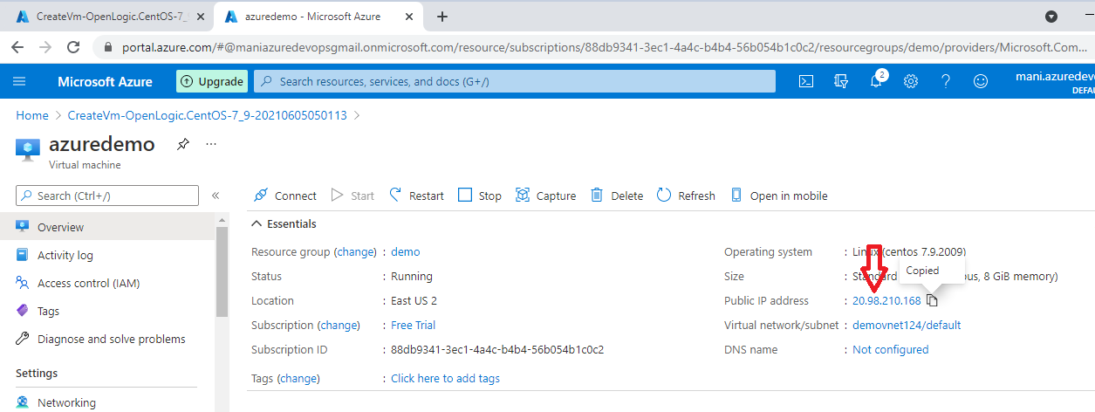

**Step 15 : connect the vm command prompt**

**Click on 🡪Cloud shell button**

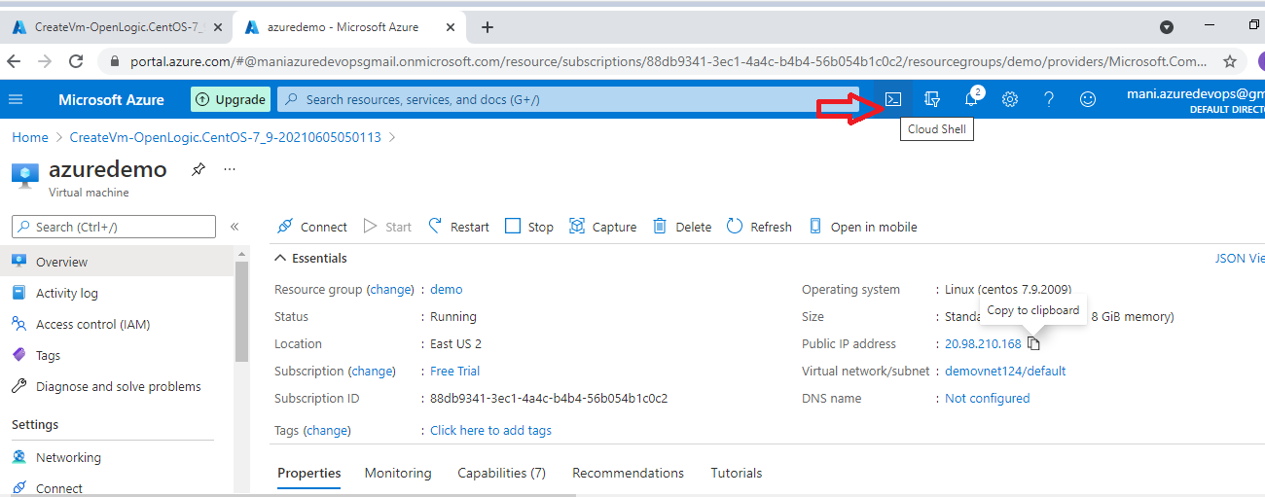

**Step 1: how to login VM**

**User name : centos**

**Password : Centos@12345**

**IP : 20.10.13.200**

**Once bash shell prompt open, give below command**

**Cmd : ssh centos@20.12.3.43**

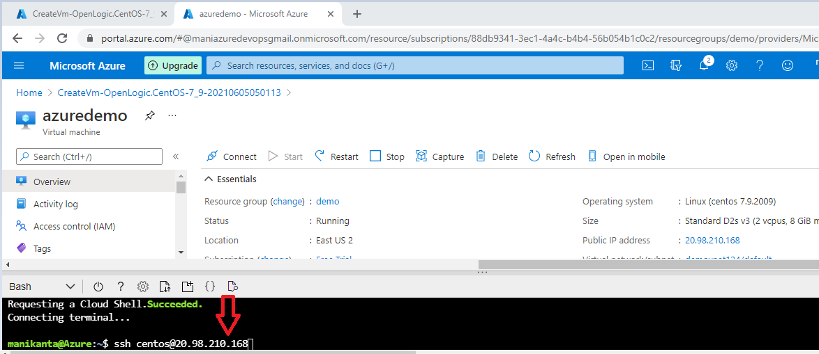

Step 16 :

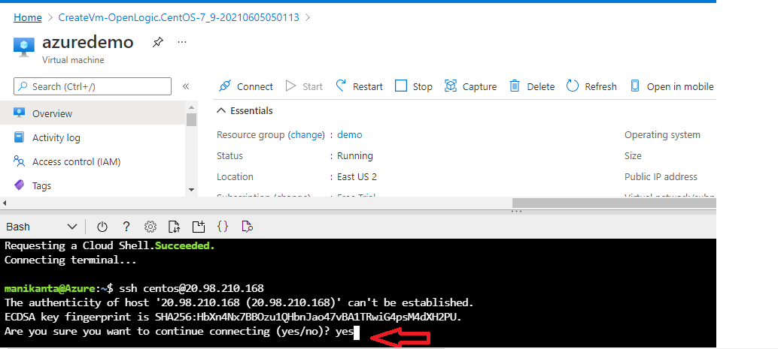

Enter password

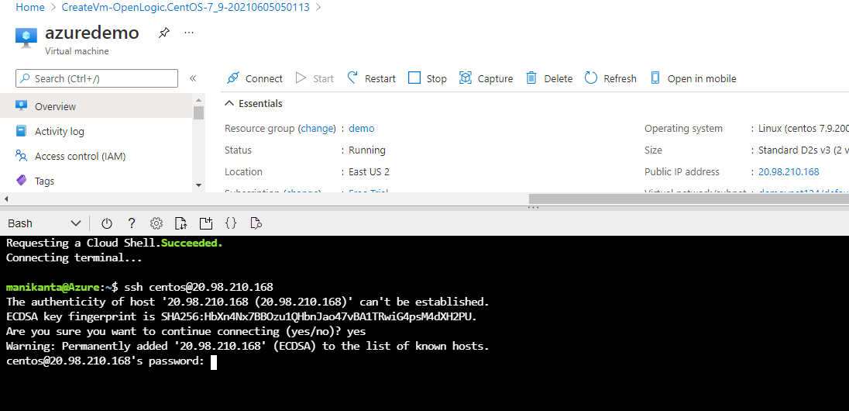

Successfully login to vm

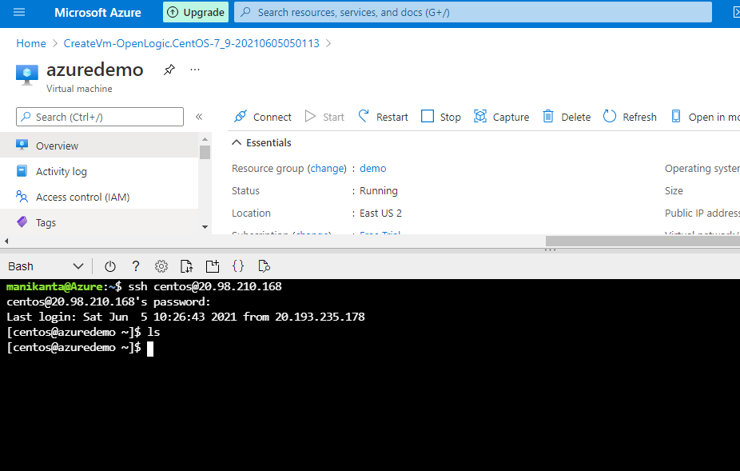

Next step : create the AKS cluster

Go to home and search : Kubernetes services

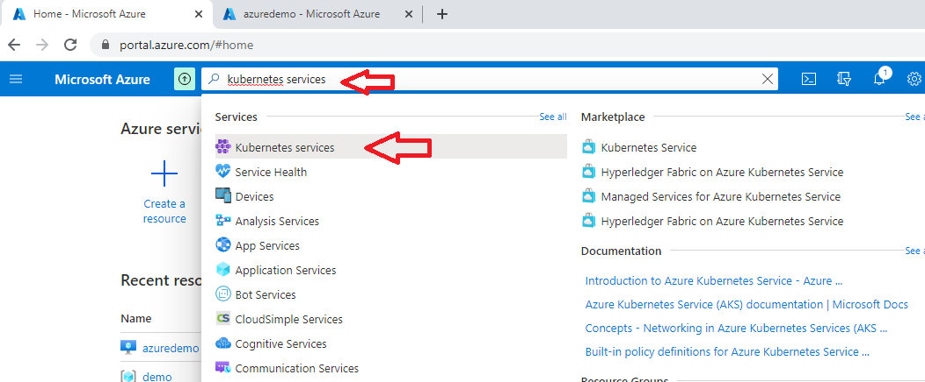

Step : click on add

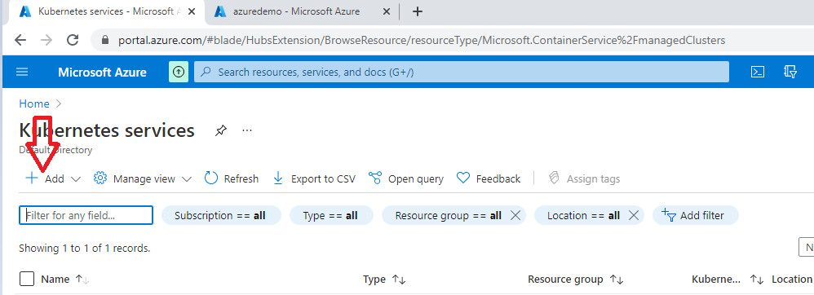

Select the add kubernestes cluster

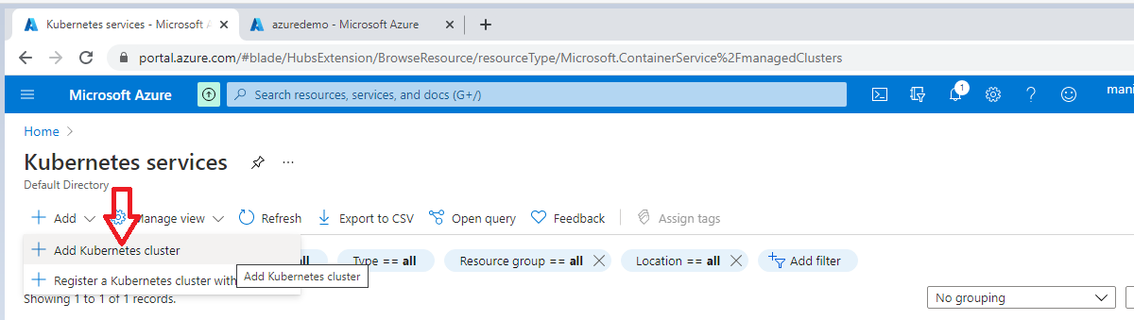

Step :

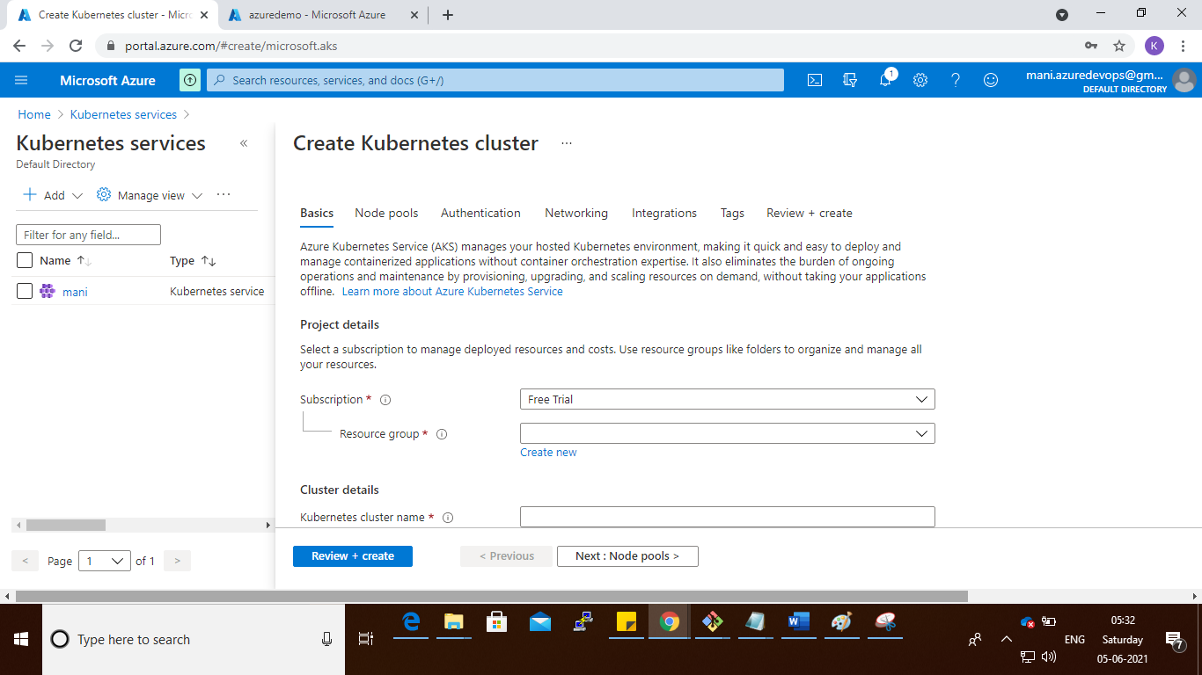

Step : select the resource group name and cluster name as you like

And also select the size of cluster

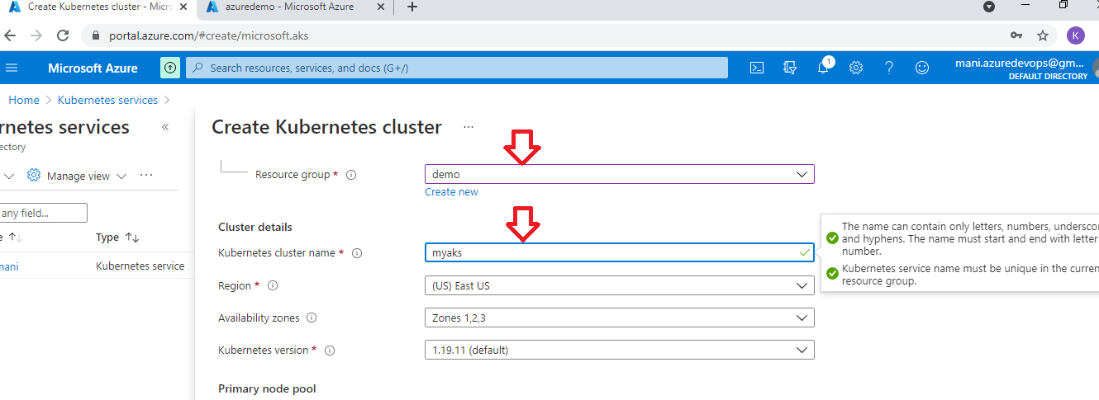

Node size I given 1

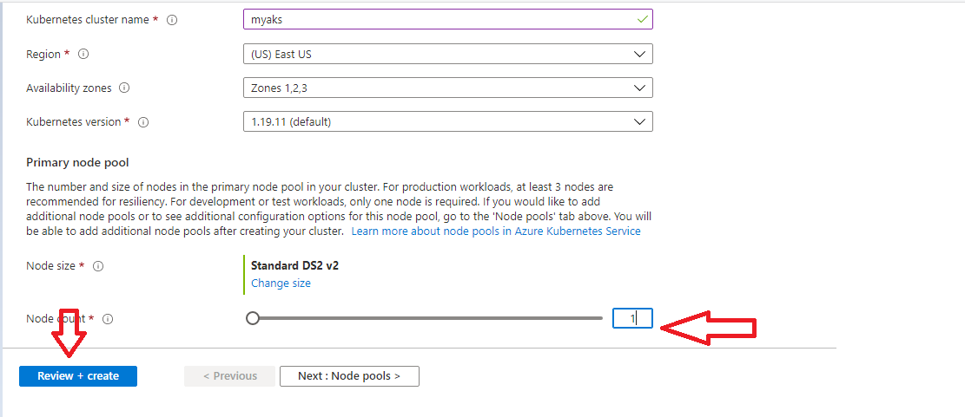

Step

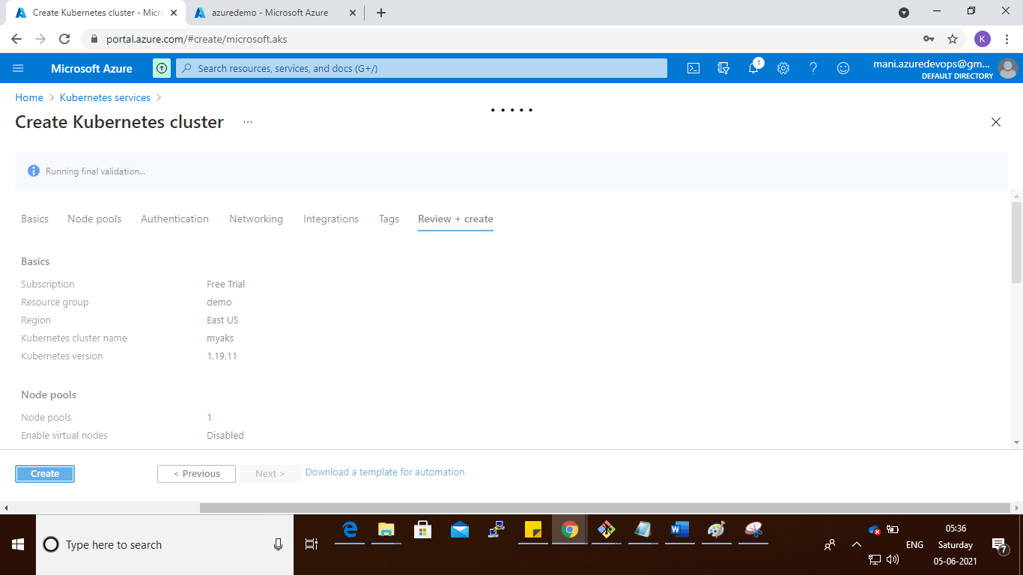

Step :

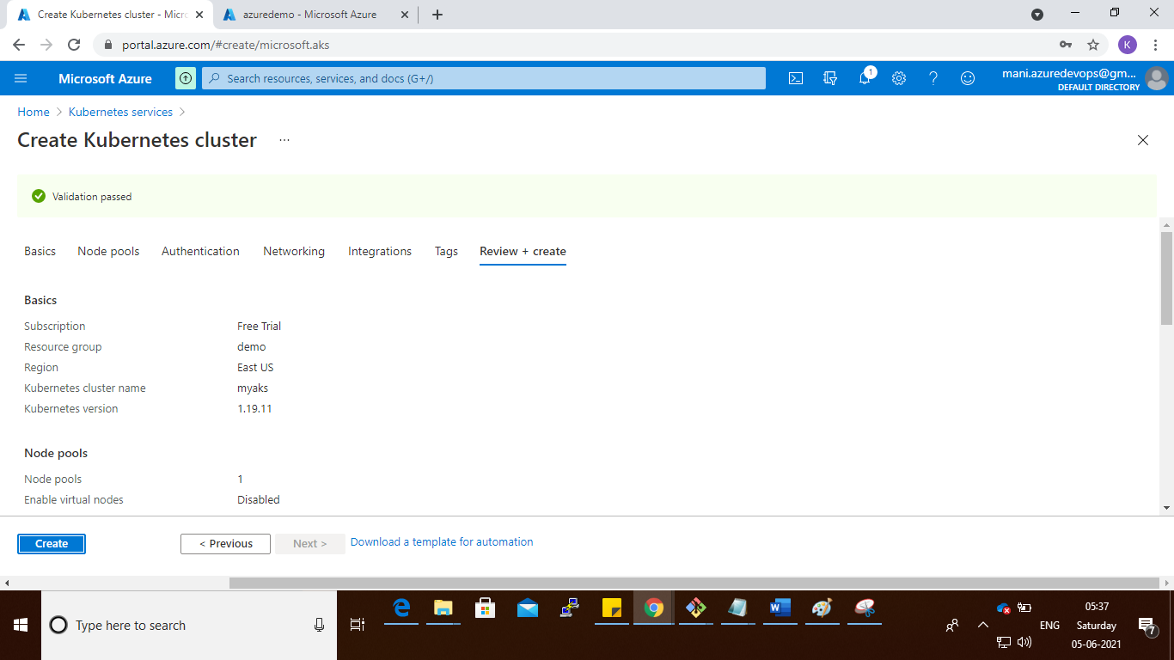

Step :

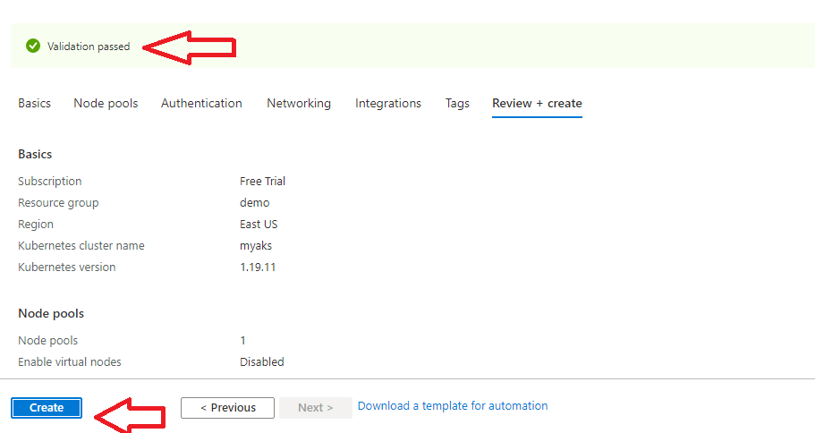

Step :

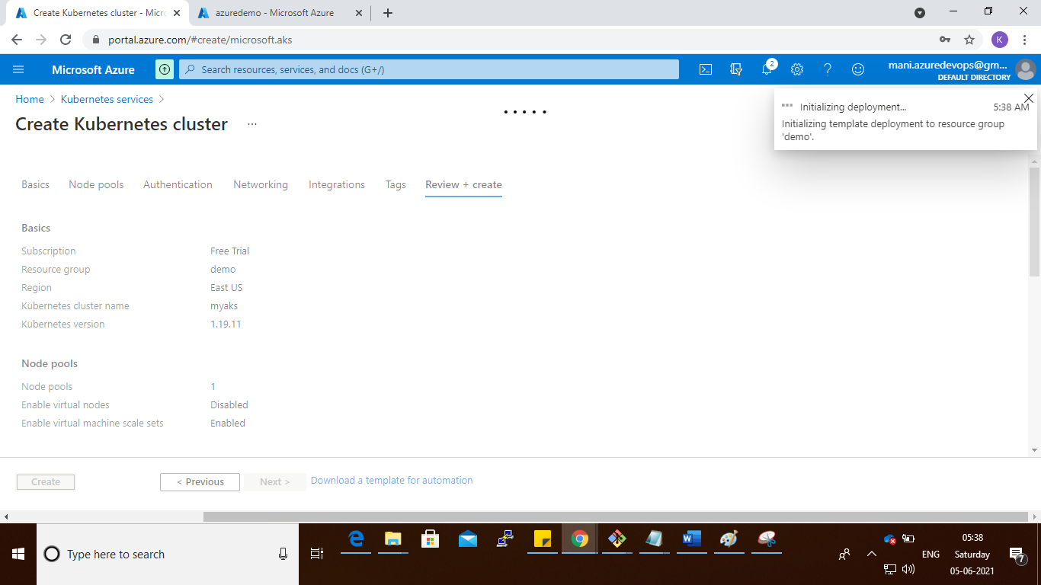

Step :

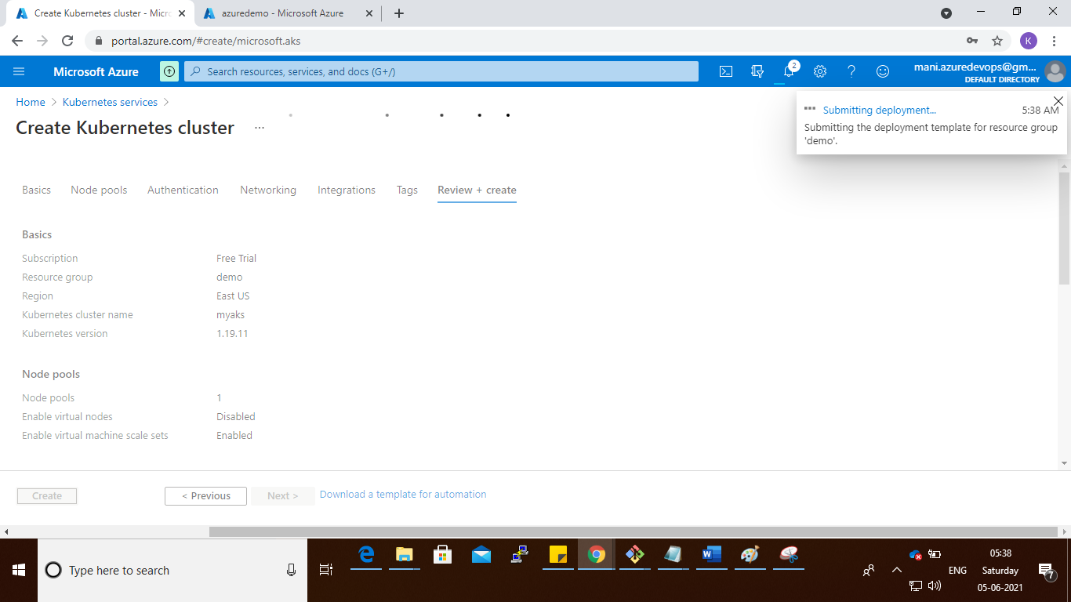

Step :

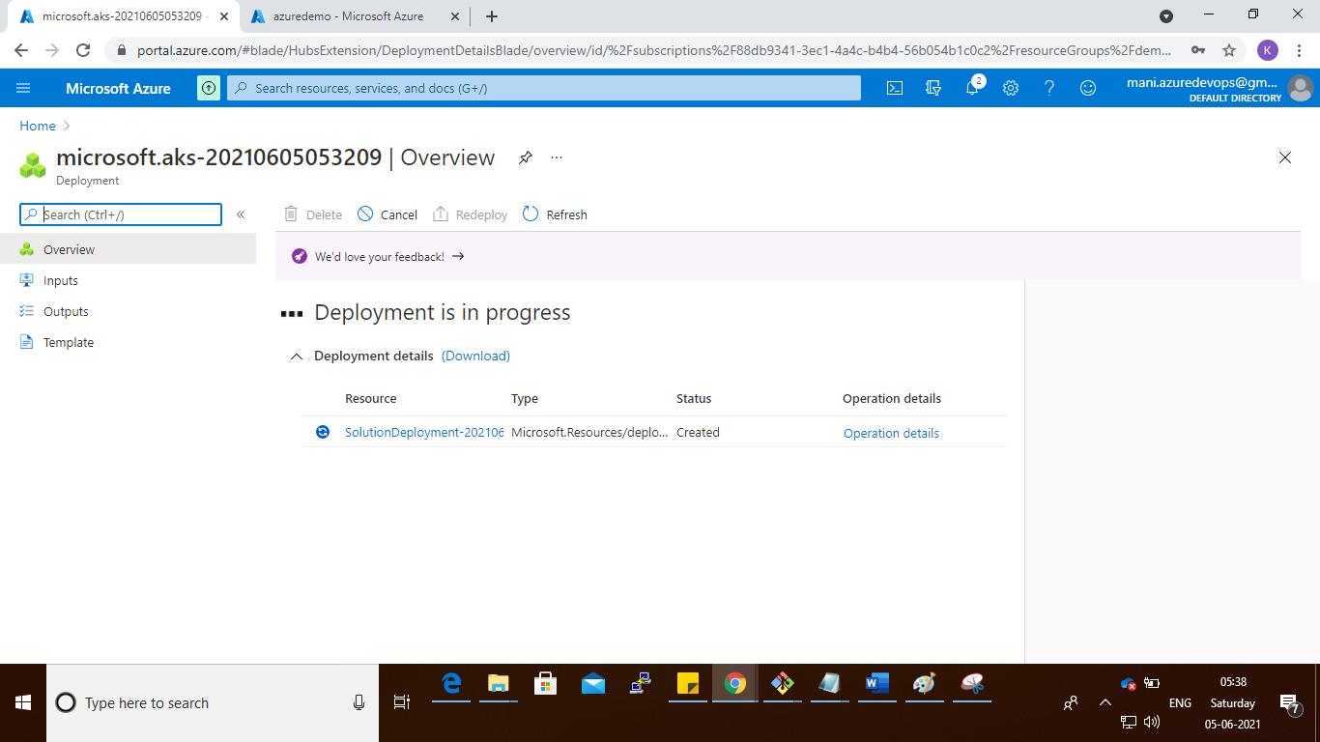

Step : go to home and search the azure devops

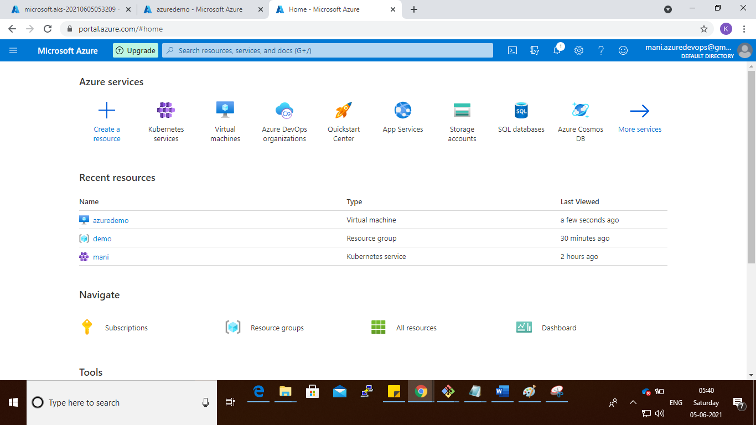

Like this

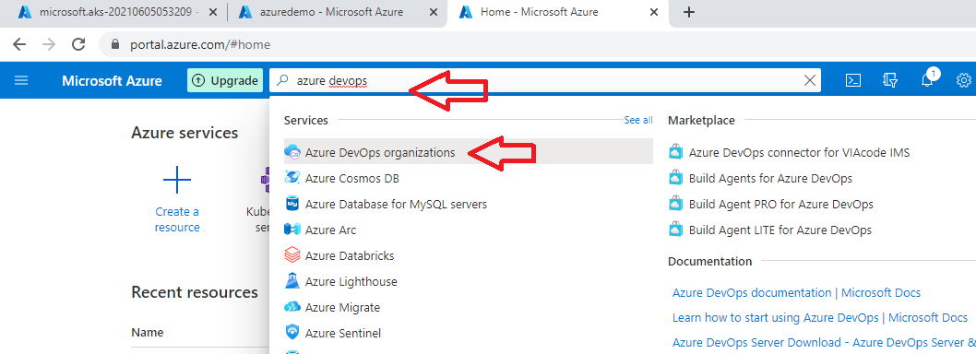

Select the azure devops organization

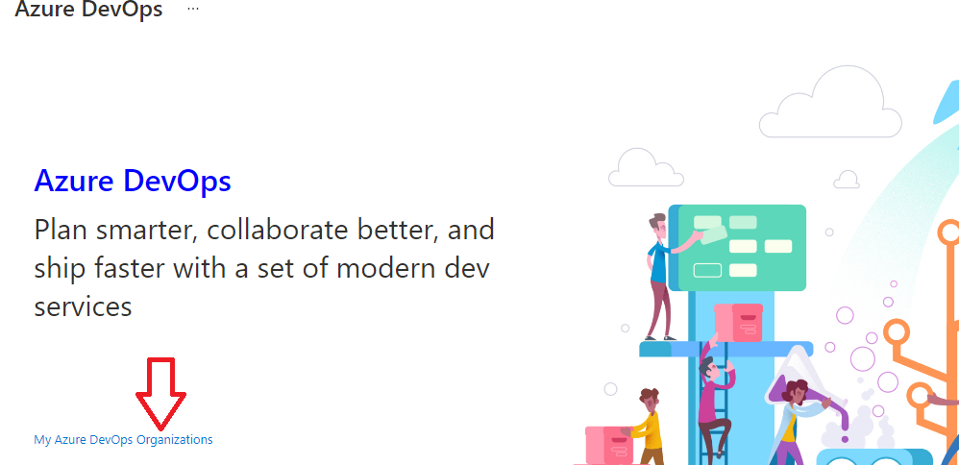

Select the My Azure Devops Organization

Step : It will open new window like below

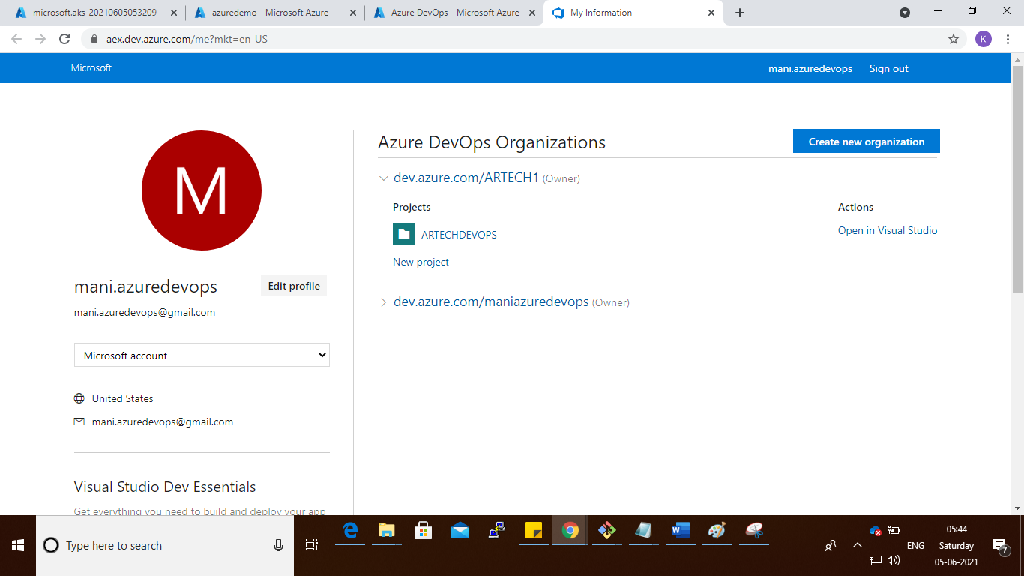

Create the new Organization

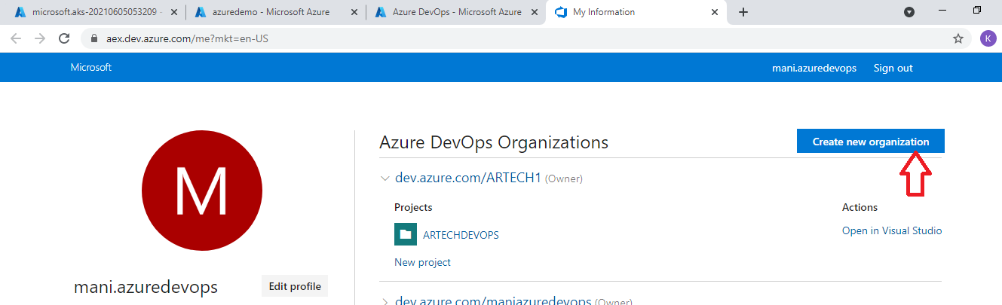

Step :

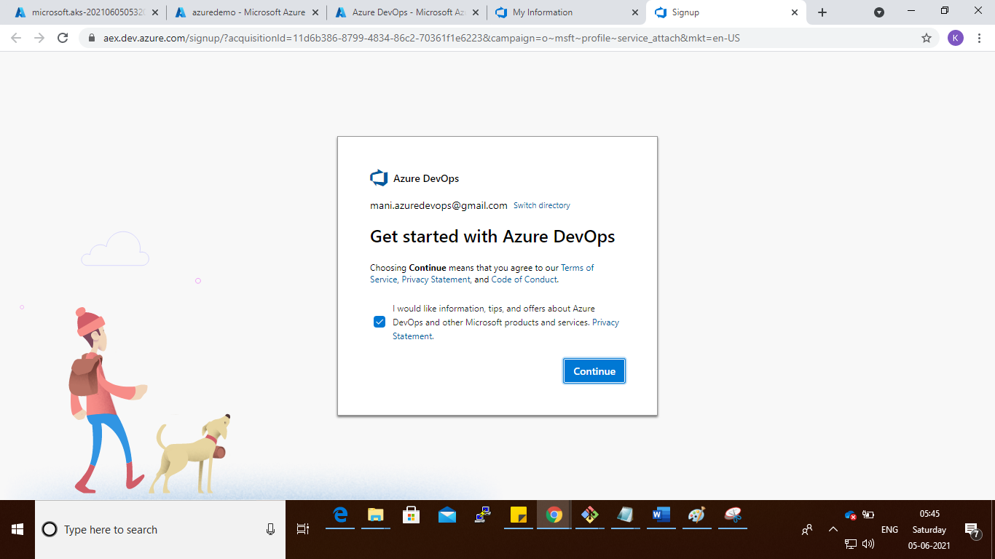

Step :

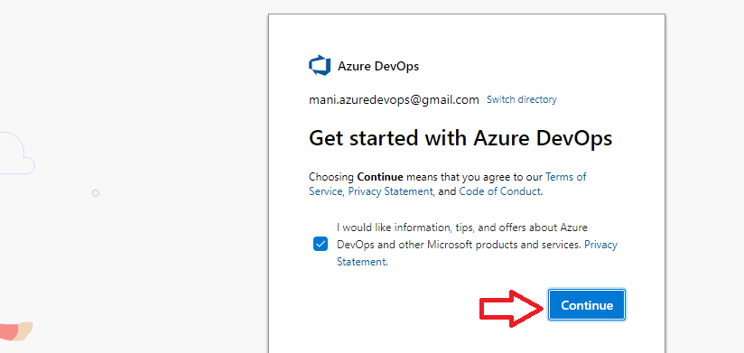

Step :

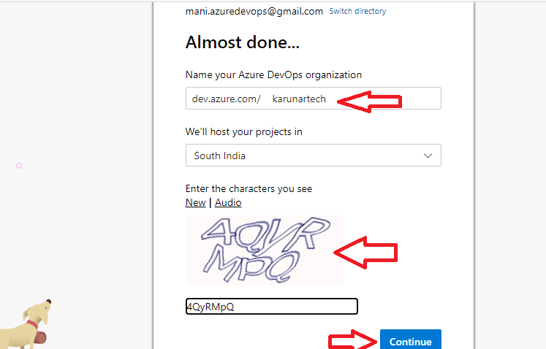

Step :

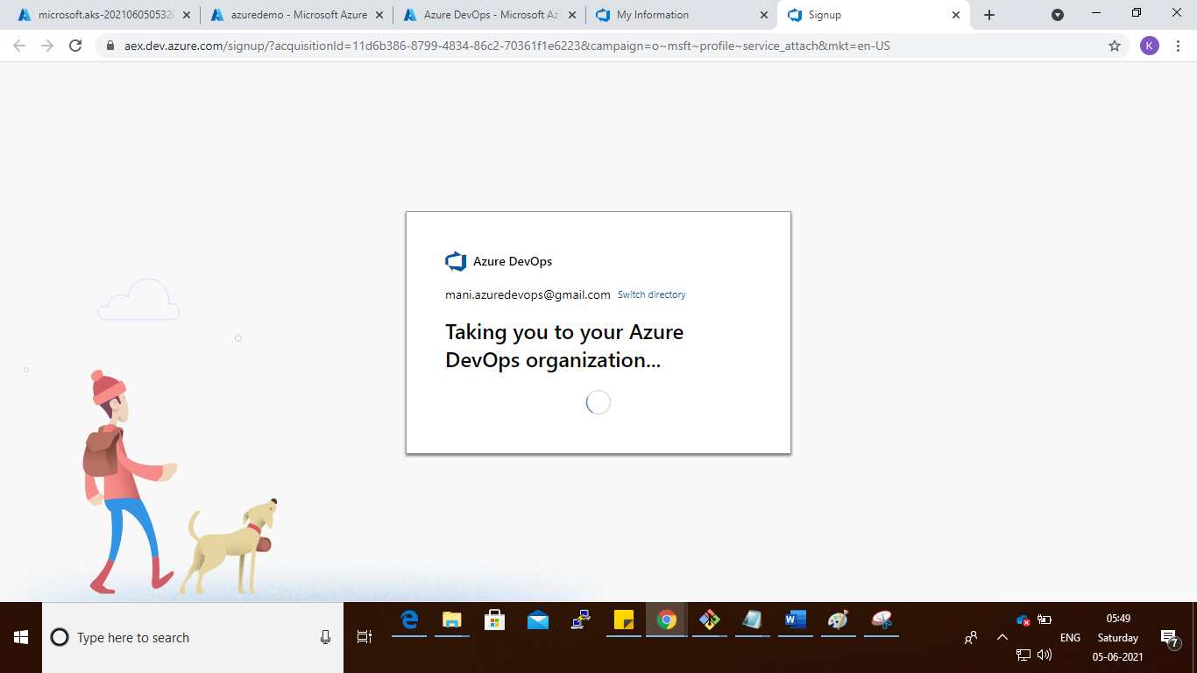

Step : after create that create the project

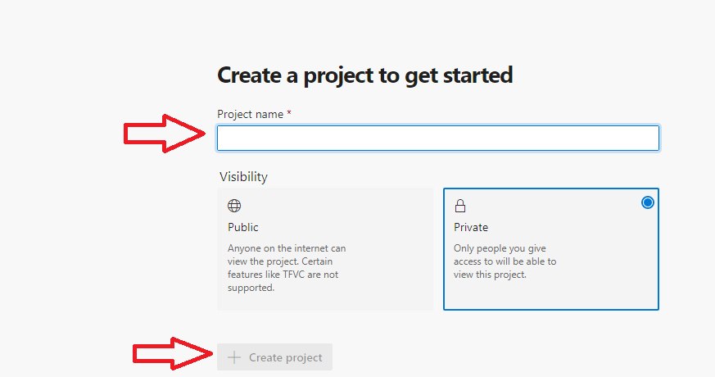

Step :

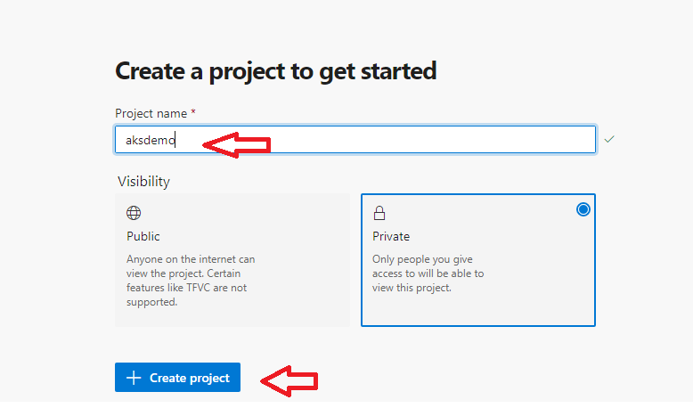

Step :

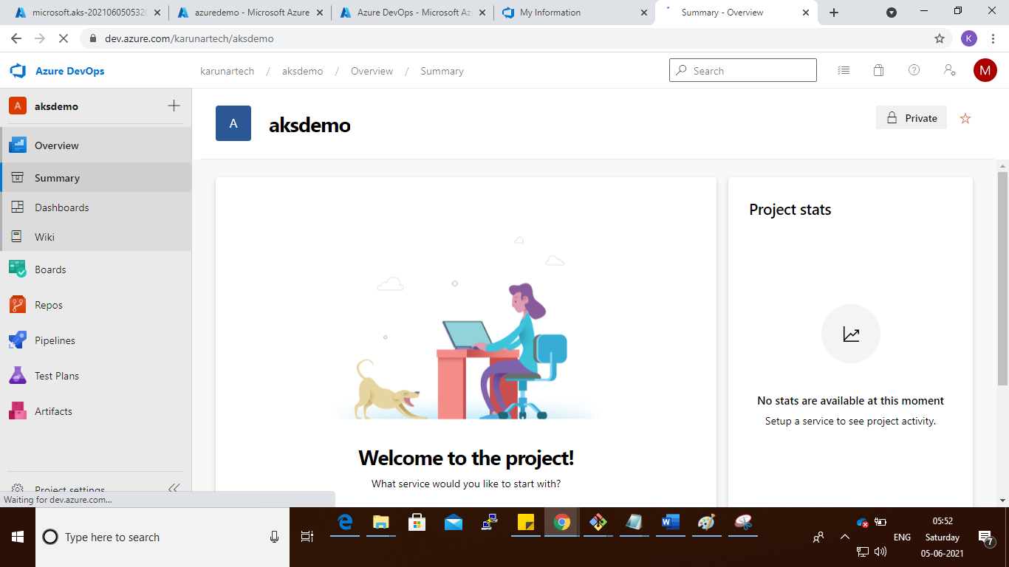

Step : go to left side bottom and clieck on Project Settings

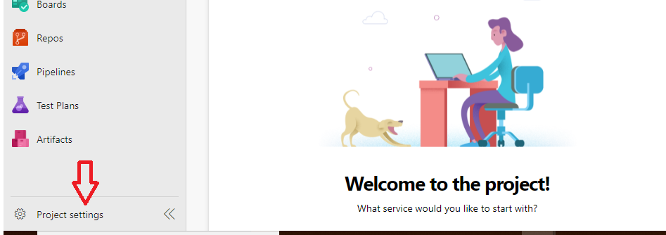

Step :

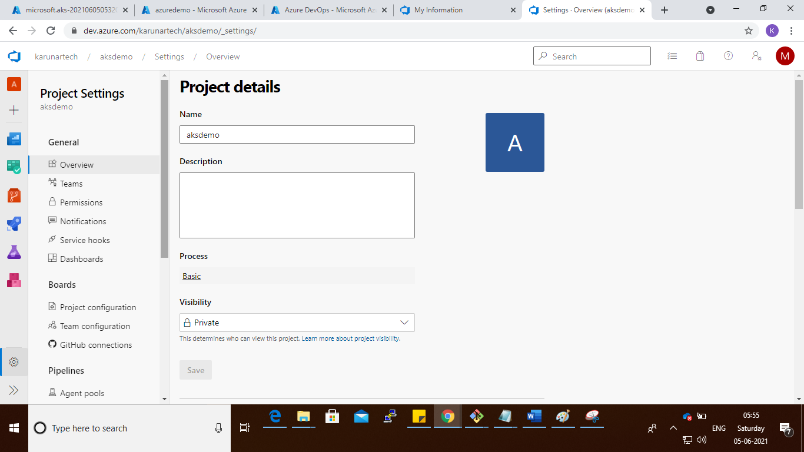

Step : click on Agent pools

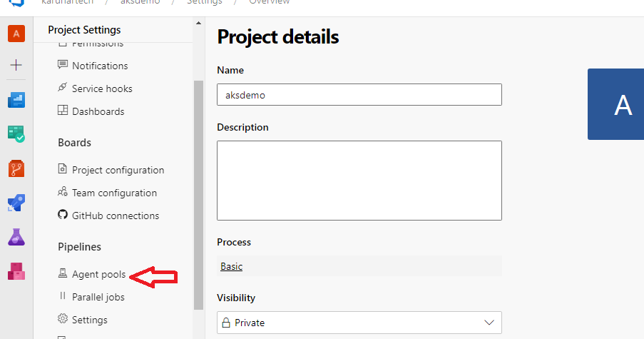

Step :

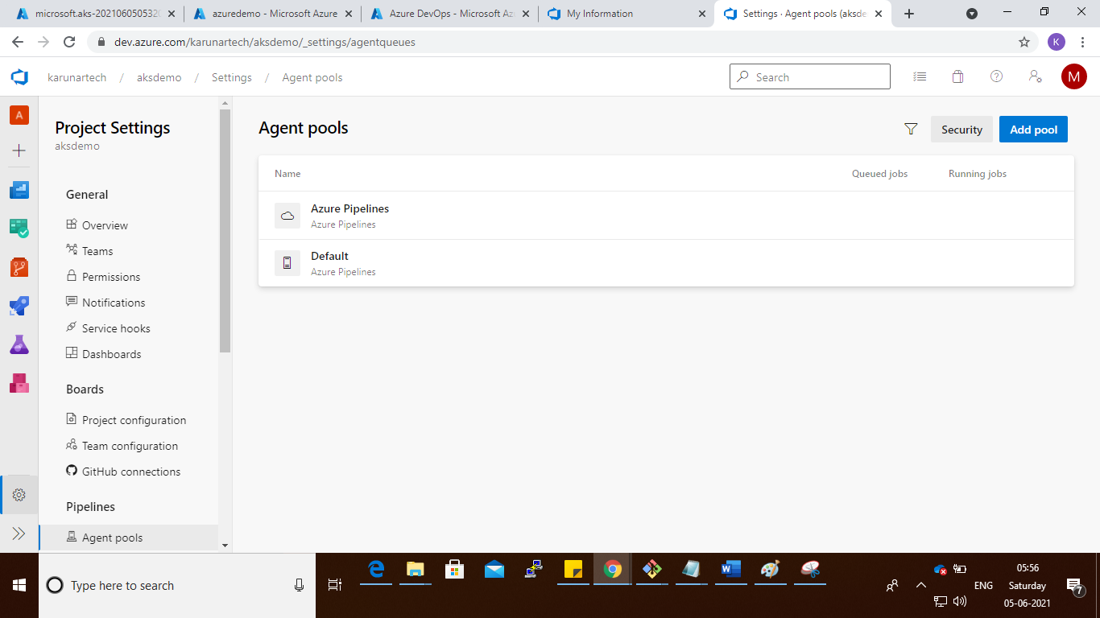

Step : click on Add pool

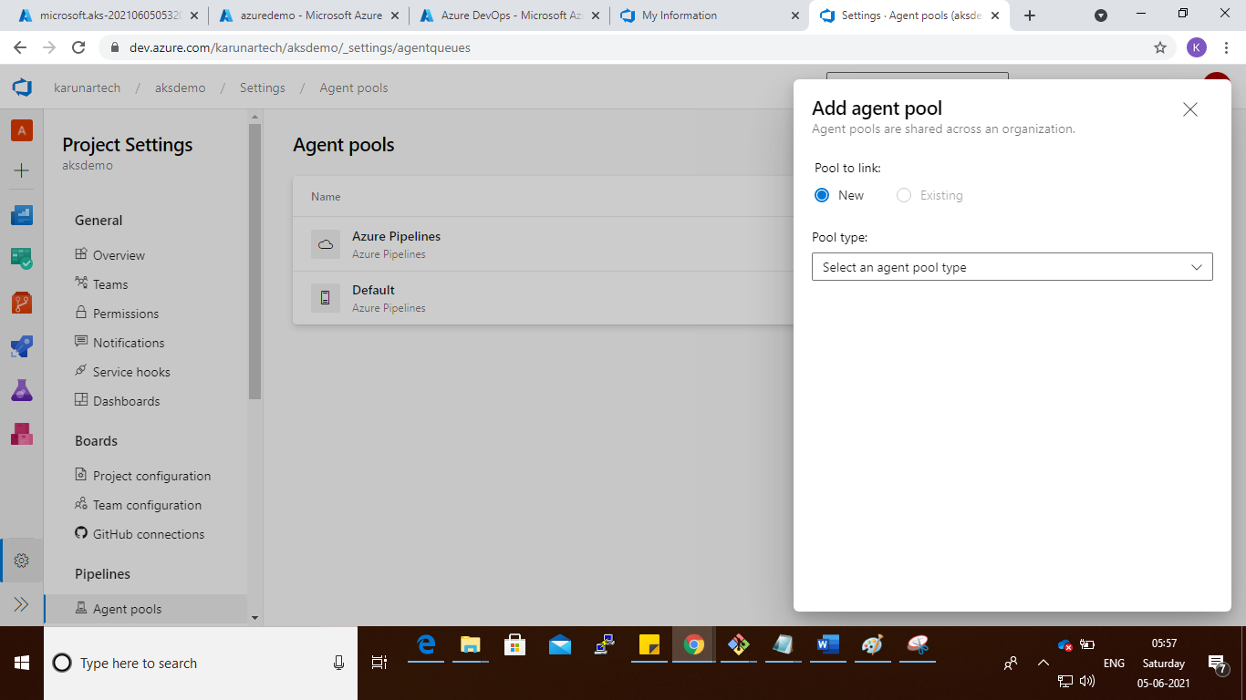

Step :

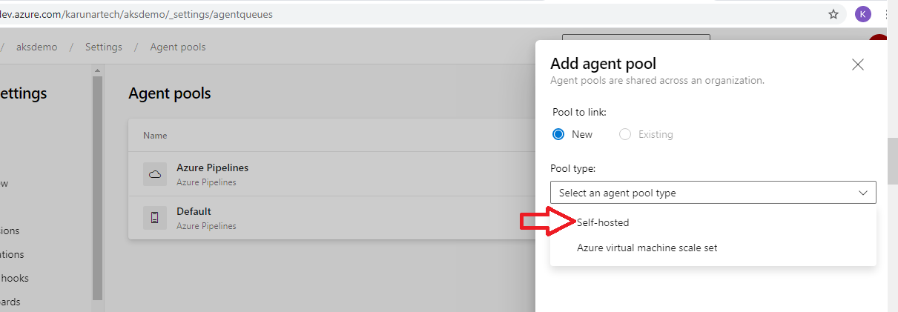

Step : self-hosted 🡪give name and click on create button

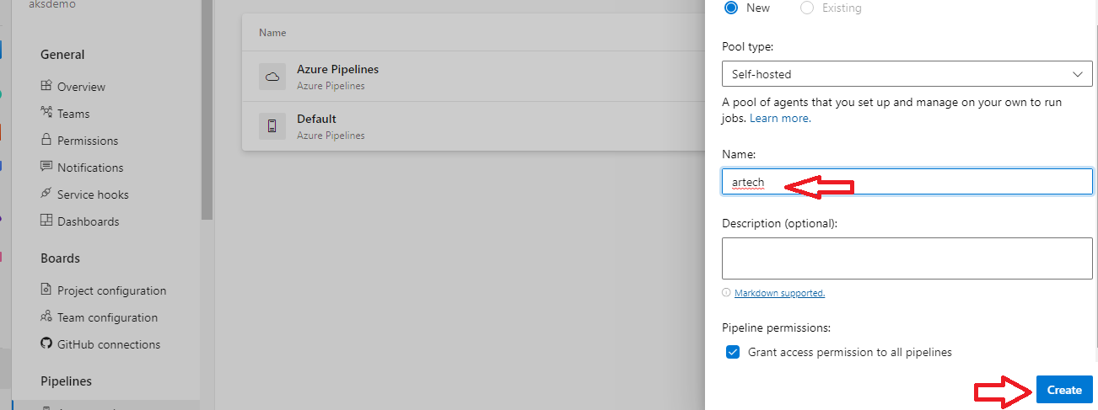

Step : click on Artech

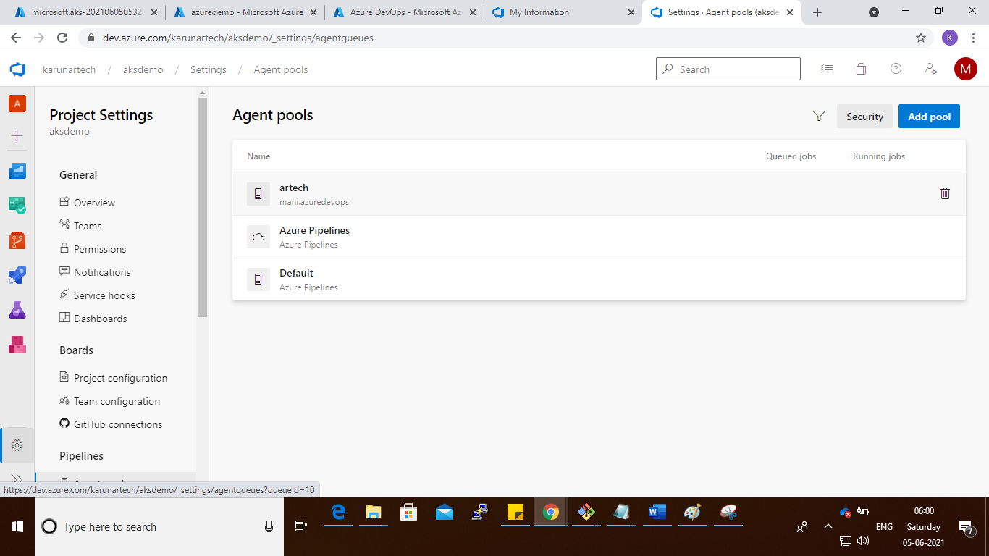

Step : click on new agent

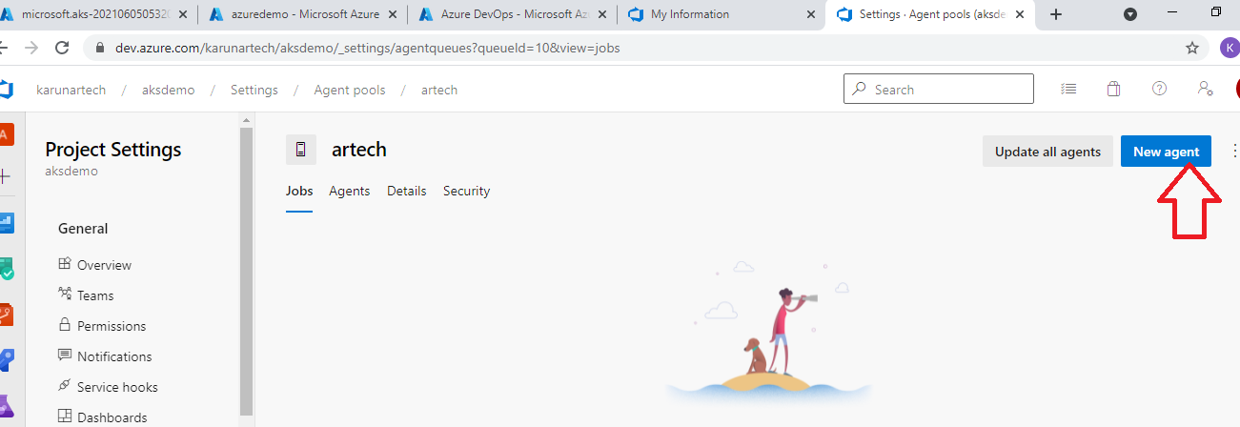

Step :

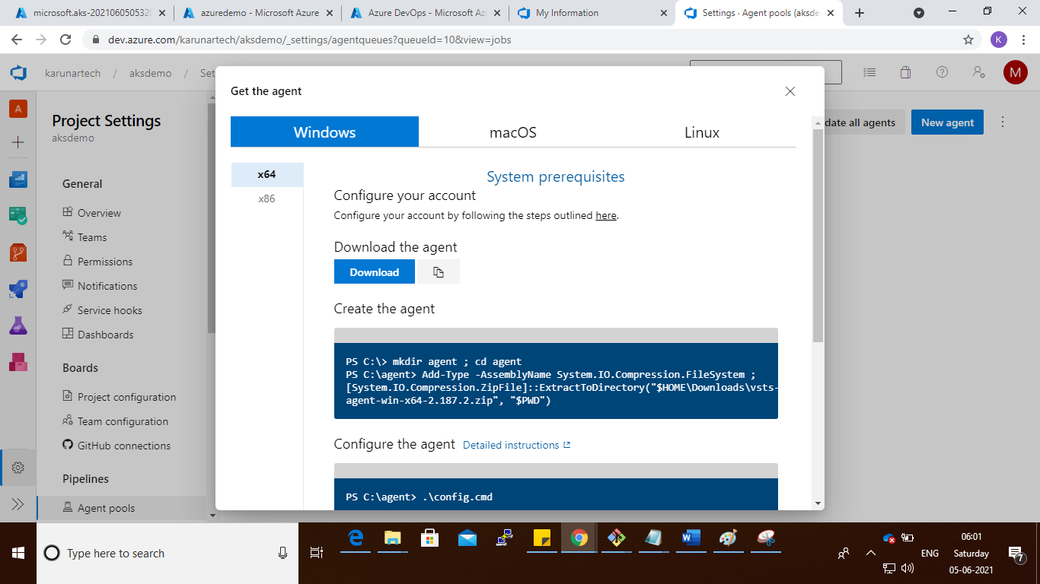

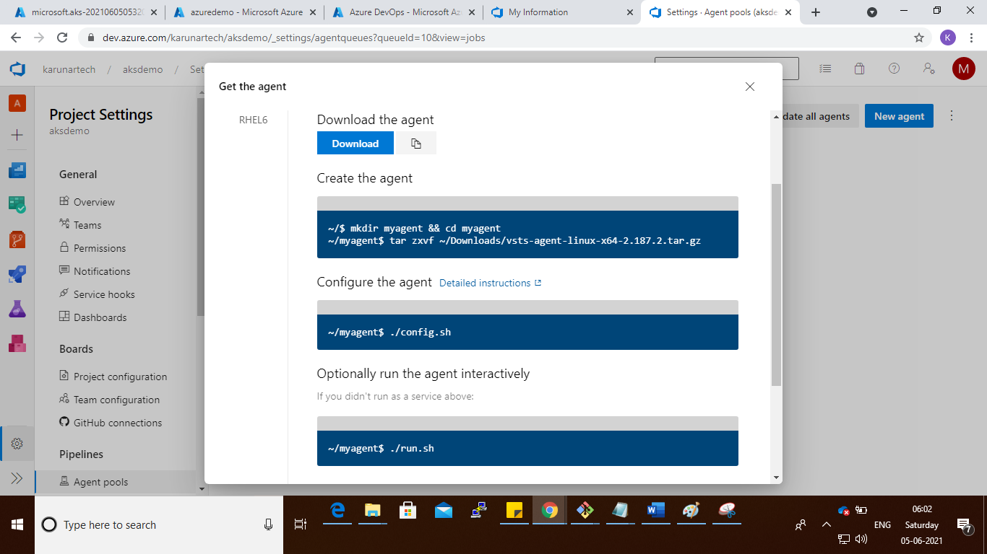

Step : select the Linux

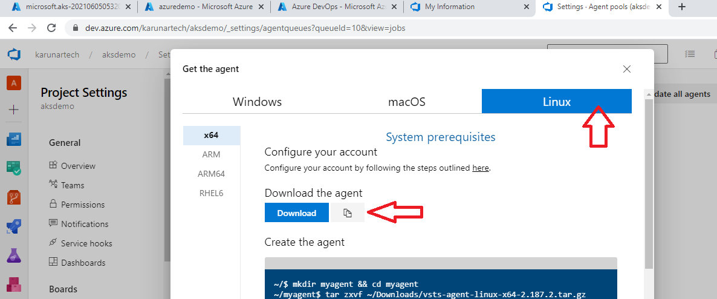

Step : Go to Azure portal and login to vm and run the commands

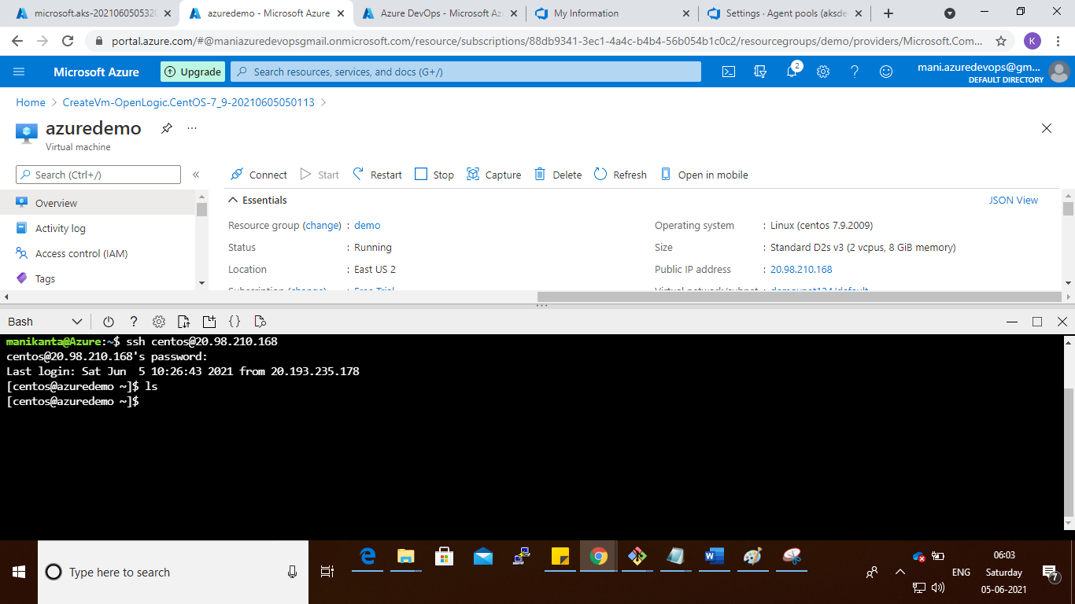

Step :

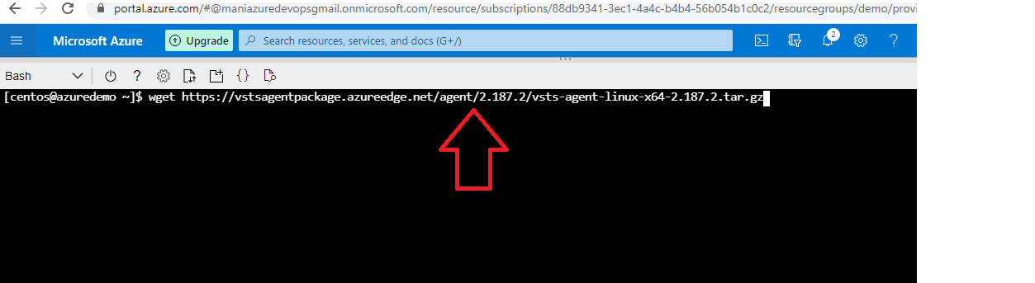

Step :

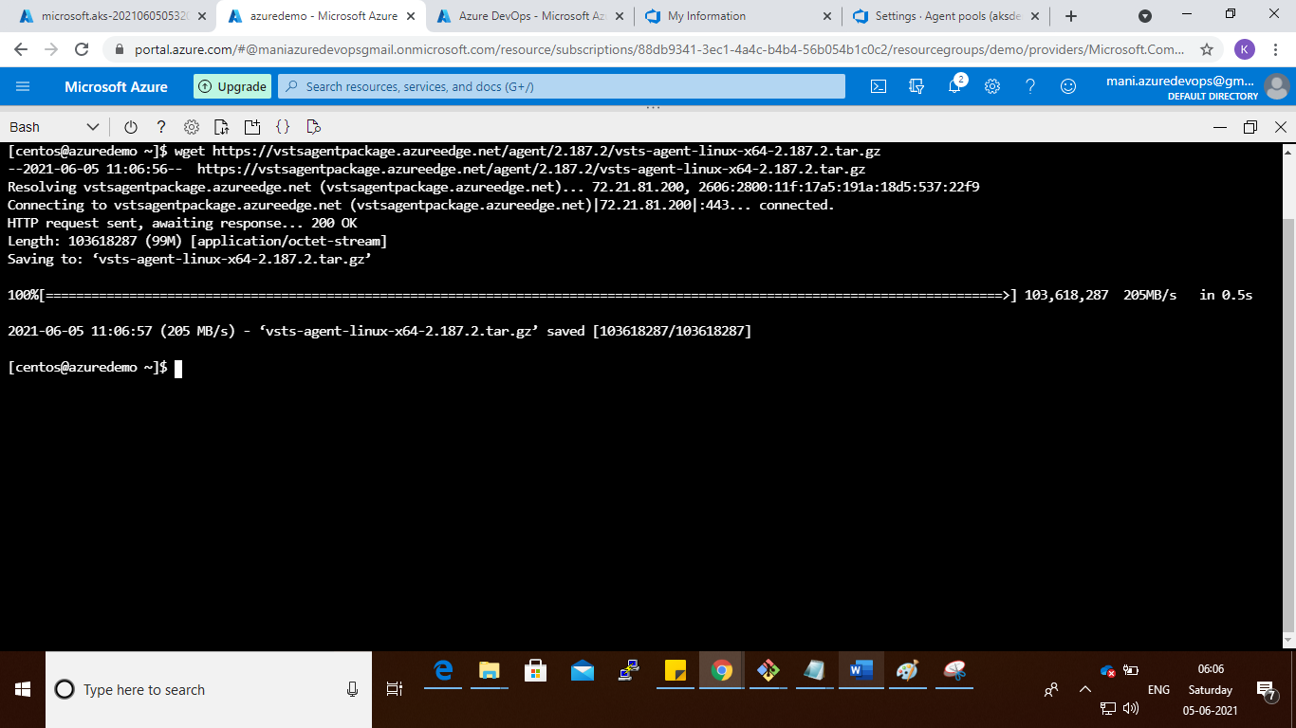

Step :

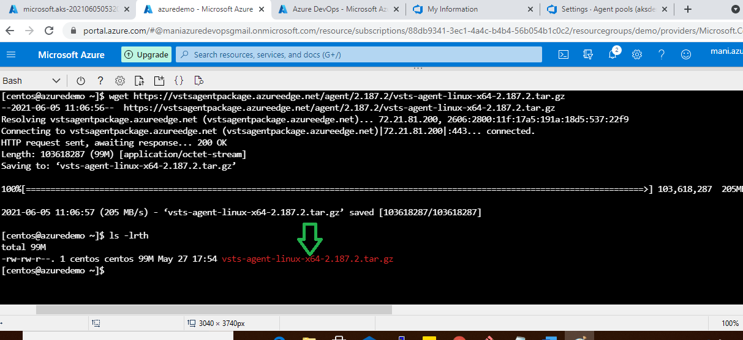

Step : tar -zxvf vsts-agent-linux-x64-2.187.2.tar.gz

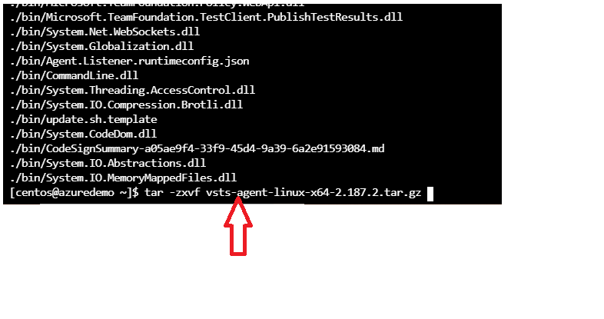

Step : after extract the file

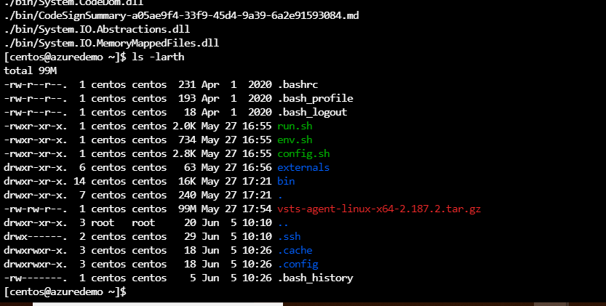

Step : run the ./config.sh

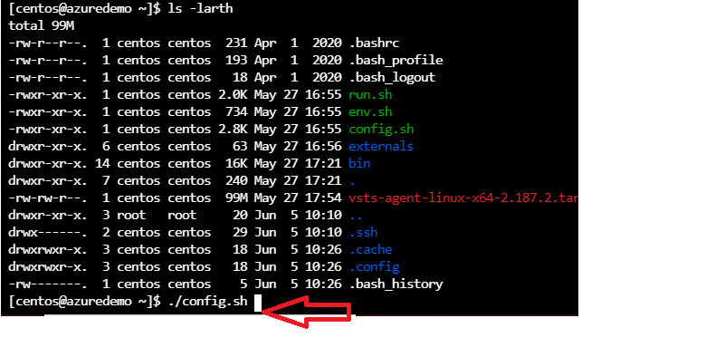

Step : afer execution you will get the dependency error run the dependency command

Step :

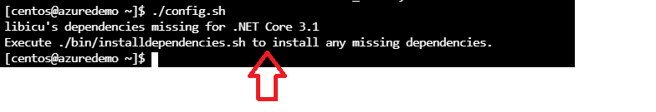

Step :

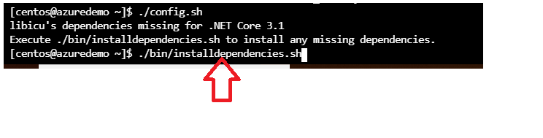

Step : run root privilege

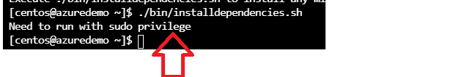

Step :

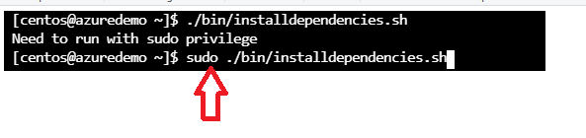

Step :

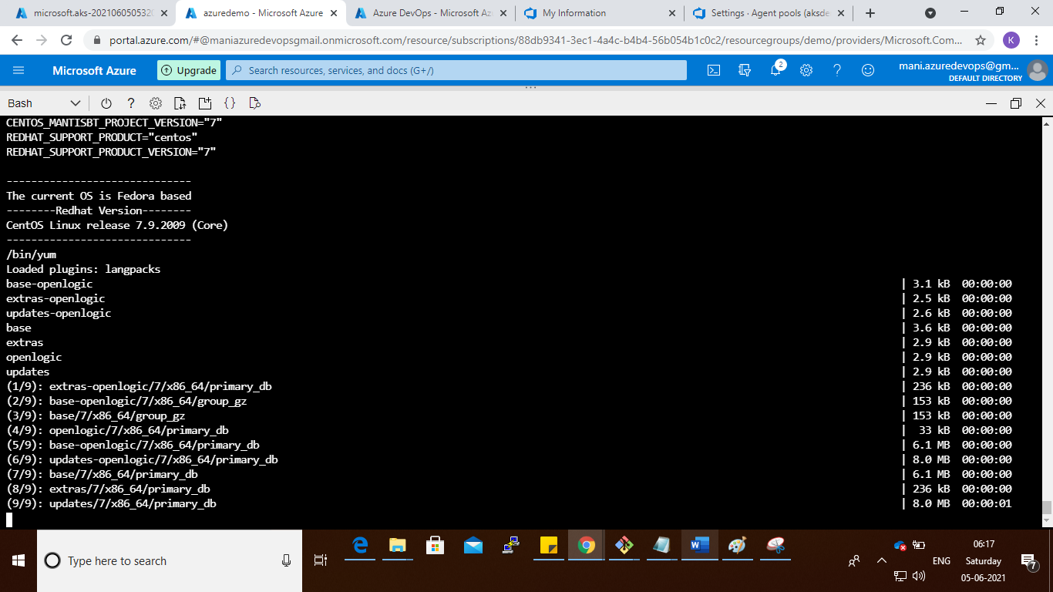

Step :

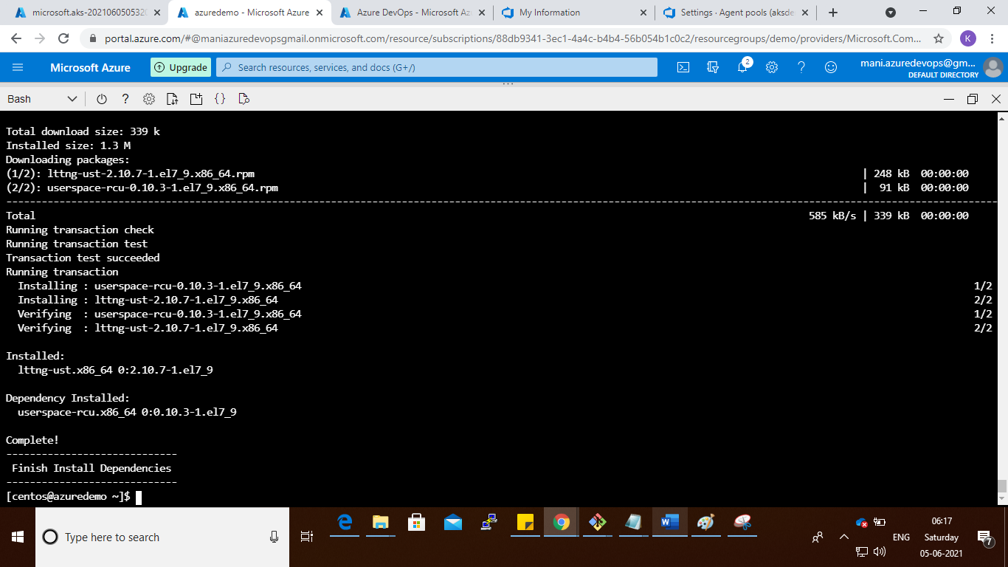

Step : run the cmd : ./config.sh

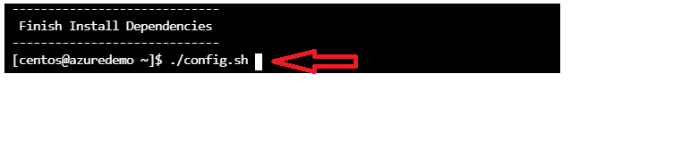

Step : press enter

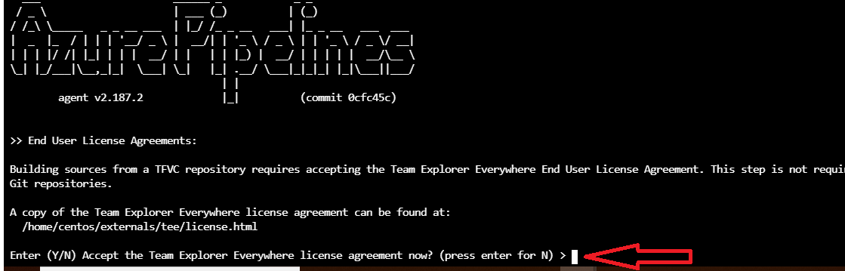

Step : enter server url

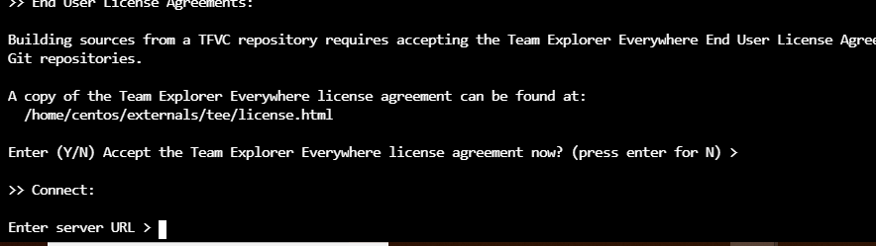

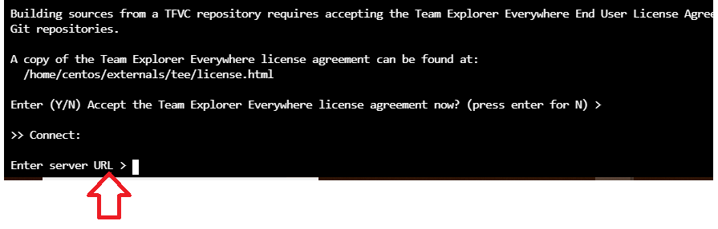

Step : go to dev.azure.com and copy the server url

<https://dev.azure.com/karunartech>

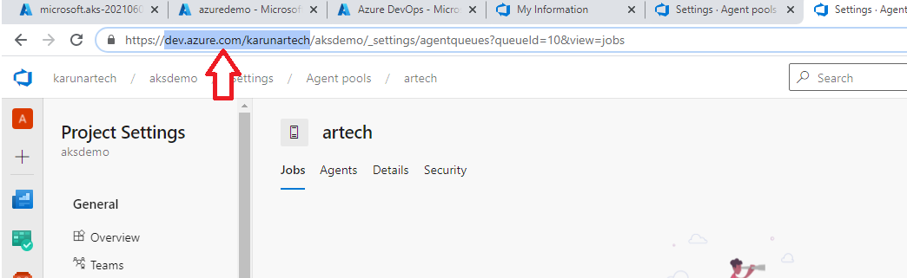

Step :

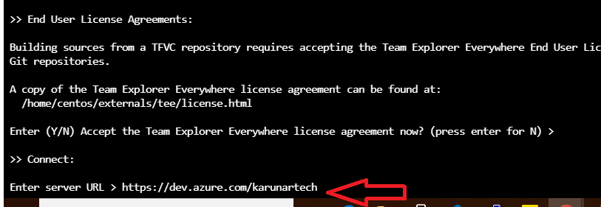

Step : press enter

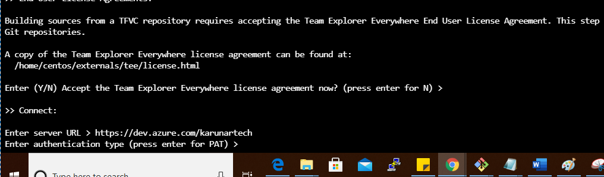

Step :

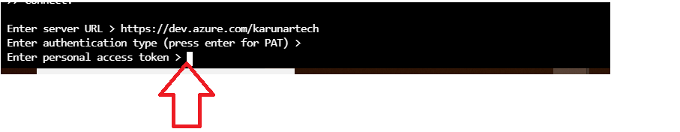

Step : go to dev.azure.com

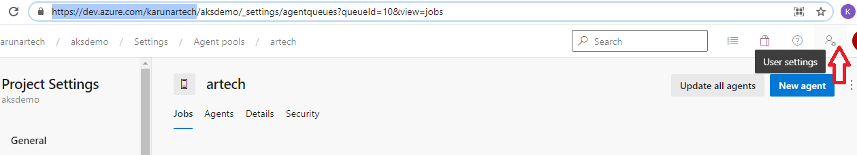

Step : click on user settings

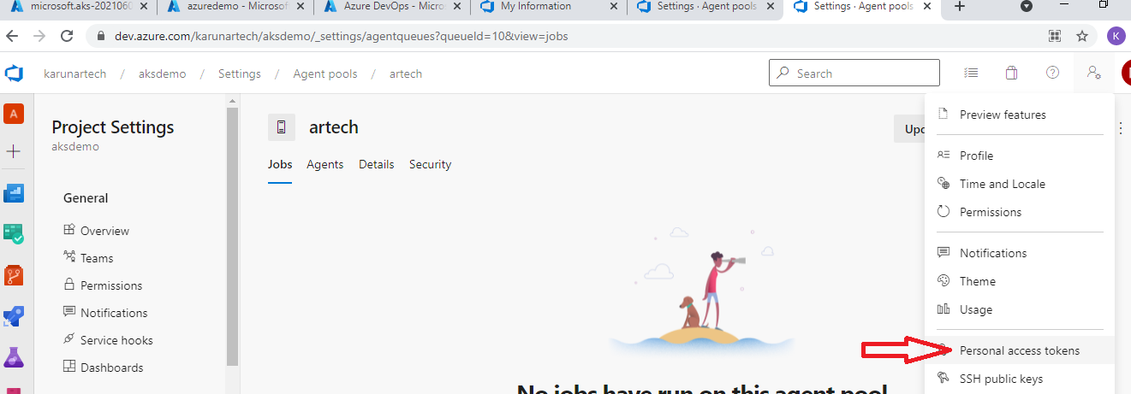

Step : click on personal access token

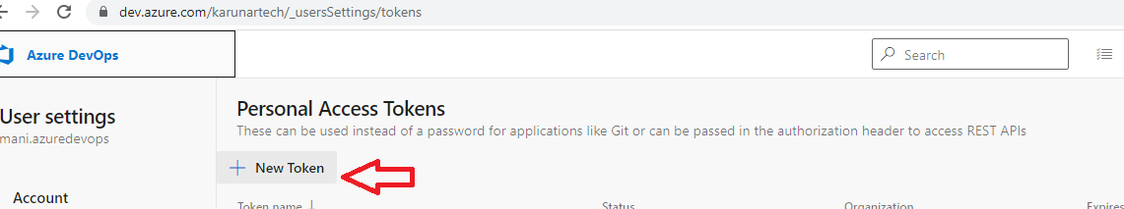

Step : new token

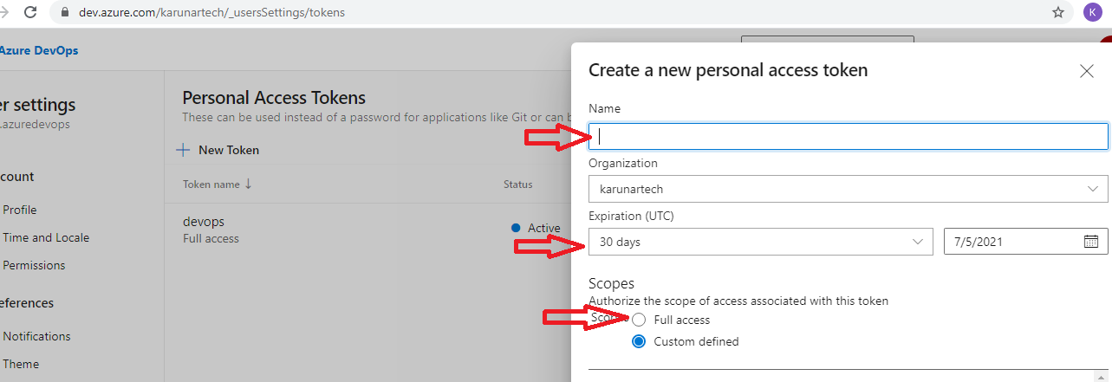

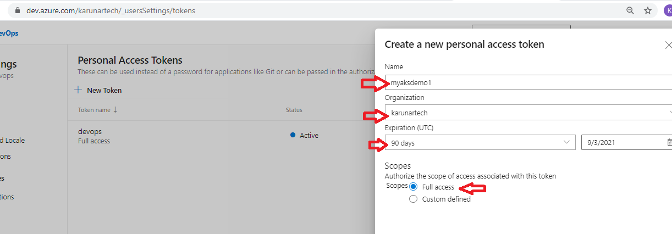

Step :

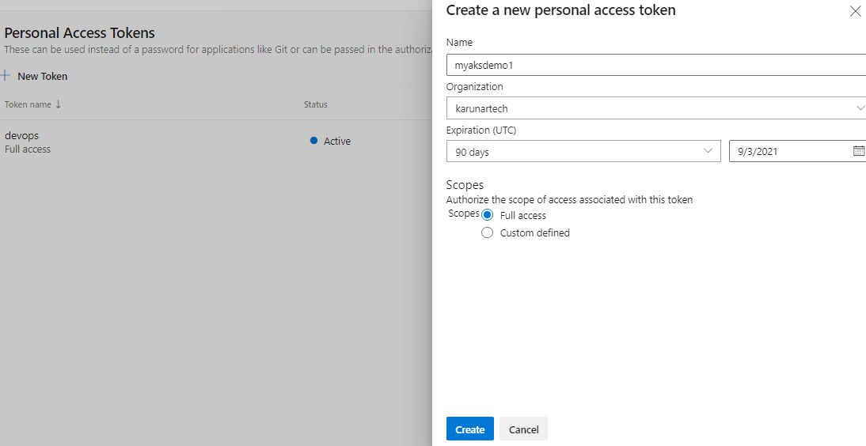

Step :

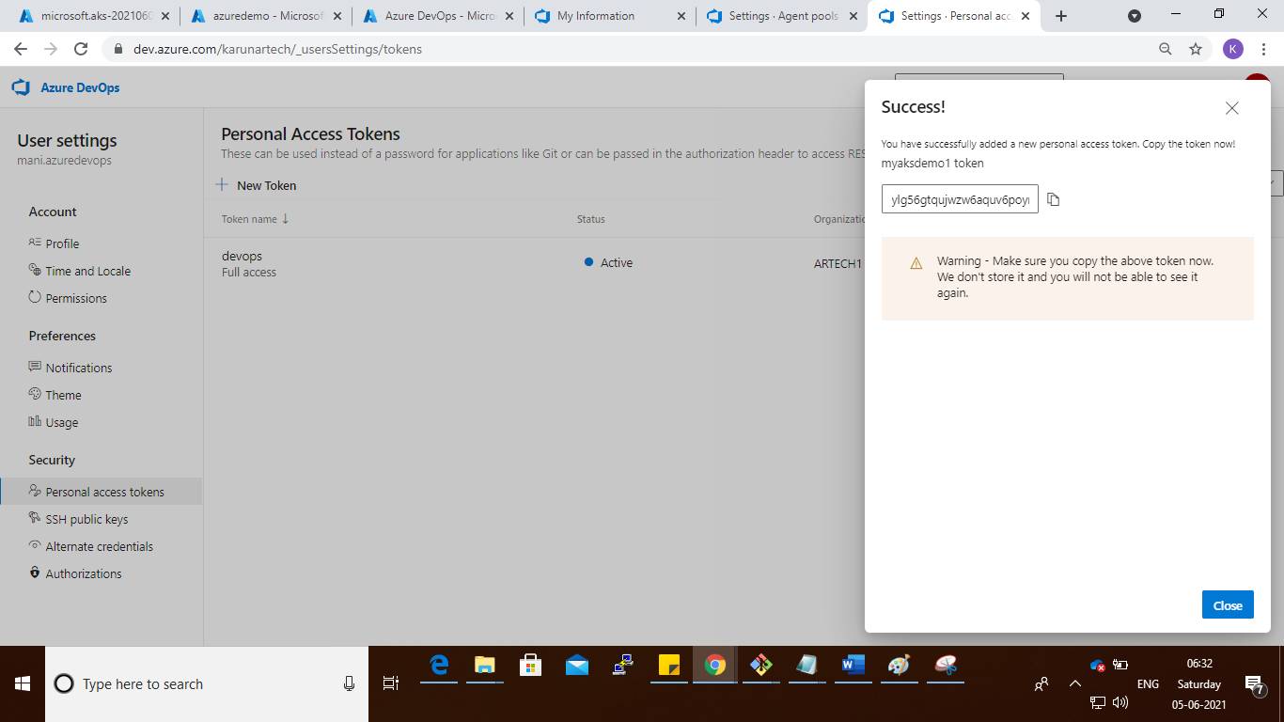

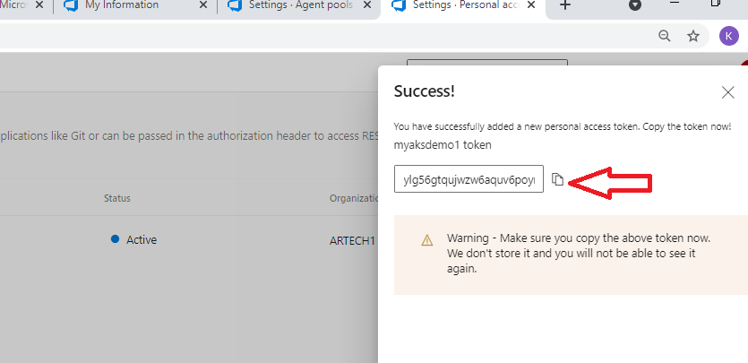

Step : copy the new token to notepad

ylg56gtqujwzw6aquv6poyn2bje7rp6tgdng4tsy7elwn7vtwc2a

step : copy the token key in vm pc

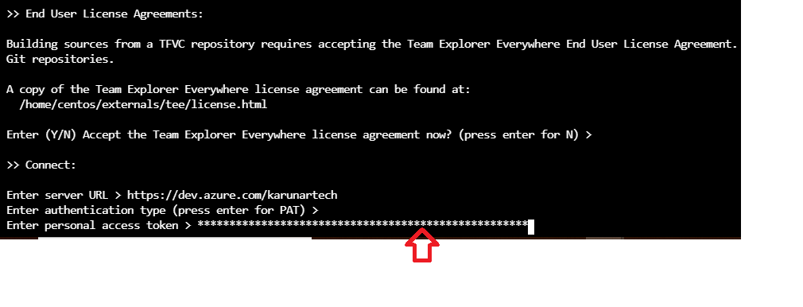

Step : press enter

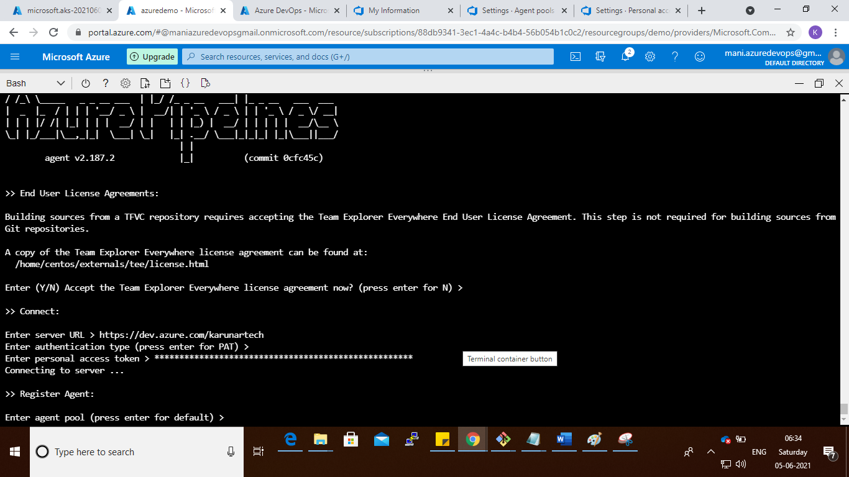

Step : give your agent name



Step :

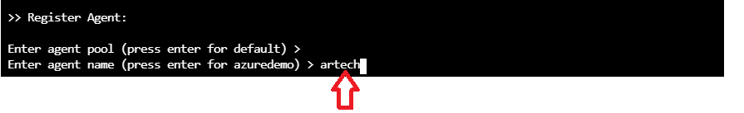

Step : press enter

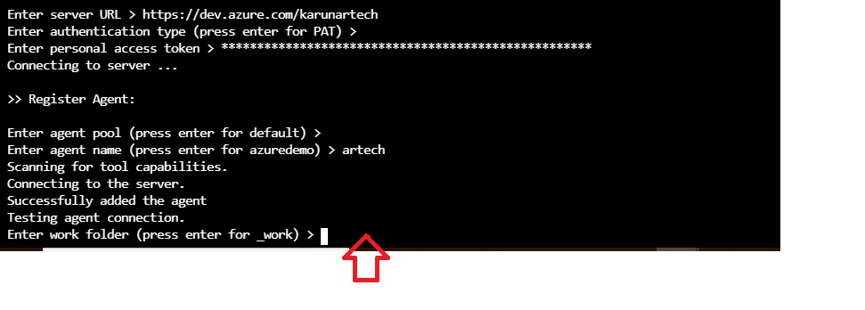

Step :

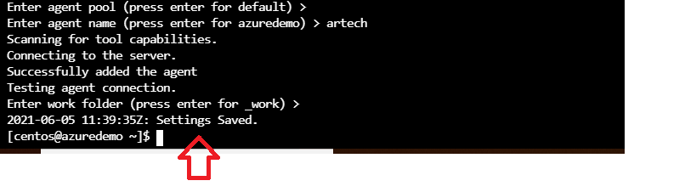

Step : ls -arth

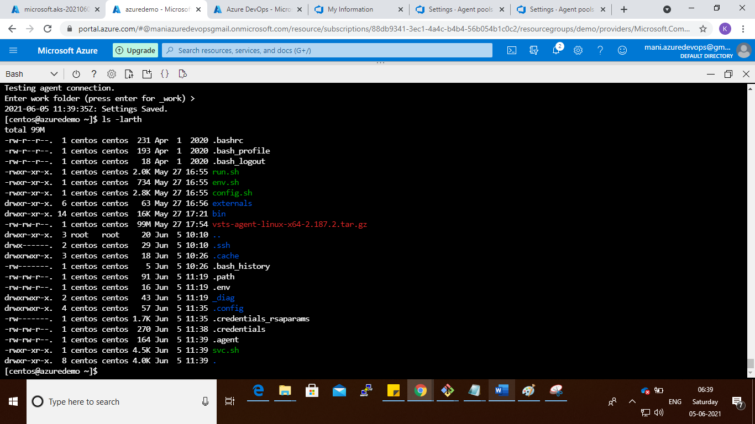

Stpe : run the cmd : ./run.sh

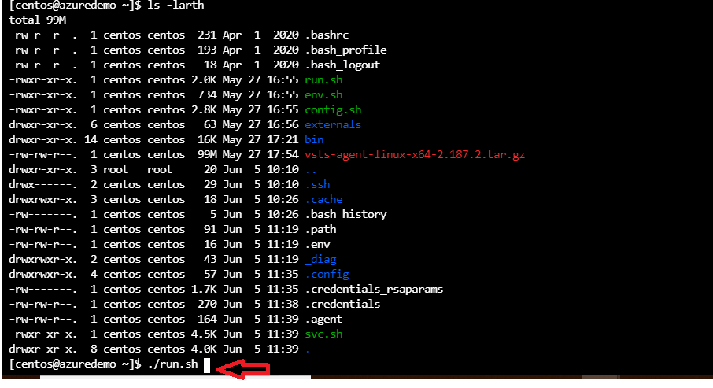

Step :

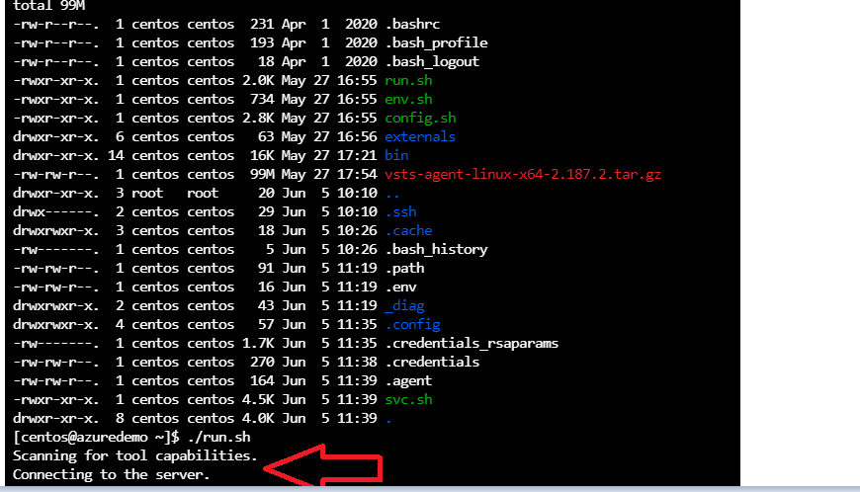

Step : go and verify the agent is online or not

Go to dev.azure.com

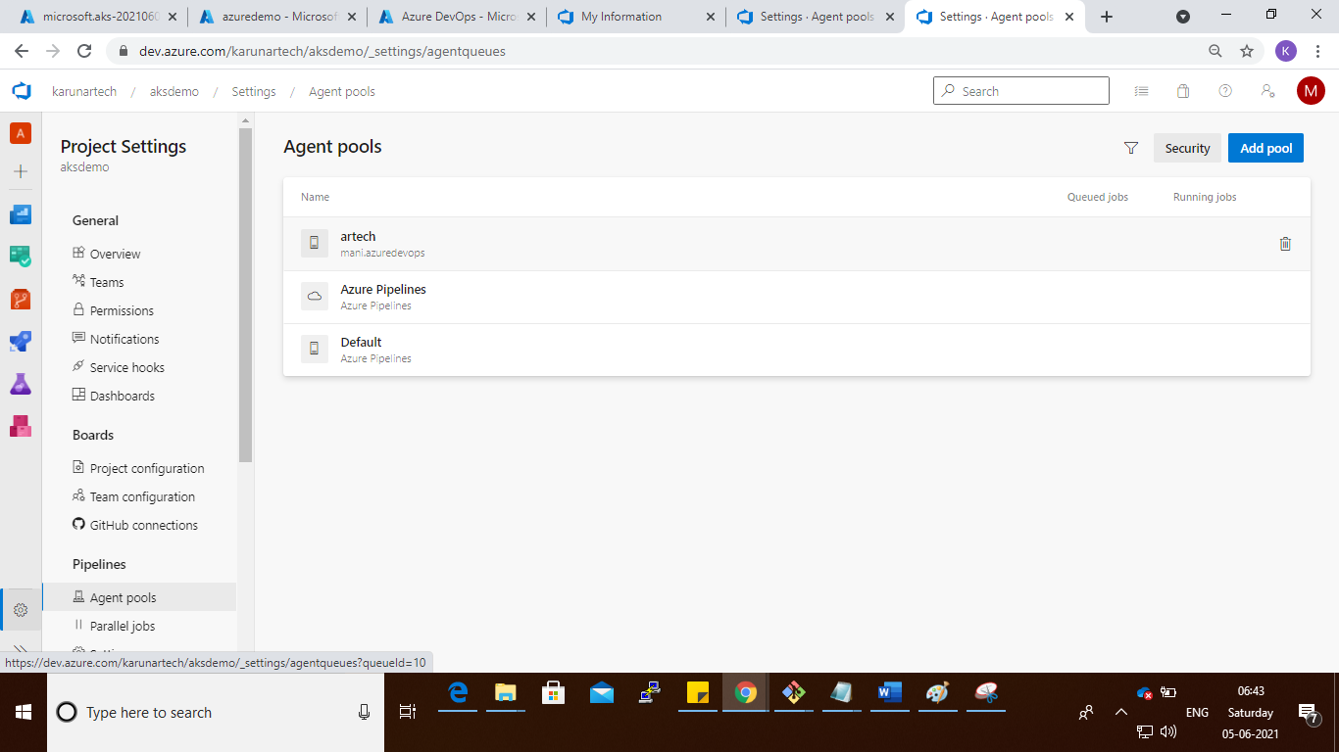

Step :

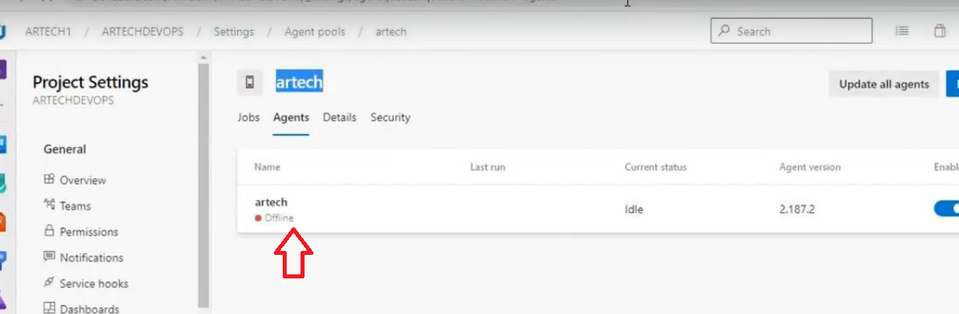

Step :

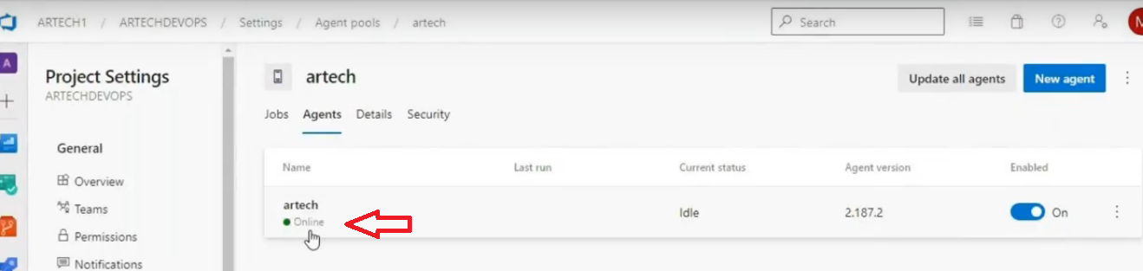

Step : got to aks cluster

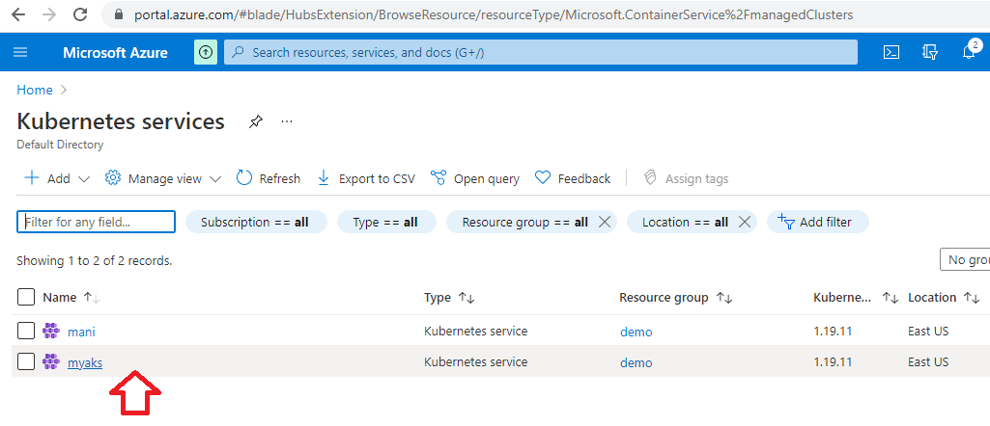

Step : connect the aks cluster

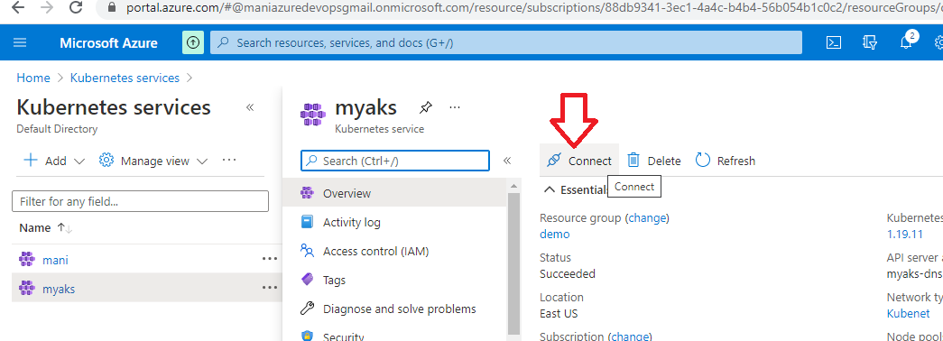

Step : copy the aks cluster command and run the command in command prompt

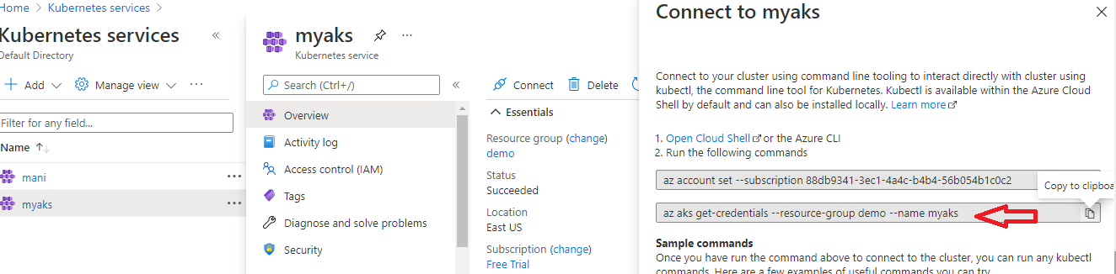

Step :

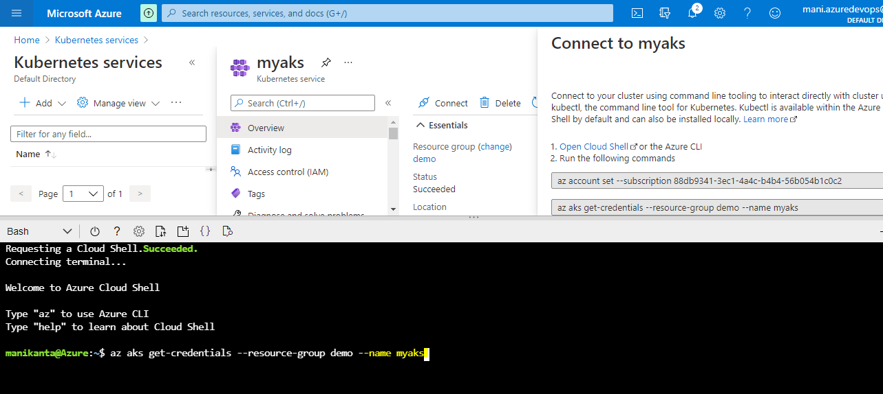

Step :

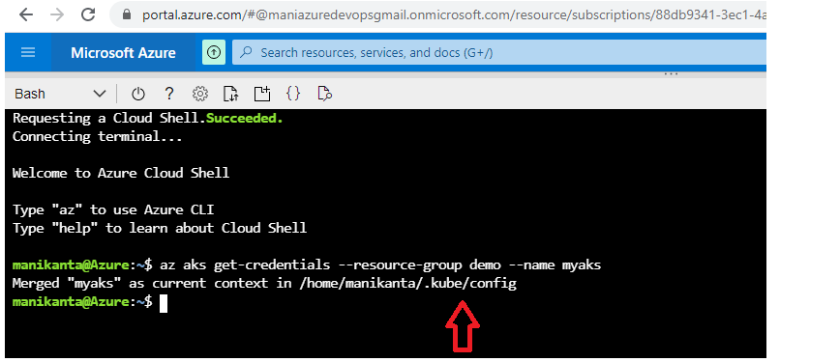

Step : copy the aks config details to notepad++ or notepad

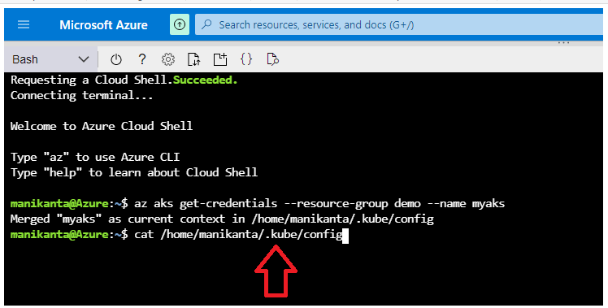

Step :



Step :

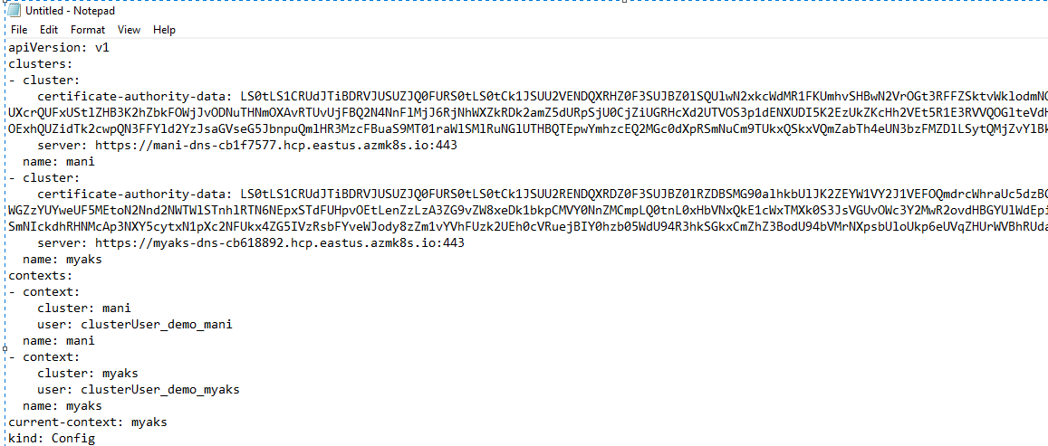

Step : go to dev.azure.com portal and inside project settings

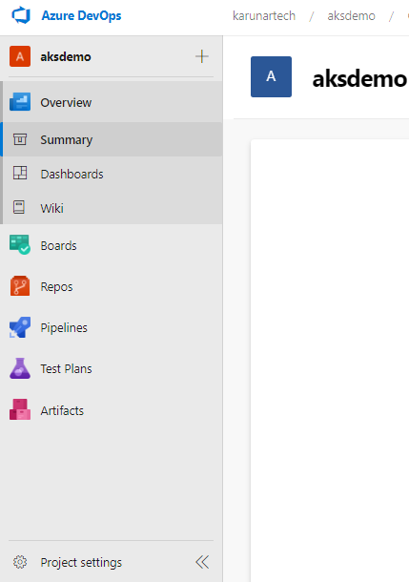

Step : go to Project settings

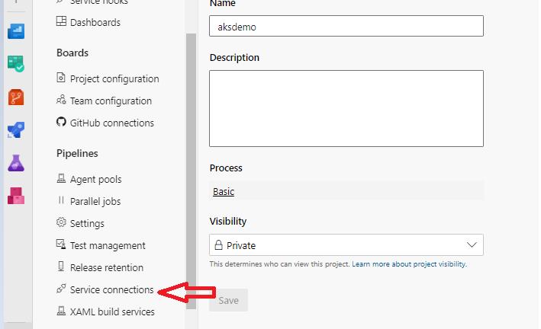

Step : go to service connections and click new service connection

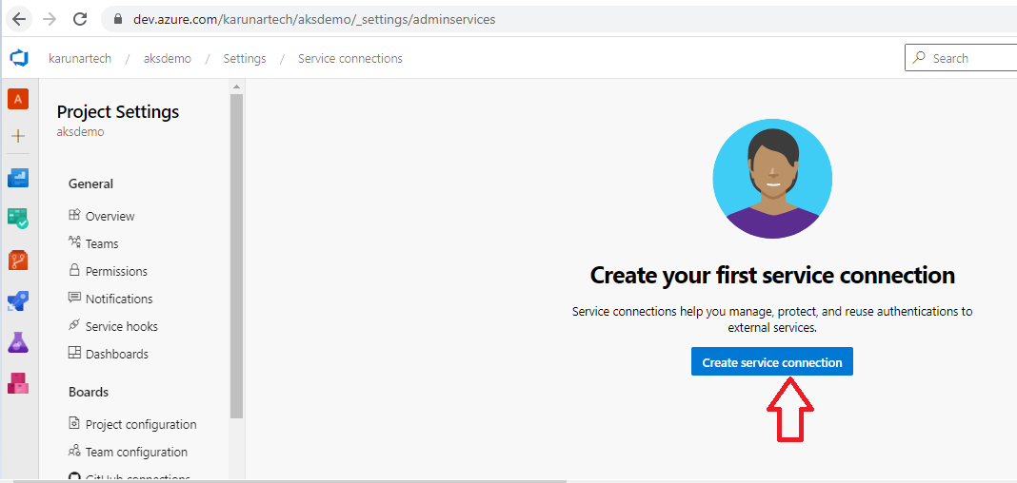

Step : search the github

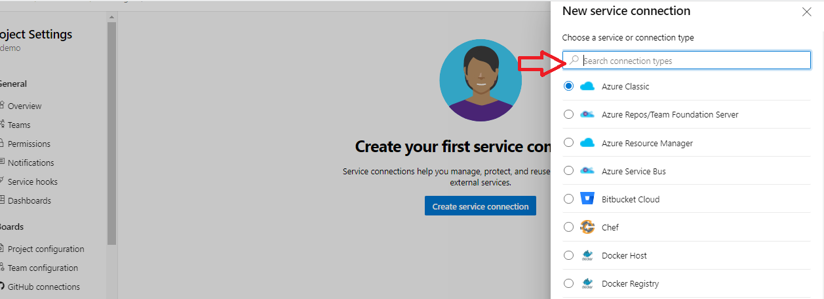

Step :

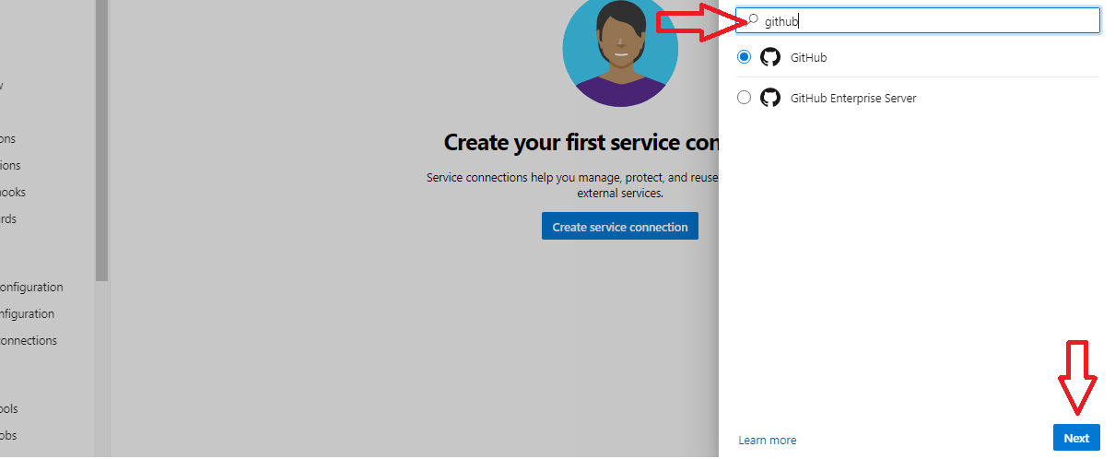

Step :

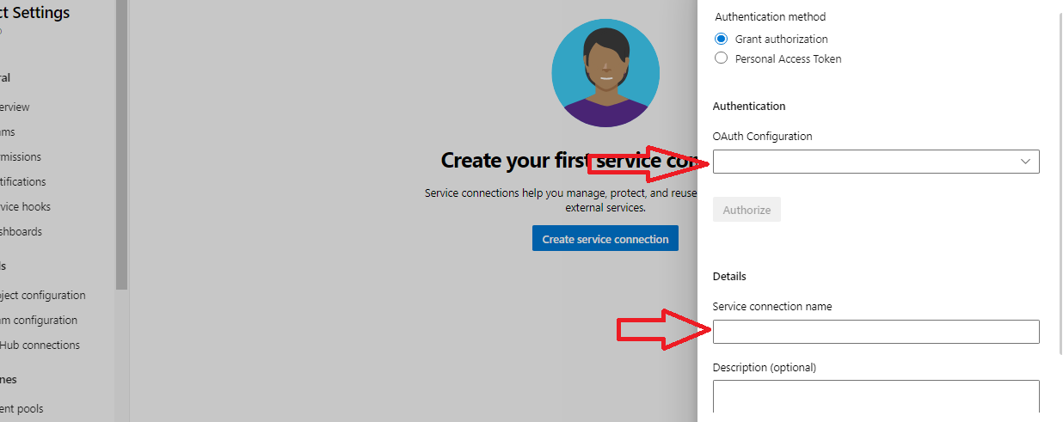

Step :

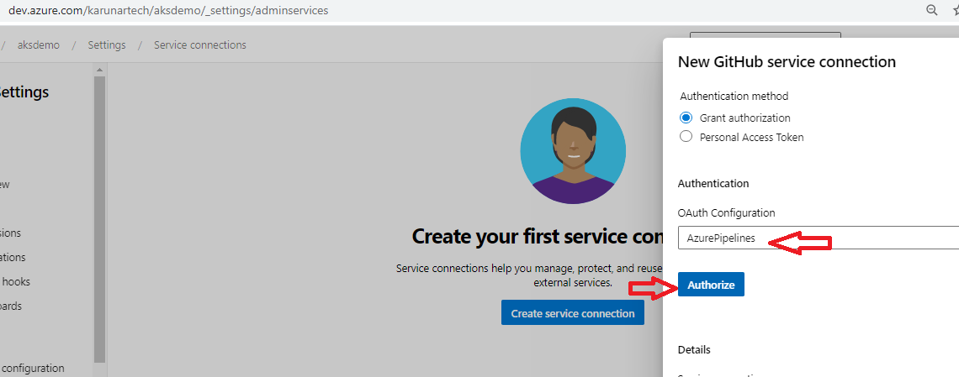

Step : once you click on Authorize it redirect to github account and select the azurepipelines

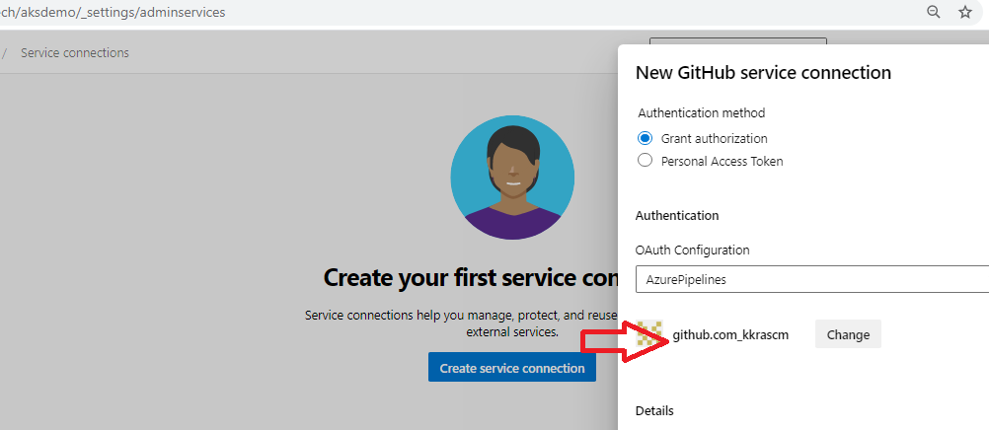

Step :

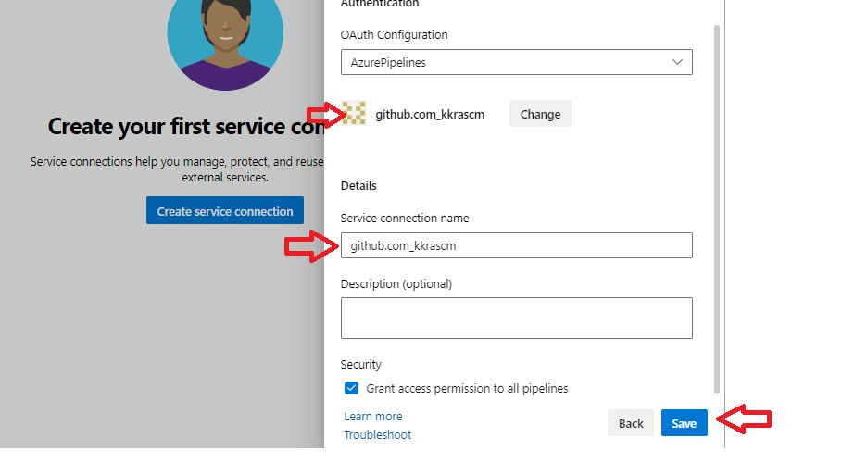

Step : take one more new connection

Search Kubernetes

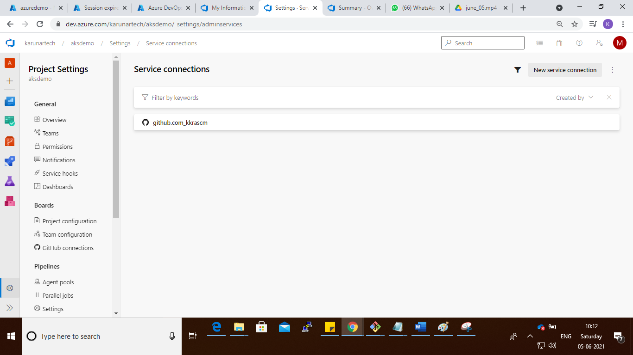

Step : search kubernetes

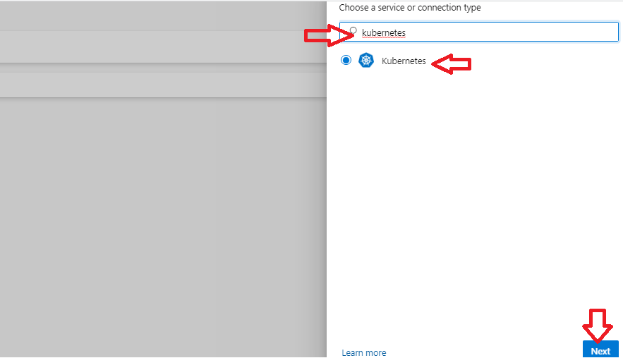

Step : select the kubeconfig

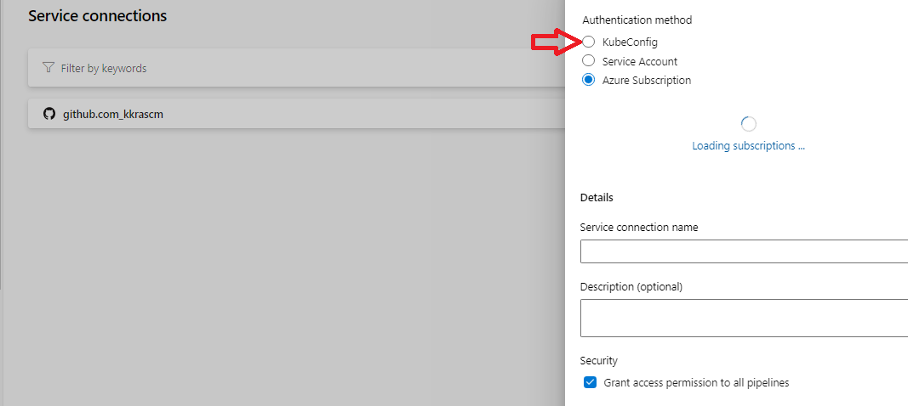

Step : copy the kubeconfig details from aks cluster, I case I already copy the aks config details to notepad++ same details I’m copying and paste to below kubeconfig box

After copying the kubeconfig details click on accept and verify

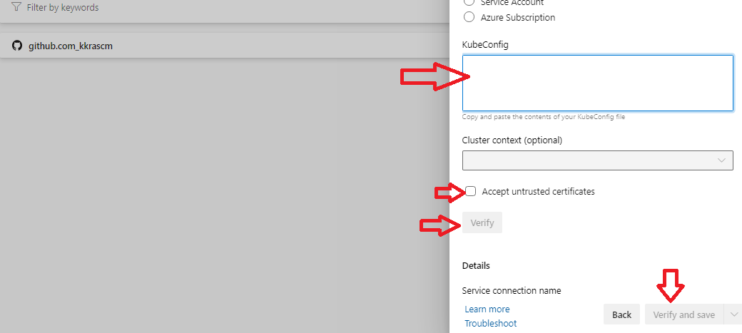

Step :



Step :

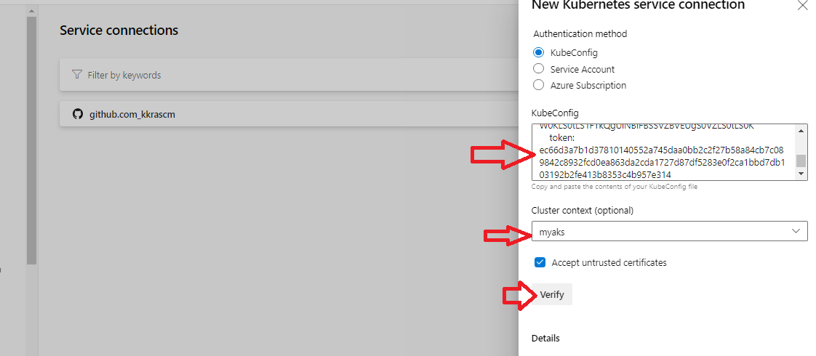

Step : verify and give service connection name as you like after that click on verify and save

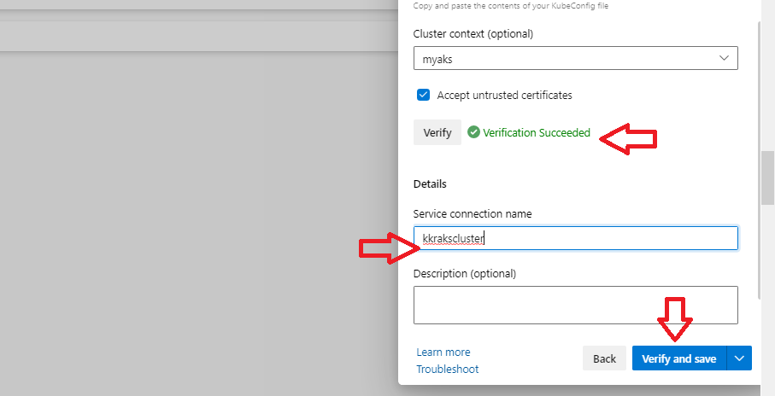

Step :

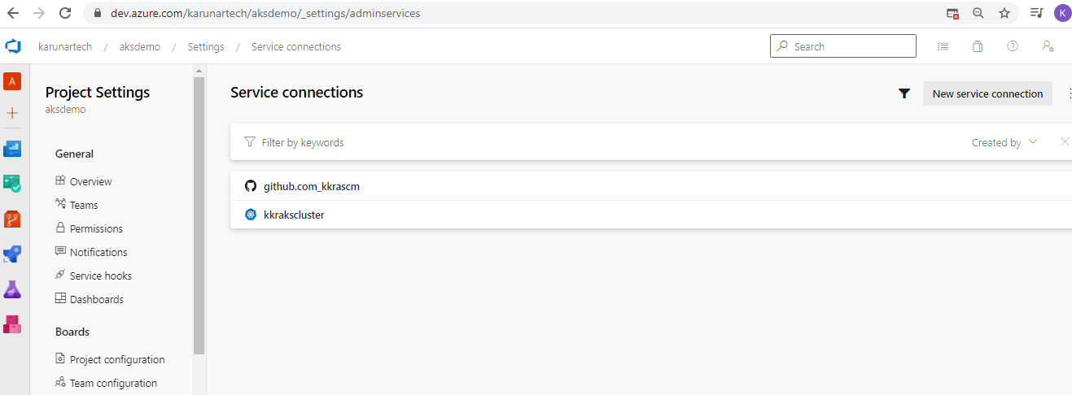

Step : create new git repository in github portal

Step :

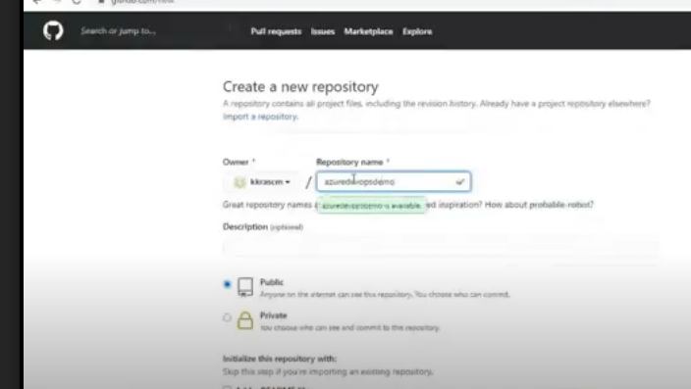

Step :

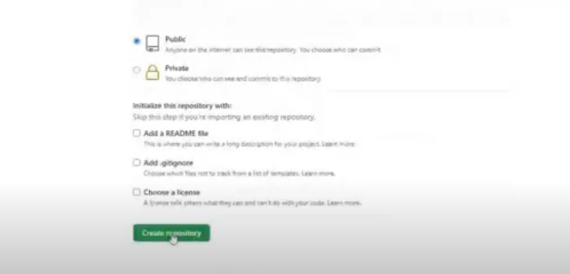

Step :

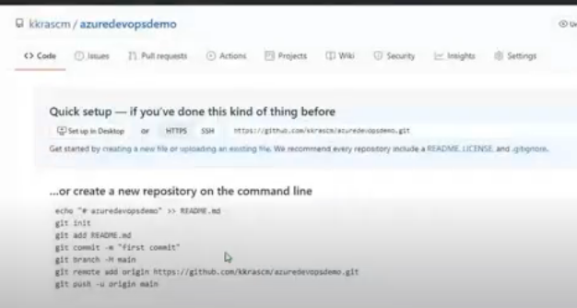

Step :

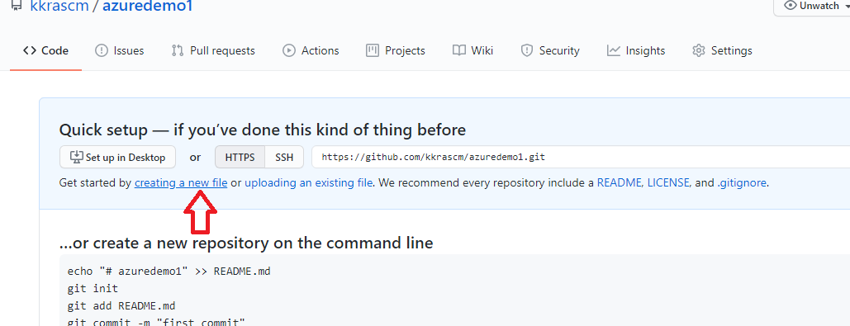

Step : click on creating a new file

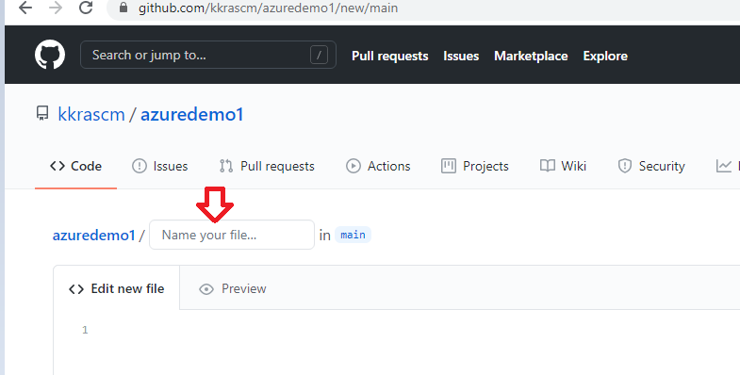

Step : file name should be like this : nginx-deployment.yaml

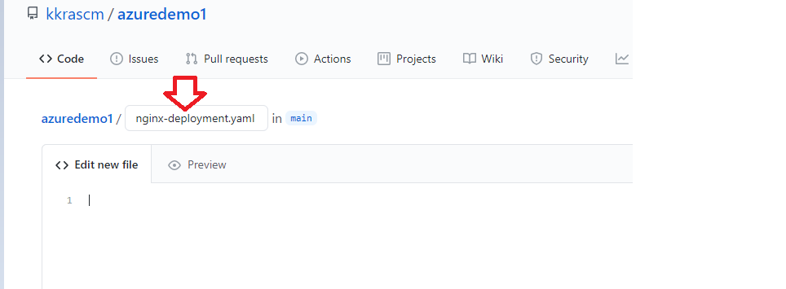

Step : copy paste the below code in github

apiVersion: apps/v1

kind: Deployment

metadata:

name: nginx-deployment

spec:

replicas: 1

selector:

matchLabels:

app: nginx-app

template:

metadata:

labels:

app: nginx-app

spec:

containers:

- name: nginx-container

image: nginx

---

apiVersion: v1

kind: Service

metadata:

name: nginx-service

spec:

ports:

- name: http

targetPort: 80

port: 80

selector:

app: nginx-app

type: LoadBalancer

step : after copy the code , commit and save

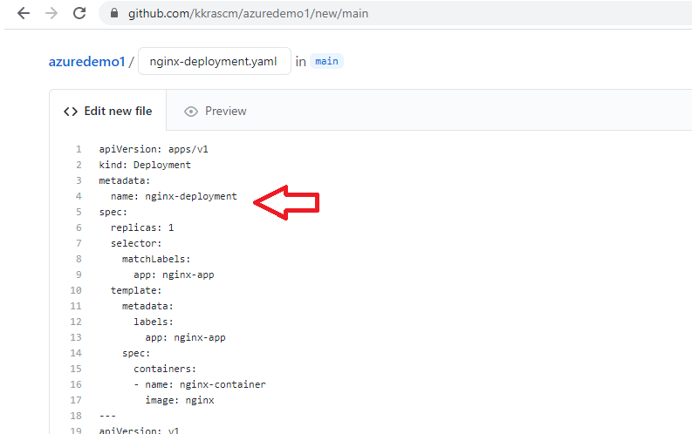

Step :

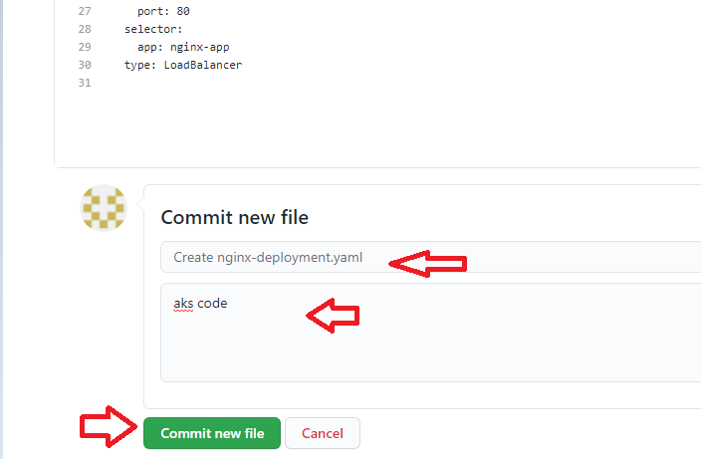

Step :

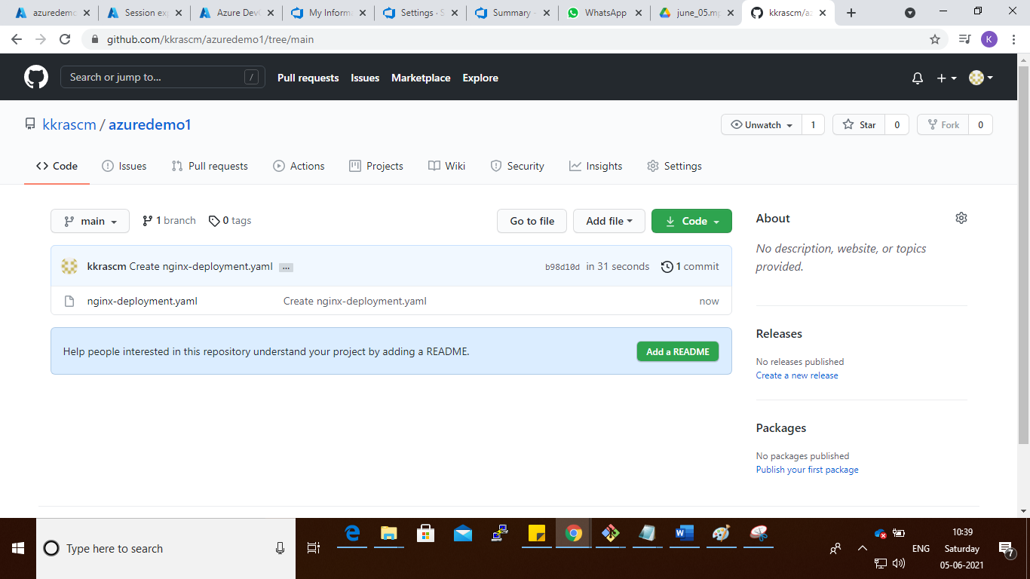

Step : go to dev.azure.com

Step : click on pipelines

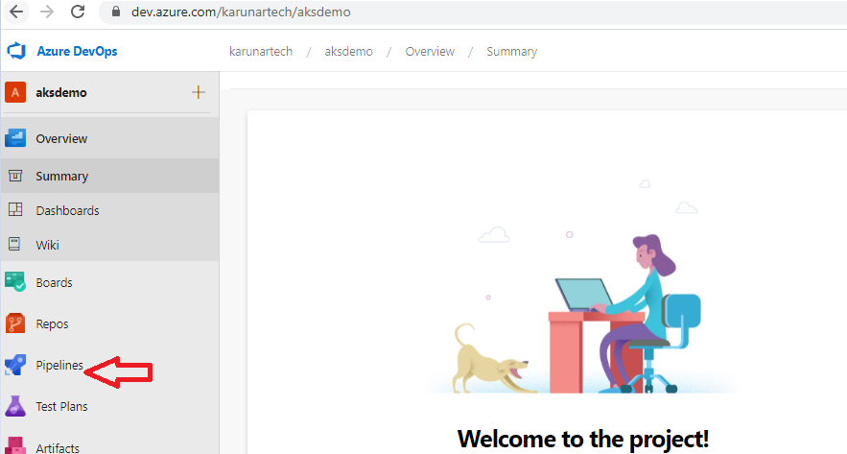

Step :

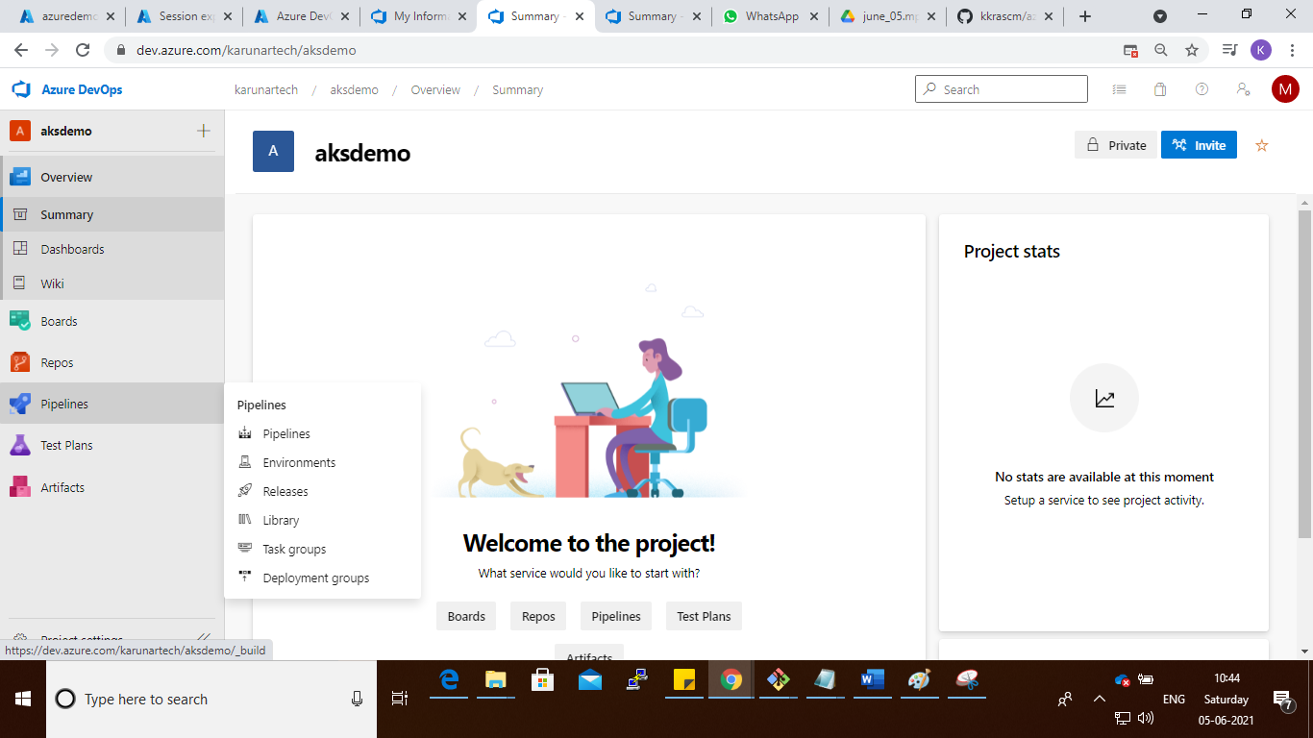

Step : create a new pipeline

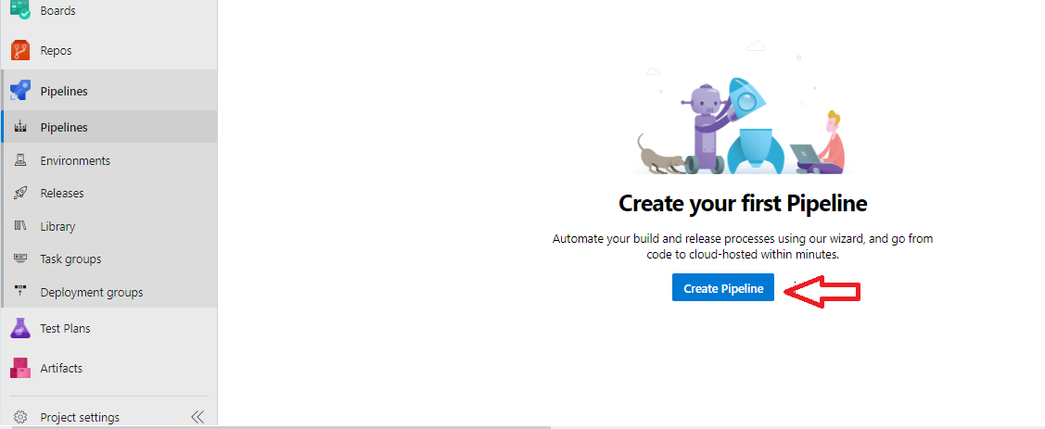

Step : click on classic piepeline

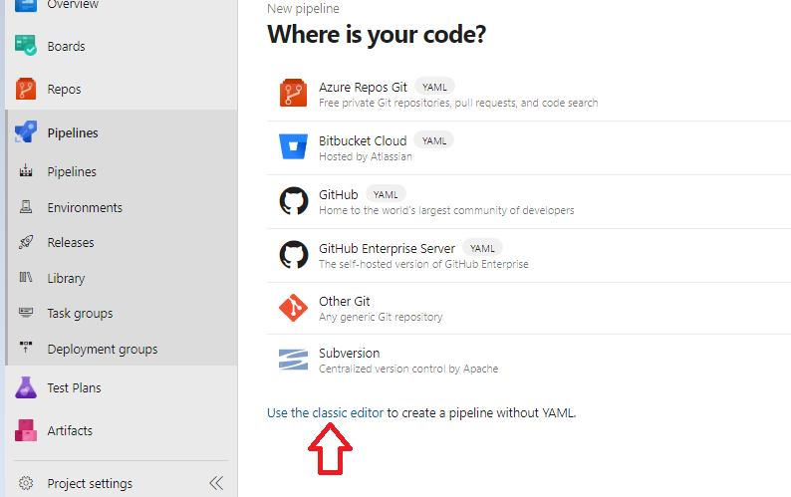

Step : select the github and github repository

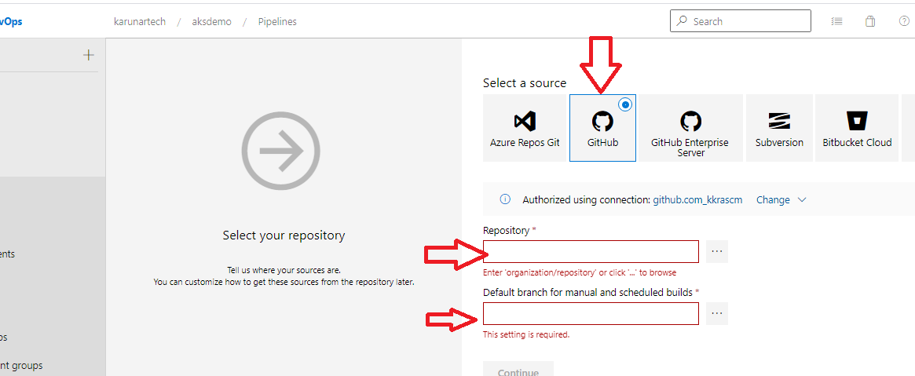

Step :

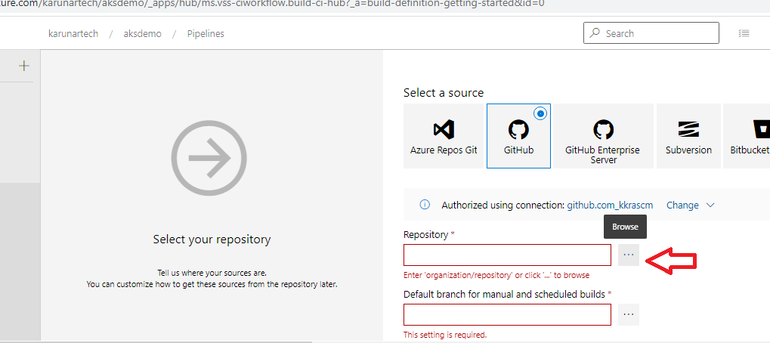

Step :

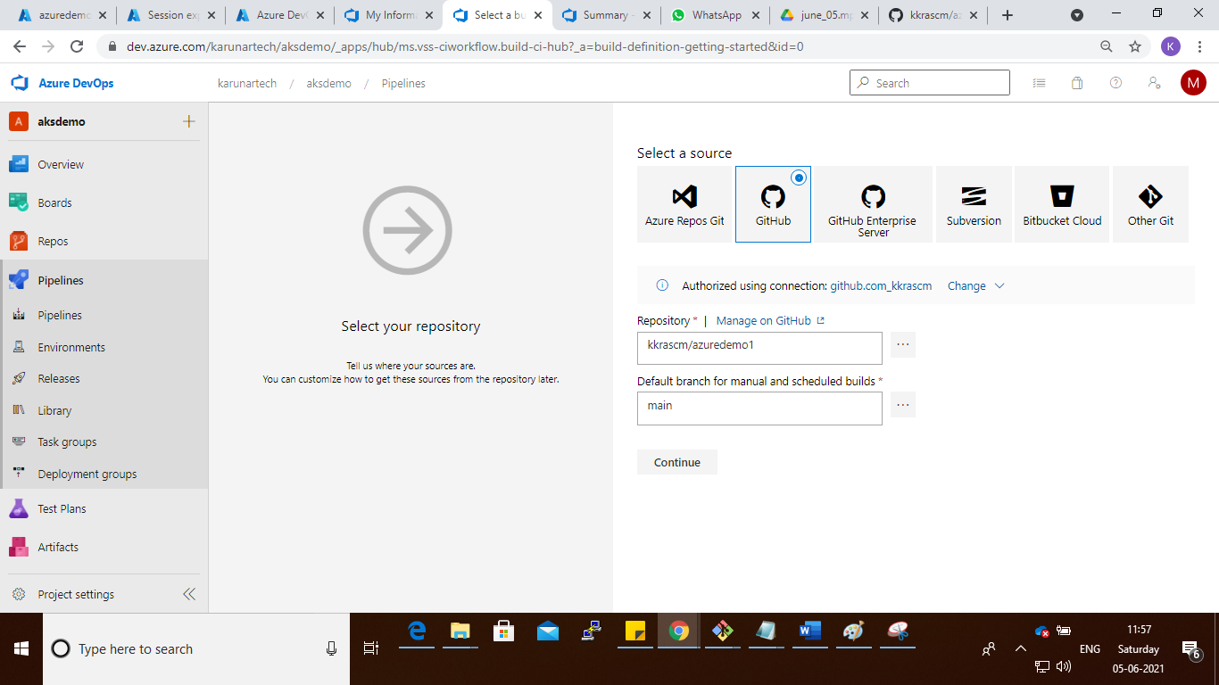

Step :

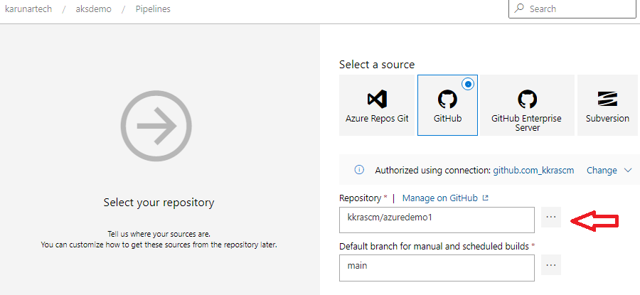

Step :

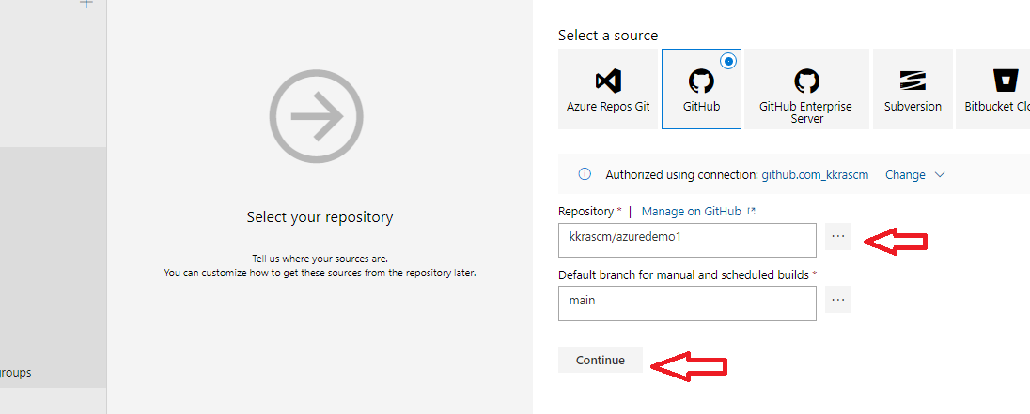

Step :

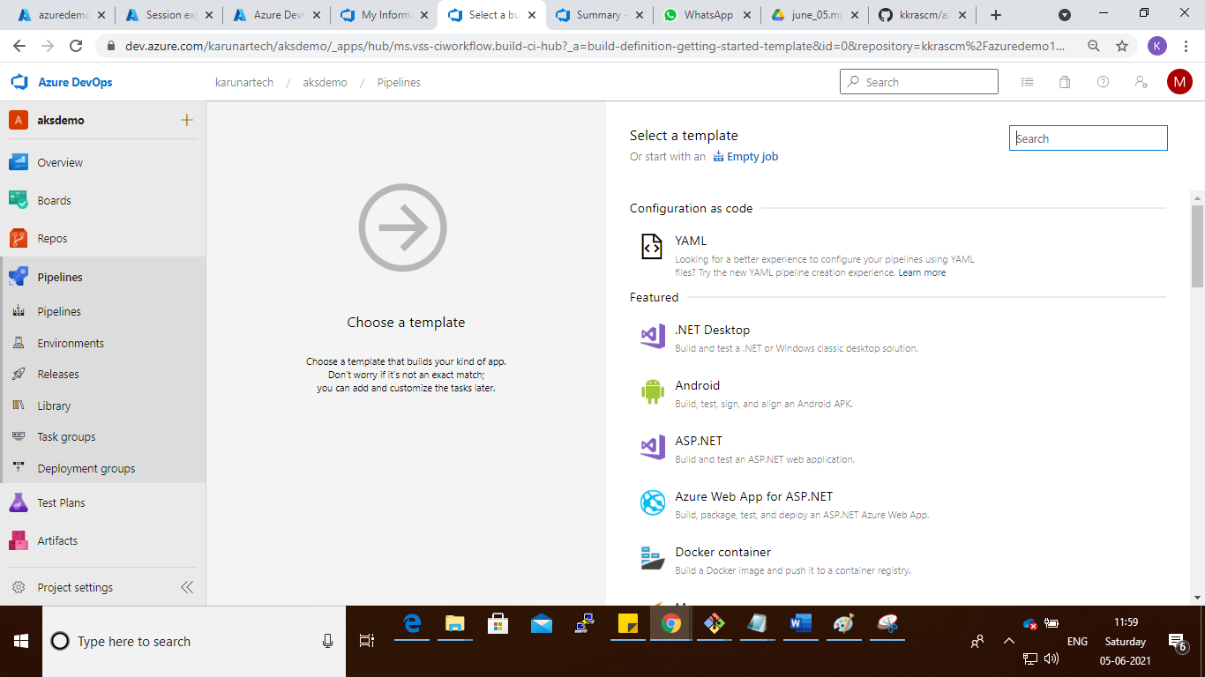

Step : search the Kubernetes and click appy

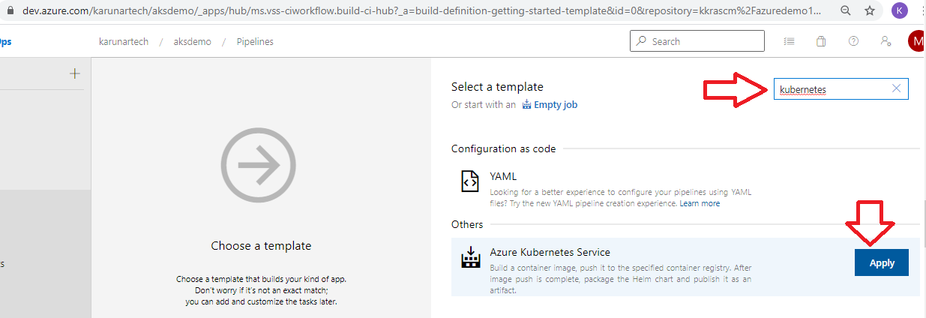

Step : click the each step and remove

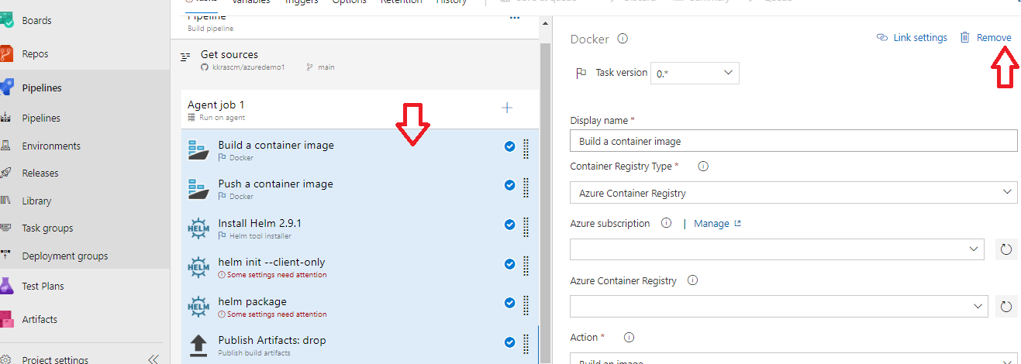

Step :

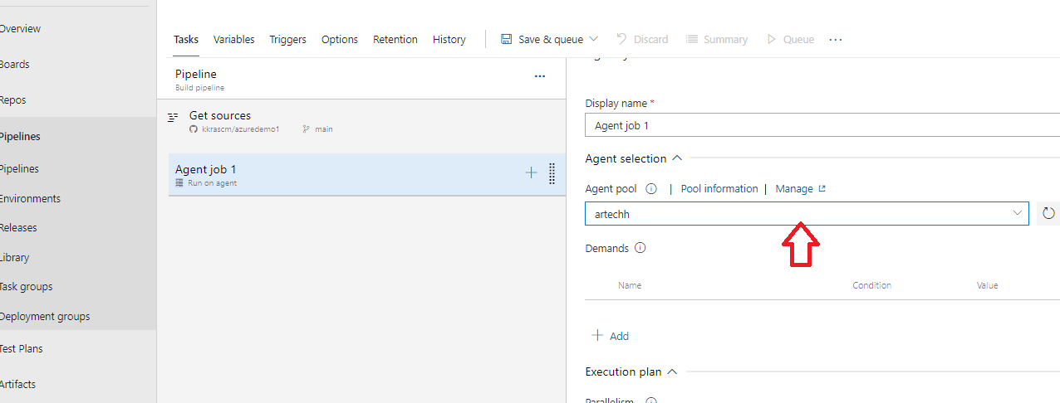

Step : click on Add a task Agent job 1

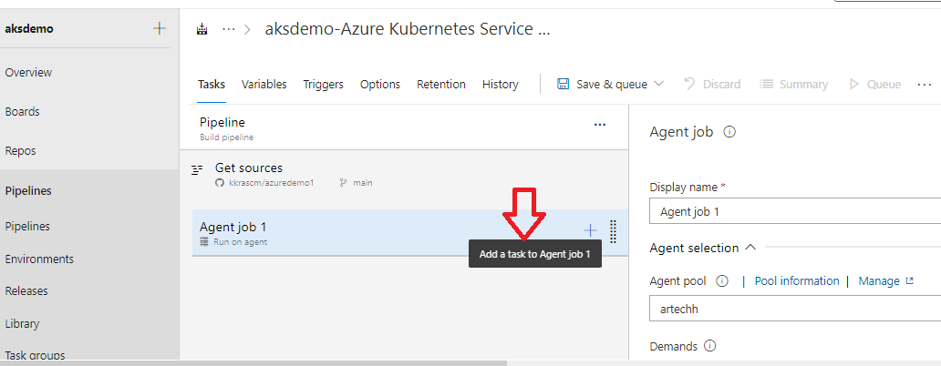

Step : search bash and add

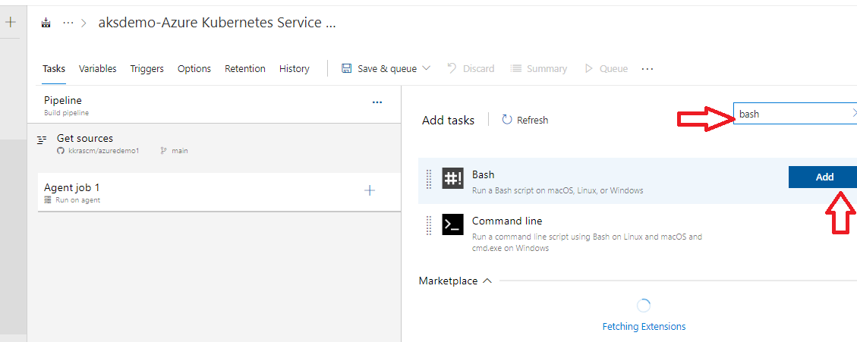

Step : select the add task

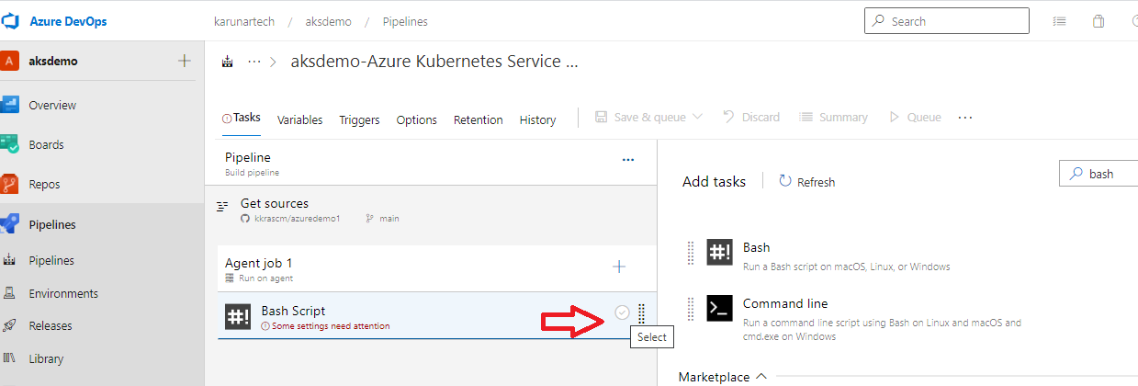

Step :

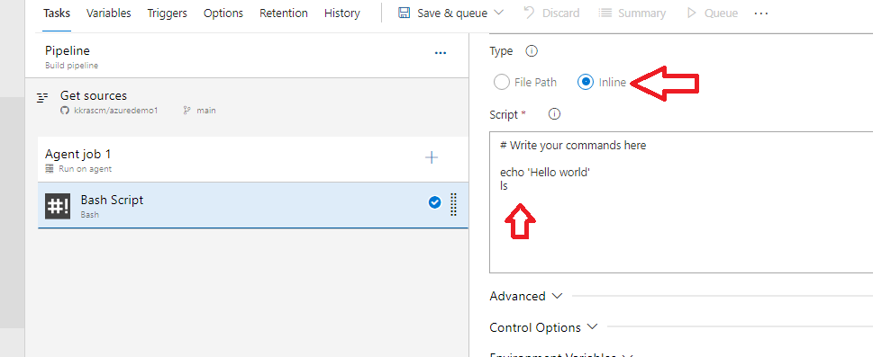

step : click on save&queue there select only save option

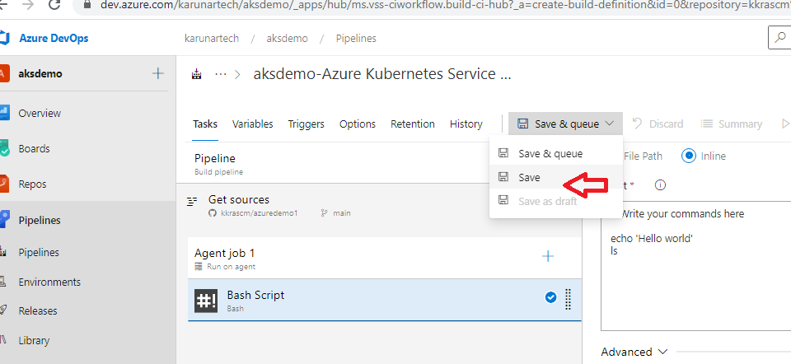

Step :

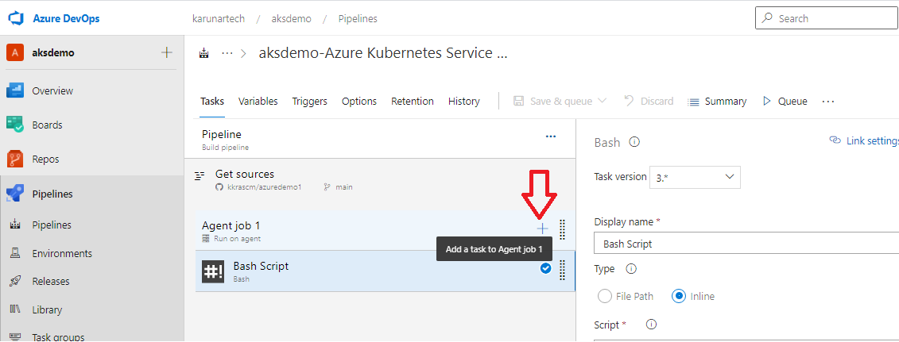

Step :

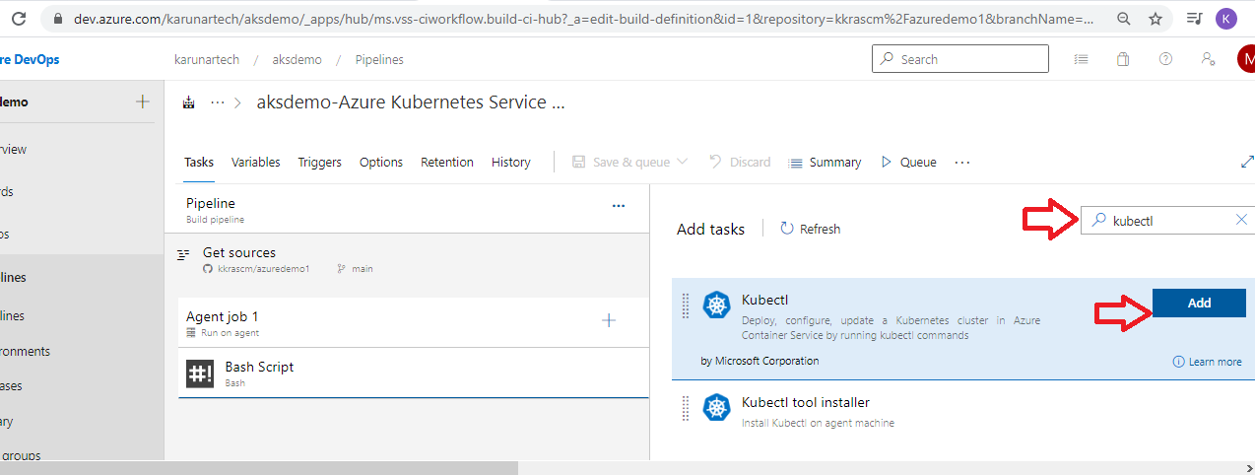

Step :

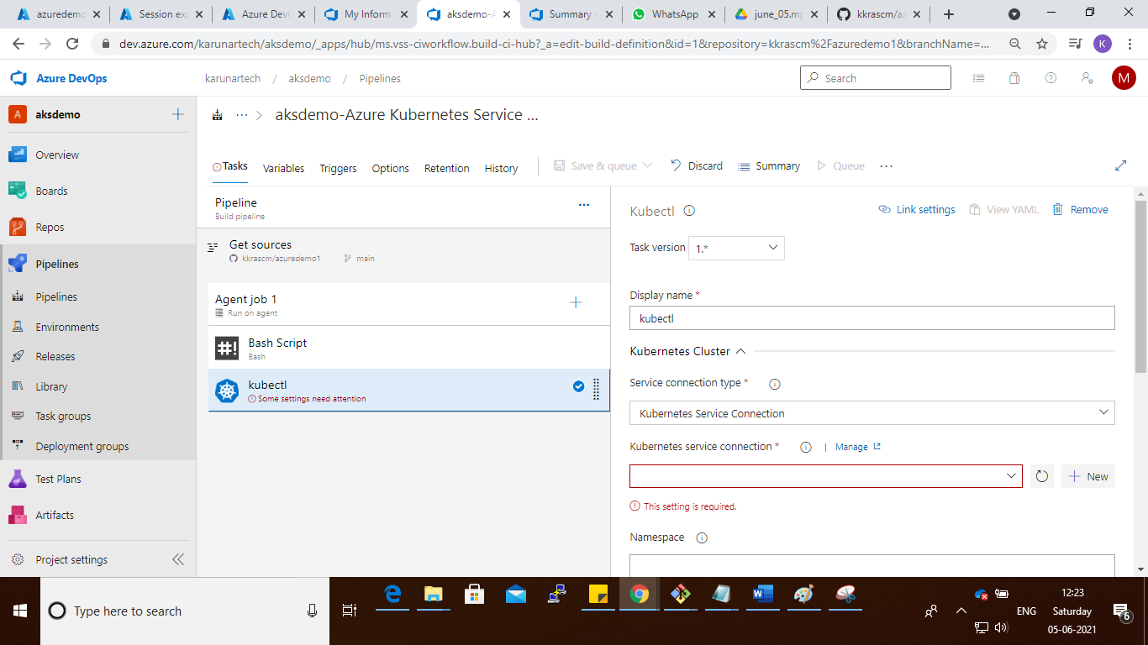

Step : select the kubernets service connection name and command is apply, give Arguments

Like : -f nginx-deployment.yaml

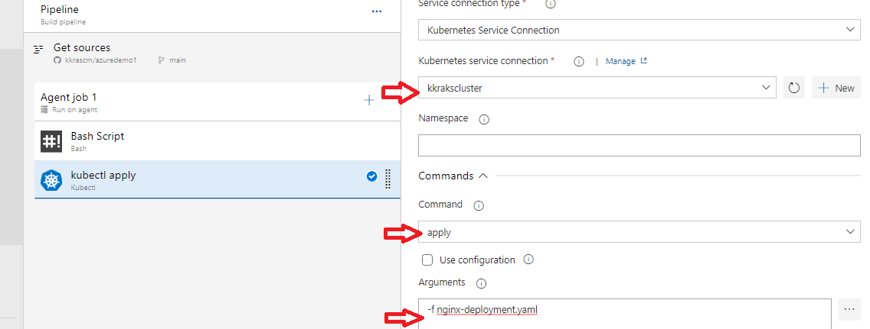

Step: save the job

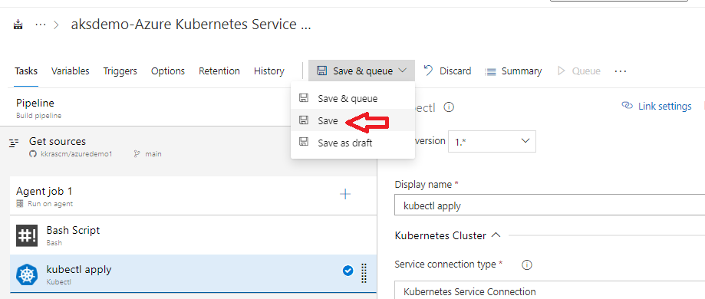

Step :

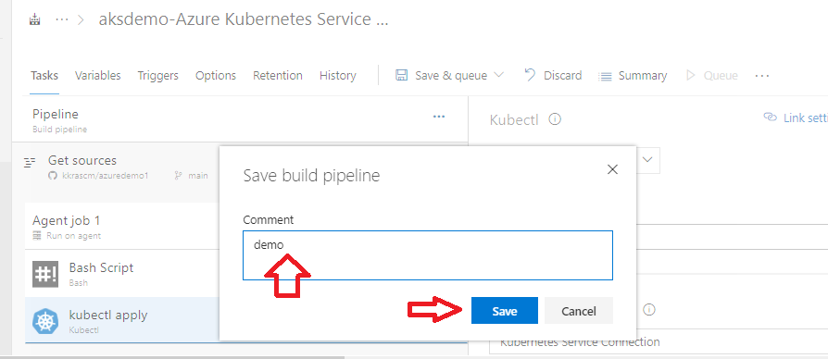

Step :

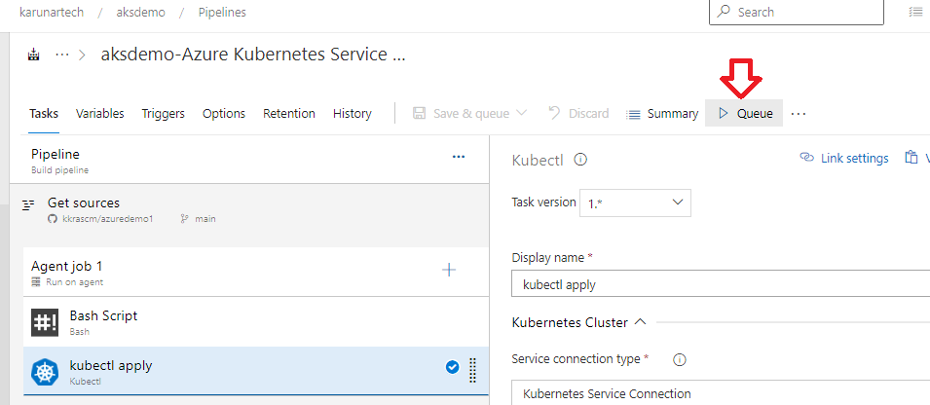

Step : select the Agent pool and run

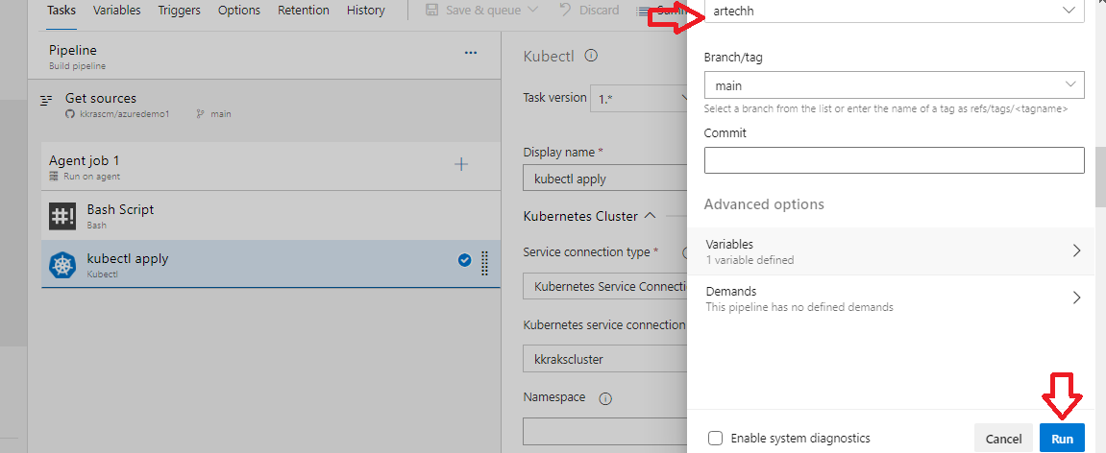

Step :

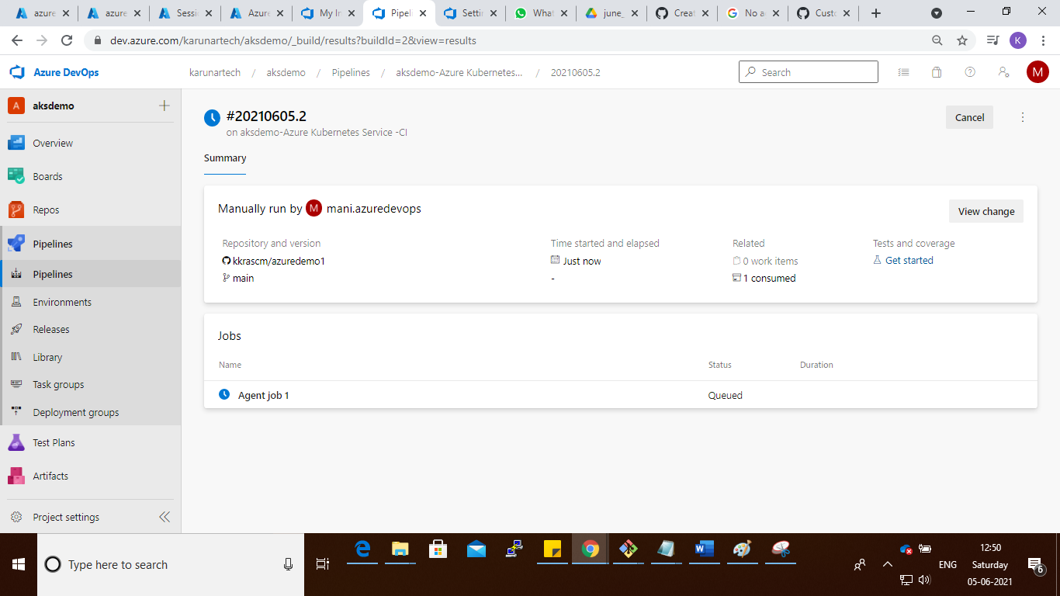

Step :

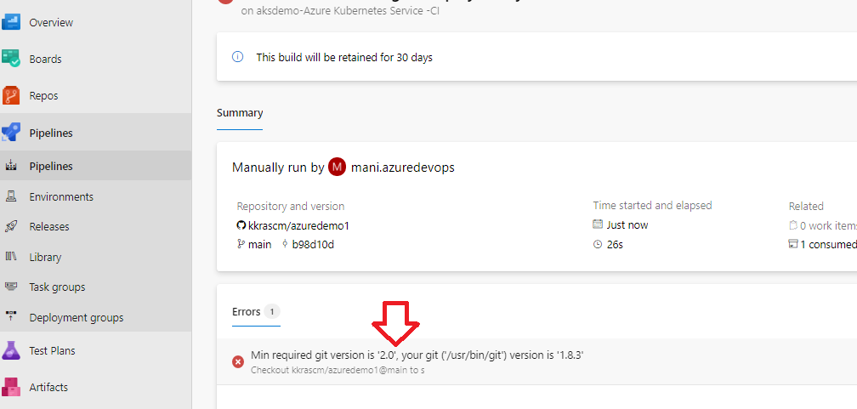

Step : sudo yum install git

Step : pipeline is failed due to git version is lower need to upgrade the git version

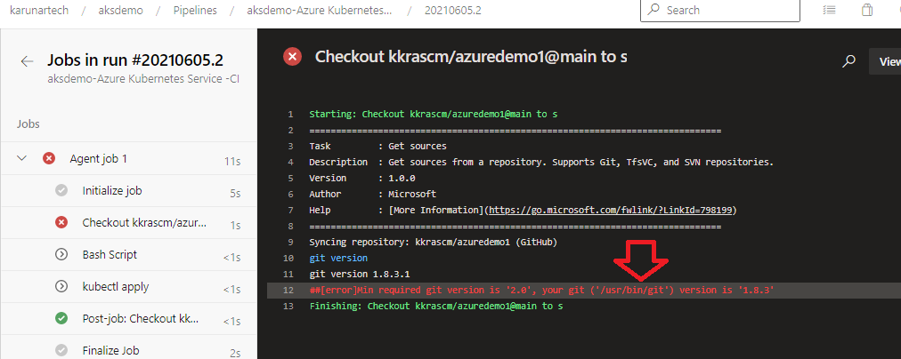

Step :

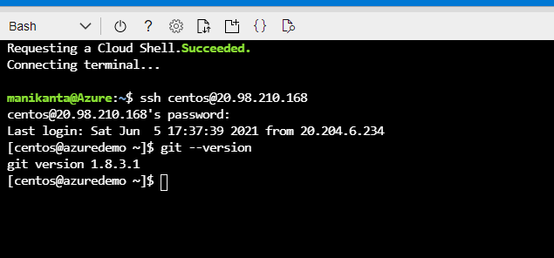

Step :

Cmd : sudo yum install http://opensource.wandisco.com/centos/7/git/x86_64/wandisco-git-release-7-1.noarch.rpm

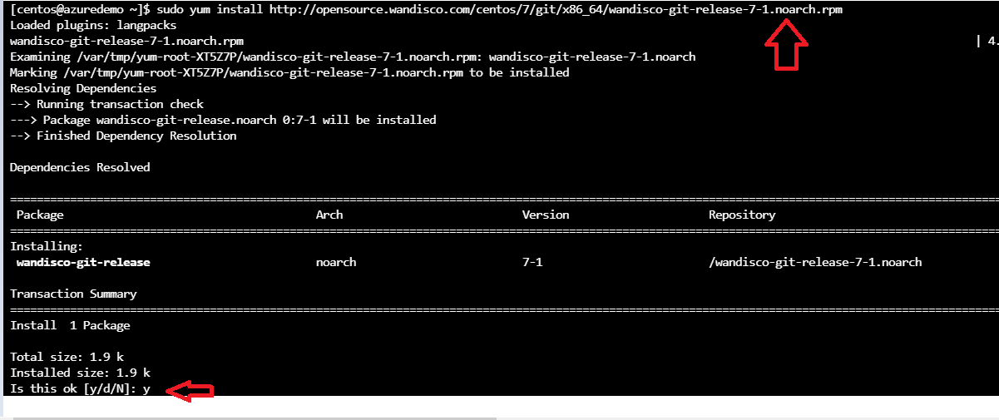

Step : sudo yum install git -y

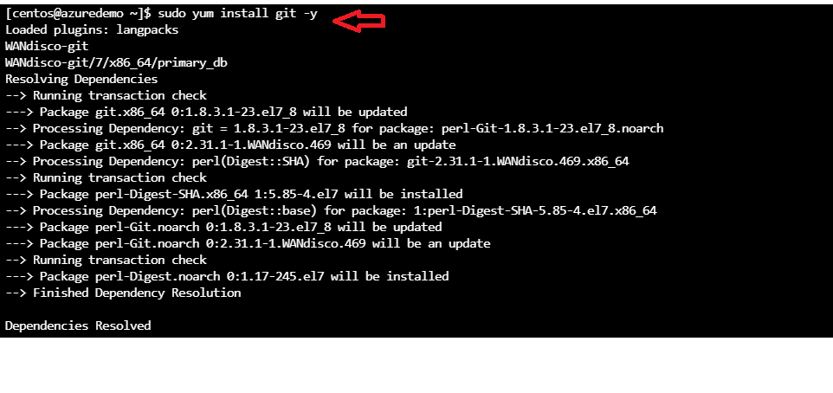

Step : check git version

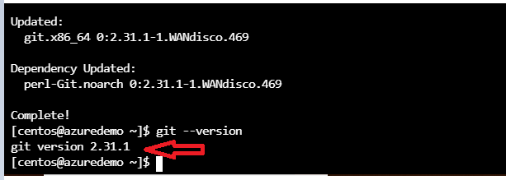

Step : re-run the failed pipeline

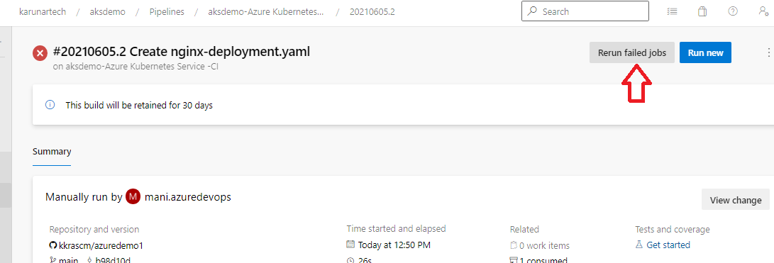

Step :

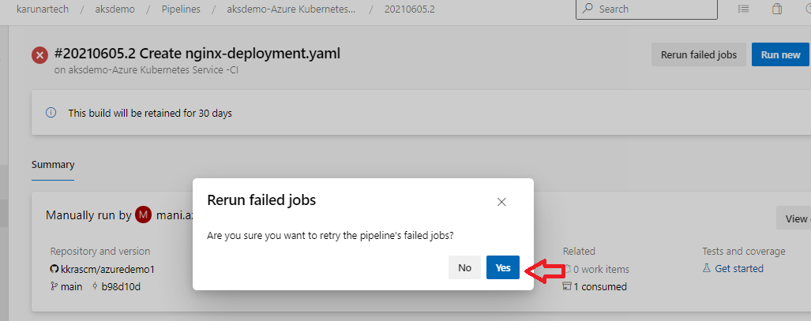

Step :

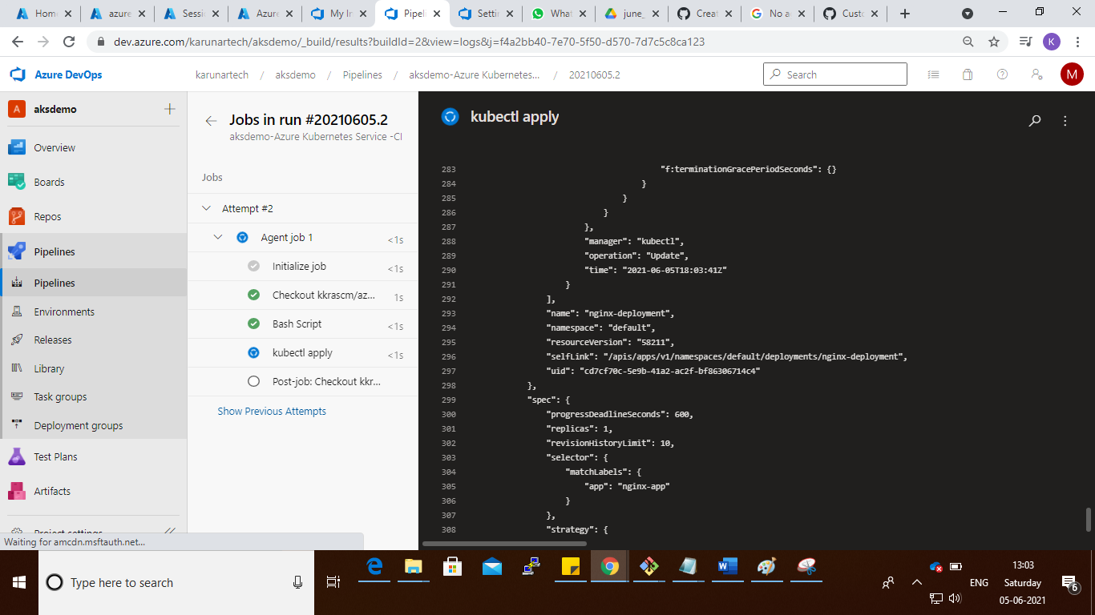

Step :

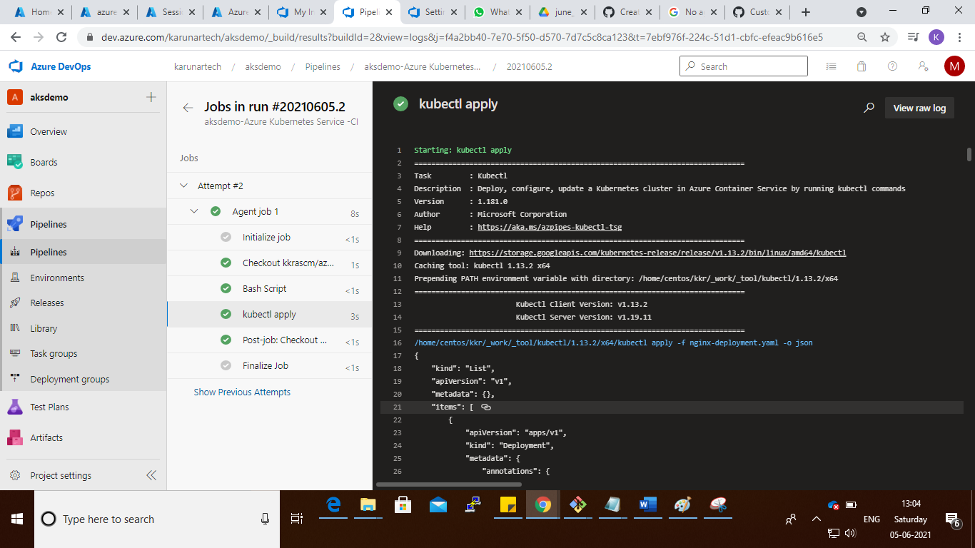

Step :

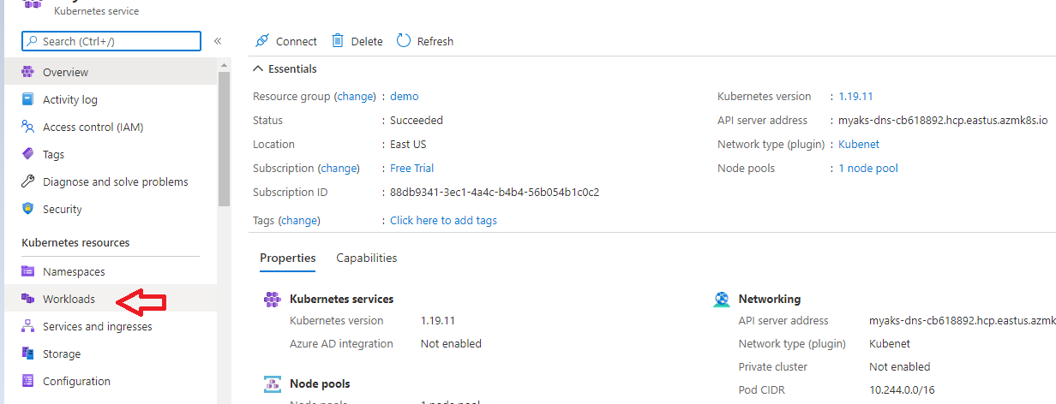

Step :

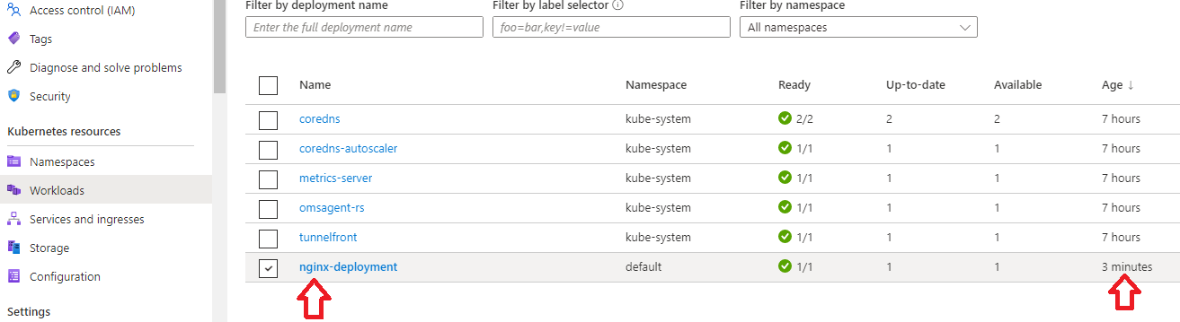

Step :

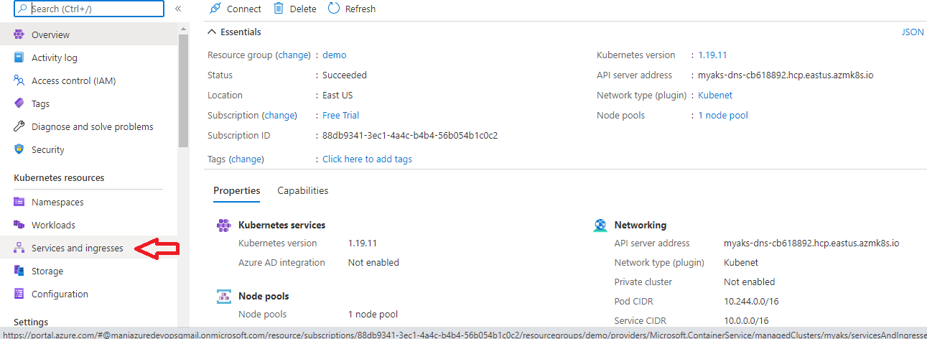

Step : click on the External ip after clicking it will open new window nginx

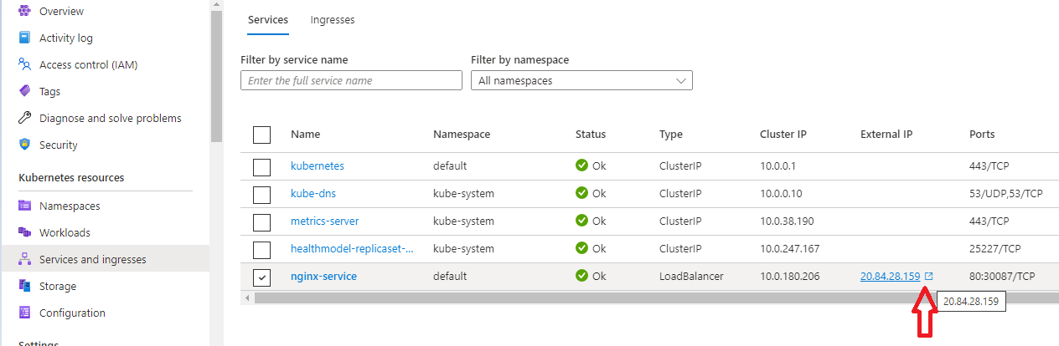

Step :

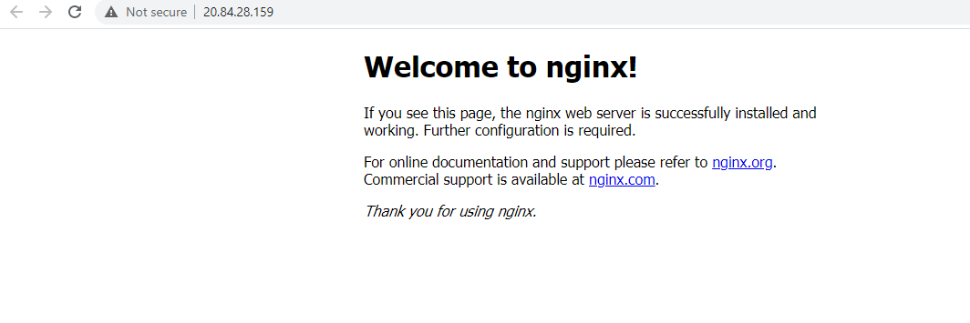

**Azure pipeline deployment completed successfully**

**Thank you**